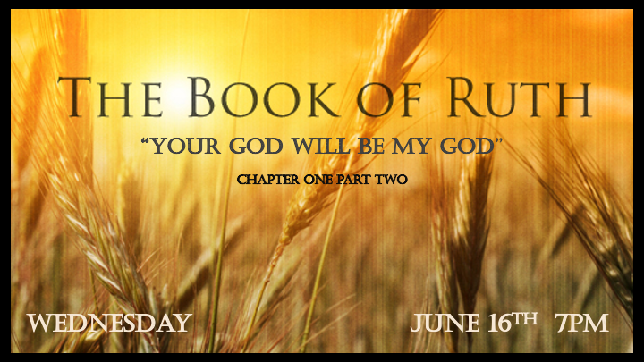

*Shallow relationships are the norm, who will show the way to make deep commitments?

*Ruth 1: 13 would you wait until they grew up? Would you remain unmarried for them? No, my daughters. It is more bitter for me than for you because the LORD's hand has turned against me!"

14 At this they wept aloud again. Then Orpah kissed her mother-in-law goodbye, but Ruth clung to her.
15 "Look," said Naomi, "your sister-in-law is going back to her people and her gods. Go back with her."

*The Hand of the Lord is often a Mystery.

- Naomi sees the hand of the Lord in all that has turned against her life.

- She didn’t realize to what depth the hand of the Lord was moving in her life and what role her life would play in the eternal plan of God.

- V:15 Ruth is not willing to go back to her pagan life or the false gods of the Moabites.

*Ruth 1:16 But Ruth replied, "Don't urge me to leave you or to turn back from you. Where you go, I will go, and where you stay, I will stay. Your people will be my people and your God my God. 17 Where you die, I will die, and there I will be buried. May the LORD deal with me, be it ever so severely, if even death separates you and me." 18 When Naomi realized that Ruth was determined to go with her, she stopped urging her.

Your people will be my people and your God my God.

- The commitment: Ruth is an example of seeing the truth and not letting go of it.

- May the Lord: Ruth uses the Hebrew word Yehovah or the English spelling Jehovah for the name of God. She has committed to the God of Abraham while leaving her old gods in Moab.

- A seven-fold decision: Is this an early pattern of full and complete salvation?
- Where you go, I will go. Question?
- Where you stay, I will stay. Question?
- Your people will be my people. Question?
- Your God will be my God. This is the biggest central question.
- Where you die, I will die. Question?
- Where you are buried, I will be buried. Question?
- If anything, other than death separates us may God severely deal with me. Question

*God’s plans are not our plans. Isaiah 55:8-10

*Deuteronomy 23:1-3 1 No one who has been emasculated by crushing or cutting may enter the assembly of the LORD.
2 No one born of a forbidden marriage nor any of their descendants may enter the assembly of the LORD, not even in the tenth generation.
3 No Ammonite or Moabite or any of their descendants may enter the assembly of the LORD, not even in the tenth generation.

- How can Ruth enter into God’s presence with the barriers of the law in Deuteronomy?

- The law reveals our inability to have a relationship with God, except for grace.

- Christ’s life & death activates grace for all: His genealogy reveals this truth.
- Tamar: A Canaanite who has a child out of incest. Genesis 38
- Rahab: A Gentile and prostitute. Joshua 2
- Ruth: A Moabite. Ruth 1
- Bathsheba: A married woman who gets pregnant by a sinful King. 2 Samuel 11

*Ruth 1:19 So the two women went on until they came to Bethlehem. When they arrived in Bethlehem, the whole town was stirred because of them, and the women exclaimed, "Can this be Naomi?" 20 "Don't call me Naomi, " she told them. "Call me Mara, because the Almighty has made my life very bitter. 21 I went away full, but the LORD has brought me back empty. Why call me Naomi? The LORD has afflicted me; the Almighty has brought misfortune upon me."
22 So Naomi returned from Moab accompanied by Ruth the Moabite, her daughter-in-law, arriving in Bethlehem as the barley harvest was beginning.

*Bitter believers miss God’s best.

- V:21 When we move from the fullness of God to empty, what have we’ve been running on?

- V:13 Identifying the hand of the Lord dealing with you or your household is tricky.

