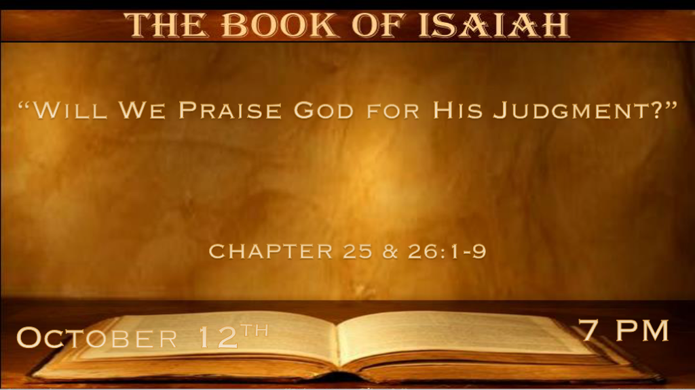

*Praising God as He diminishes the noise of the end times.
*Isaiah 25:1 O LORD, You are my God. I will exalt You, I will praise Your name, for You have done wonderful things;
Your counsels of old are faithfulness and truth. 2 For You have made a city a ruin, a fortified city a ruin, a palace of foreigners to be a city no more; It will never be rebuilt. 3 Therefore the strong people will glorify You; The city of the terrible nations will fear You. 4 For You have been a strength to the poor, a strength to the needy in his distress, a refuge from the storm, a shade from the heat; For the blast of the terrible ones is as a storm against the wall. 5 You will reduce the noise of aliens, as heat in a dry place; As heat in the shadow of a cloud, the song of the terrible ones will be diminished.

- V:1 The Counsels of the old are faithfulness and truth
- The O.T. has been under attack.
- In the last days, the O.T. is proving its faithfulness and truth.

- V:2-4 A city, a people, and nations will learn.
- The fear of the Lord will be learned by all.
- Sadly, even as Sodom is an example of a ruined city, people do not fear the Lord.
- A refuge from the storm.

- V:5 There is a lot of noise in this world.
Possibly the greatest thing needed today is the decrease of the noise or deception that is getting louder every day.

* Praising God for what He is going to do.

*Isaiah 25:6 And in this mountain The LORD of hosts will make for all people a feast of choice pieces, a feast of wines on the lees, of fat things full of marrow, of well-refined wines on the lees. 7 And He will destroy on this mountain the surface of the covering cast over all people, and the veil that is spread over all nations. 8 He will swallow up death forever, and the Lord GOD will wipe away tears from all faces; The rebuke of His people He will take away from all the earth; For the LORD has spoken.
9 And it will be said in that day: “Behold, this is our God; We have waited for Him, and He will save us. This is the LORD; We have waited for Him; We will be glad and rejoice in His salvation.” 10 For on this mountain the hand of the LORD will rest, and Moab shall be trampled down under Him, as straw is trampled down for the refuse heap. 11 And He will spread out His hands in their midst as a swimmer reaches out to swim, and He will bring down their pride together with the trickery of their hands.
12 The fortress of the high fort of your walls He will bring down, lay low, and bring to the ground, down to the dust.

- V:6 Is this the wedding banquet?
Matthew 22:1-14 A type of rapture where some of the guests actually refuse to go to the banquet.

- V:7-8 The destruction of evil.
The veil is destroyed. People are blinded to who Jesus is and what God has done through His son. This is especially true for the Jewish people.
Jesus swallow up death forever! 1st Corinthians 15:54 Death is destroyed it is swallowed up in victory!

- V:9 Don’t stop looking or waiting for Jesus.
I believe this a message to those waiting for the rapture and it has a double application for those waiting for His return

- V:10-12 The second coming of Jesus will settle everything.
On the mountain of Zion, we will see Jesus' favor, power, and glory.

He will deal with Moab. This is modern-day Jordan. They have kept the people of Israel from the temple mount and in that day nothing will keep people from God (Jesus).

*In That Day we shall learn righteousness.

*Isaiah 26:1 In that day this song will be sung in the land of Judah: “We have a strong city; God will appoint salvation for walls and bulwarks. 2 Open the gates, that the righteous nation which keeps the truth may enter in. 3 You will keep him in perfect peace, whose mind is stayed on You, because he trusts in You. 4 Trust in the LORD forever, for in YAH, the LORD, is everlasting strength. 5 For He brings down those who dwell on high, the lofty city; He lays it low, He lays it low to the ground,
He brings it down to the dust. 6 The foot shall tread it down—The feet of the poor and the steps of the needy.” 7 The way of the just is uprightness; O Most Upright, You weigh the path of the just. 8 Yes, in the way of Your judgments, O LORD, we have waited for You; The desire of our soul is for Your name and for the remembrance of You. 9 With my soul I have desired You in the night, Yes, by my spirit within me I will seek You early; For when Your judgments are in the earth, The inhabitants of the world will learn righteousness.

- V:1-2 The Lord is our song.
*Psalm 118:14 The LORD is my strength and song, and He has become my salvation.

David writes this Psalm while he is surrounded by his enemies because he trusted in the Lord

Solomon will write the famous Proverb 3:5-6 Trust in the Lord with all your heart and lean not on your own understanding.

- V:3-4 The Lord is our strength.
V:3 The secret of perfect peace is revealed. It’s a mind that surrenders to God.
V:4 Trusting in the Lord is an everlasting strength. (Peace is a fruit of the Spirit that transforms our thinking.)

- V:5-6 The ways of humanity will change again.
The ways of man are replaced with the ways of God. This is the millennial reign language.

The least of these the poor and needy will not be looked down upon.

- V:7-9 The way of the upright.
The way is just or right. This speaks to how the righteous live their life.

The way of the righteous has a sanctified desire. We desire God’s way day and night.

Our desire is displayed in our waiting on Jesus and trusting in His Name.

This section ends with a promise. God will become the teacher. Teaching us the way of righteousness. We will be learnings of His righteousness.

