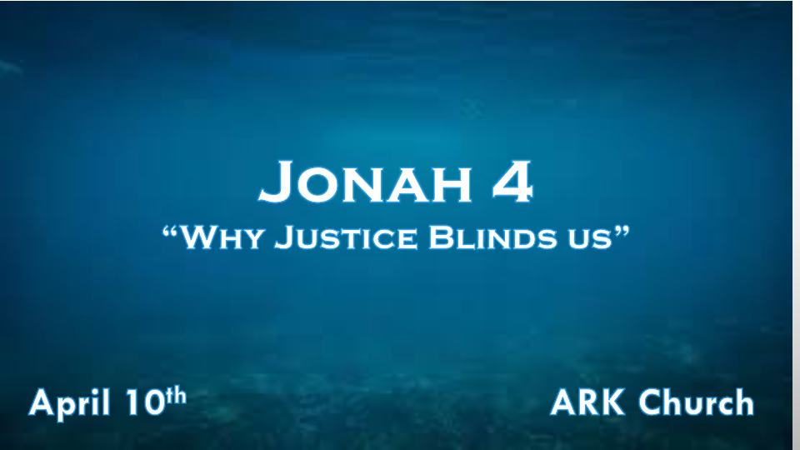

*The absence of mercy in a Christian's life can have terrible consequences.

*Jonah 4:1 But it displeased Jonah exceedingly, and he became angry. 2 So he prayed to the LORD, and said, "Ah, LORD, was not this what I said when I was still in my country? Therefore I fled previously to Tarshish; for I know that You are a gracious and merciful God, slow to anger and abundant in lovingkindness, One who relents from doing harm. 3 Therefore now, O LORD, please take my life from me, for it is better for me to die than to live!"

- V:1 Why do followers of God get angry?

Genesis 4:5-8 Cain kills his brother out of his perception about the offering God rejected. (Would Cain have said the rejection was unjust?)

Righteous anger is Jesus overturning the money changers in the temple.

*Ephesians 4:25 Therefore, putting away lying, "Let each one of you speak truth with his neighbor," for we are members of one another. 26 "Be angry, and do not sin": do not let the sun go down on your wrath, 27 nor give place to the devil.

The calling is to be angry at sin but not the sinner. Maturity of spirit is vital to get this right.

- V:2-3 Jonah's view of God's Character is correct in this situation. Why does Jonah wish to die?

Mercy, not judgment, is what we pray for ourselves. Jonah knew the Assyrians would continue to be the enemy of Israel.

Can we rejoice when our enemies receive mercy?

*James 2:13 For judgment is without mercy to the one who has shown no mercy. Mercy triumphs over judgment.

Jonah has a heart issue. He, deep down, doesn't want his enemies delivered from judgment.

*A loving God disciplines those He loves. A foolish person argues with God.

*Jonah 4:4 Then the LORD said, "Is it right for you to be angry?"
5 So Jonah went out of the city and sat on the east side of the city. There he made himself a shelter and sat under it in the shade, till he might see what would become of the city. 6 And the LORD God prepared a plant and made it come up over Jonah, that it might be shade for his head to deliver him from his misery. So Jonah was very grateful for the plant. 7 But as morning dawned the next day God prepared a worm, and it so damaged the plant that it withered. 8 And it happened, when the sun arose, that God prepared a vehement east wind; and the sun beat on Jonah's head, so that he grew faint. Then he wished death for himself, and said, "It is better for me to die than to live."
9 Then God said to Jonah, "Is it right for you to be angry about the plant?"
And he said, "It is right for me to be angry, even to death!"

- V:4-5 Has our desire for justice in our world made us lose sight of repentance and mercy?
Do we hate the sinner more than the sin that controls them?

Wouldn't it be more powerful to see more Saul to Paul-conversions than to see God bring judgment on sinners?

- V:6 The source of deliverance from our misery isn't justice.
Comfort can come from the simple things in life.

No one finds joy through judgment. There can be a sense of peace when justice happens.

James 2:13 God's word says Mercy triumphs. I love the triumphant spirit.

*Luke 6:35 But love your enemies, do good, and lend, hoping for nothing in return; and your reward will be great, and you will be sons of the Most High. For He is kind to the unthankful and evil. 36 Therefore be merciful, just as your Father also is merciful.

- V:7-9 Jonah cared more about a plant than life itself. Twisted perspectives destroy hope.
Jonah, a prophet, makes errors in judgment and God's heart.
Jonah trusted his perspective on life greater than God's.
When you are your only source of perspective on any situation, you are living in the shallows

*A Generation Without Discernment is Doomed.

*Jonah 4:10 But the LORD said, "You have had pity on the plant for which you have not labored, nor made it grow, which came up in a night and perished in a night. 11 And should I not pity Nineveh, that great city, in which are more than one hundred and twenty thousand persons who cannot discern between their right hand and their left—and much livestock?"

- God loves object lessons.
Self-centered people have an entitled mindset.

- Those who cannot discern the right hand from the left cannot make moral judgments.
The book of Jonah shows God's concern, care, and salvation goes beyond Israel and the Jews.

- God prepares great things and simple things.
God prepared a great fish, the plant, the worm, and the wind.

God often uses creation to get humanity's attention. He is the same God today.

