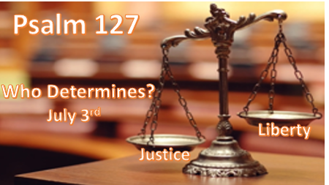

*Lessons we’ve learned from God’s Word on who determines truth.

*Isaiah 33:22 For the LORD is our Judge, The LORD is our Lawgiver, The LORD is our King; He will save us.
Ben Franklin on July 2, 1776, said; “If a sparrow cannot fall to the grown without God noticing, is it possible for an Empire to rise and be great without his aid.

*What is in vain (useless) and how is gain obtained?

*Psalm 127:1 (NKJV) Unless the LORD builds the house,
They labor in vain who build it;
Unless the LORD guards the city, The watchman stays awake in vain.
2 It is vain for you to rise up early, To sit up late, To eat the bread of sorrows; For so He gives His beloved sleep.

- *V:1 How does the Lord build a house?
He starts by being the foundation and the key cornerstone of each home and family. The foundation must be good or else it’s a vain/worthless effort.

- *How is the Lord the protector of our cities?
*Psalm 18:2 The LORD is my rock and my fortress and my deliverer;
My God, my strength, in whom I will trust;
My shield and the horn of my salvation, my stronghold.
As we return to 2 Thessalonians 3:3 next week there is a special promise of protection from the evil one.

- V:2 God gives rest to those who surrender life to him.
He leads me beside the still waters.

*Every Christian must see children the way God does.

*Psalm 127:3 Behold, children are a heritage from the LORD,
The fruit of the womb is a reward.
4 Like arrows in the hand of a warrior,
So are the children of one’s youth.

- V:3 (Behold)Bear this Witness, to this world that children are a heritage (gift) from the Lord.
- Children are the legacy of their parent's relationship with God. Our children have the potential to mark this world with the goodness and faithfulness of God’s plan.
- We don’t destroy the fruit. The womb bearing a child is a reward. Every child is a symbol of a blessing, but not every child will become a blessing.
We must train up a child in the way they should go. (Proverbs 22:6)
- The deceiver lies to society about why children are here and what they will bring to your life.

- V:4 An analogy about children and arrows.
- Children like arrows will hit the target the parents aim them at.
Children will also hit the target that society aims them at unless the truth is reinforced in their lives.

- Children like arrows will fly or remain in the quiver depending on the parent's attitudes toward God and their children being a gift.
Overprotection of children happens when you do not place them in the hands of Jesus.

*Sold-out Christians must learn to trust the movement of the Holy Spirit and Prophecy, and they must test everything. (2 Thessalonians 5:19-22)

They lift up good and abstain from all evil.

*The pursuit of happiness, liberty, and justice for all.

*Psalm 127:5 Happy is the man who has his quiver full of them;
They shall not be ashamed,
But shall speak with their enemies in the gate.

- V:5 Happiness is found in influencing the next generation to God.
Happiness is not self-centered. It is in influencing others to the kingdom of God.

- No shame is given to the one who protects life.
There is no liberty or justice for those who don’t protect life. This is part of the deceiver’s lie too.

- We must speak to the enemies that are at the gate and not let them rule the city or question the meaning of life.
Liberty will be lost by letting the enemies of God rule in our land.
Justice is lost when a generation that doesn’t honor God is in charge.

I believe in a land where freedom reigns. I believe the U.S.A. has been that land. It’s time to reclaim the promises of God and set the record straight.

