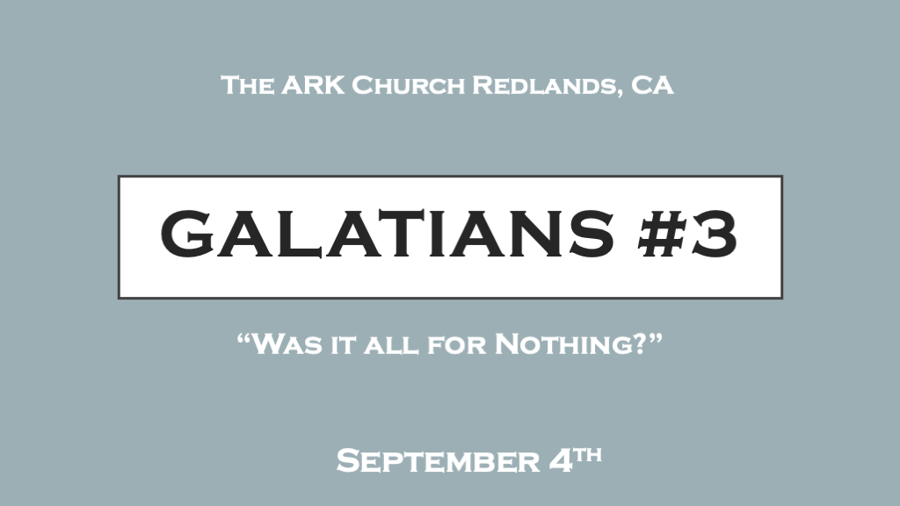

*How foolish is Christianity becoming?

*Understanding a relationship with God with bridge of Grace. (Personal Argument)

*Galatians 3:1 O foolish Galatians! Who has bewitched you that you should not obey the truth, before whose eyes Jesus Christ was clearly portrayed among you as crucified? 2 This only I want to learn from you: Did you receive the Spirit by the works of the law, or by the hearing of faith? 3 Are you so foolish? Having begun in the Spirit, are you now being made perfect by the flesh? 4 Have you suffered so many things in vain—if indeed it was in vain?
5 Therefore He who supplies the Spirit to you and works miracles among you, does He do it by the works of the law, or by the hearing of faith?— 6 just as Abraham “believed God, and it was accounted to him for righteousness.” 7 Therefore know that only those who are of faith are sons of Abraham. 8 And the Scripture, foreseeing that God would justify the Gentiles by faith, preached the gospel to Abraham beforehand, saying, “In you all the nations shall be blessed.” 9 So then those who are of faith are blessed with believing Abraham.

- V:1-2 Paul uses stern language about a falsehood and that the Galatians are being deceived.
Some so-called Christians teach Christ death was not need for us to gain heaven.
A false religion will attack the fact of Christ death.
We can only receive the Spirit of God by faith. (Not intellect, nor through an emotional ploy, and etc.)

- V:3 Foolishness is believing we start our relationship with Jesus by faith but we achieve spiritual mature in that relationship by works.
Sadly, many believers cannot tell the difference from a church service or message that has the anointing of God’s Spirit and one that is absent of it. Because you must know it personally first before experiencing it corporately.

- V:4-5 You cannot achieve a spiritual relationship or good standing in a relationship with God through your flesh. (Acts 14:8-16) The crippled man (gentile) from birth healed. They call Paul and Barnabas gods. They ripped their own clothes and said we are men like you, human.

- V:6-9 Abraham is the role model of having a friendship with God by believing God.
*Genesis 15:6 And he believed in the LORD, and He accounted it to him for righteousness.
*Isaiah 41:8 “But you, Israel, are My servant, Jacob whom I have chosen, the descendants of Abraham My friend.

*Grace is the essential and only ingredient for our relationship. (Scriptural Argument)

*Galatians 3:10 For as many as are of the works of the law are under the curse; for it is written, “Cursed is everyone who does not continue in all things which are written in the book of the law, to do them.” 11 But that no one is justified by the law in the sight of God is evident, for “the just shall live by faith.” 12 Yet the law is not of faith, but “the man who does them shall live by them.”
13 Christ has redeemed us from the curse of the law, having become a curse for us (for it is written, “Cursed is everyone who hangs on a tree”), 14 that the blessing of Abraham might come upon the Gentiles in Christ Jesus, that we might receive the promise of the Spirit through faith.

- V:10-12 We can bring nothing to the table in obtaining a relationship with Jesus except our belief/faith.

- V:13-14 Our Savior became cursed in our place. So that the relationship/friendship with God could be restored for all humanity.
The curse of our sin is placed on Christ and He becomes the cursed that Isaiah 53 says God punishes.
What’s place on Christ? You are correct when you say sin, and punishment. Be careful if you say anything else. What was placed on Christ was used to bring restoration. It makes a difference if we believe God’s wrath is placed on Jesus. Wrath is righteous anger being placed on him. Wrath has no path of restoration attached to it.

*Grace is God’s steadfast promise.

*Galatians 3:15 Brethren, I speak in the manner of men: Though it is only a man’s covenant, yet if it is confirmed, no one annuls or adds to it. 16 Now to Abraham and his Seed were the promises made. He does not say, “And to seeds,” as of many, but as of one, “And to your Seed,” who is Christ. 17 And this I say, that the law, which was four hundred and thirty years later, cannot annul the covenant that was confirmed before by God in Christ, that it should make the promise of no effect. 18 For if the inheritance is of the law, it is no longer of promise; but God gave it to Abraham by promise.

- V:15-16 The promise of Grace is traced back to Abraham. The Genealogy of Jesus in Matthew Chapter reveals this truth. Jesus’ humanity is traced back to Abraham seed.
In Chapters 3 & 4 the teaching of the doctrine of Grace, the word “Promise is used 11x, the word “Law” 19x, and the word “Faith” 14x.
Abraham is the bloodline to Jesus and is a foreshadow of a righteous relationship with God. He sacrifices his one and only son Isaac (Genesis 22)

- V:17-18 Don’t remove the power from the promise.

*We all need Tutors on our spiritual journey. (The Logical argument)

*Galatians 3:19 What purpose then does the law serve? It was added because of transgressions, till the Seed should come to whom the promise was made; and it was appointed through angels by the hand of a mediator. 20 Now a mediator does not mediate for one only, but God is one. 21 Is the law then against the promises of God? Certainly not! For if there had been a law given which could have given life, truly righteousness would have been by the law. 22 But the Scripture has confined all under sin, that the promise by faith in Jesus Christ might be given to those who believe. 23 But before faith came, we were kept under guard by the law, kept for the faith which would afterward be revealed. 24 Therefore the law was our tutor to bring us to Christ, that we might be justified by faith. 25 But after faith has come, we are no longer under a tutor. 26 For you are all sons of God through faith in Christ Jesus. 27 For as many of you as were baptized into Christ have put on Christ. 28 There is neither Jew nor Greek, there is neither slave nor free, there is neither male nor female; for you are all one in Christ Jesus. 29 And if you are Christ’s, then you are Abraham’s seed, and heirs according to the promise.

- True

