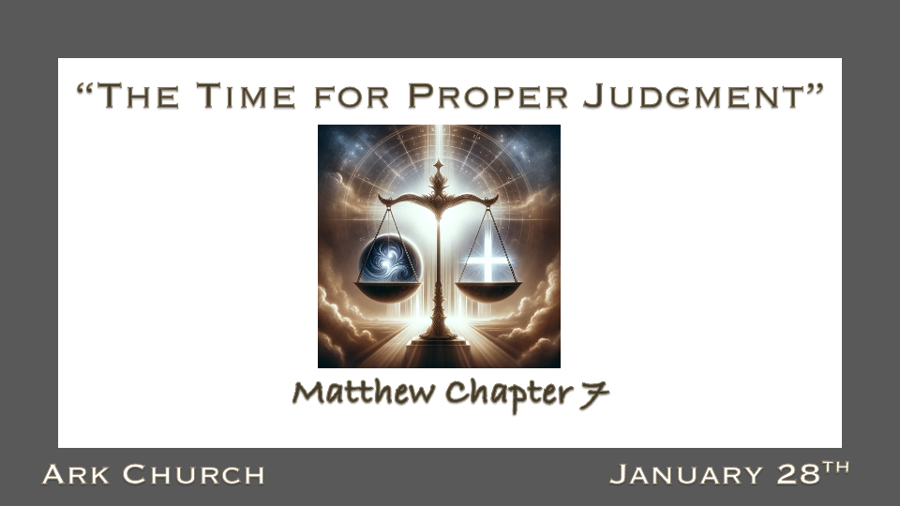
The overall themes of Matthew chapters 3-6 are ingredients of salt, light, and righteousness of discipleship. We picked up the piece Who's your Master in Matthew 6? The good Master is the one who teaches their disciples how to know and judge properly between good and evil, right. Discerning what spirit we are hearing from is a key to proper judgment.

*Discipleship is more than a class; it is a relationship.

*Matthew 6:24 "No one can serve two masters; for either he will hate the one and love the other, or else he will be loyal to the one and despise the other. You cannot serve God and mammon.

*Matthew 7:1 "Judge not, that you be not judged. 2 For with what judgment you judge, you will be judged; and with the measure you use, it will be measured back to you. 3 And why do you look at the speck in your brother's eye, but do not consider the plank in your own eye? 4 Or how can you say to your brother, 'Let me remove the speck from your eye'; and look, a plank is in your own eye? 5 Hypocrite! First remove the plank from your own eye, and then you will see clearly to remove the speck from your brother's eye.

- *Do you have a more significant relationship with Jesus than you do your money?

When Money is the master, it will teach you how to connect to the material world.

God leads you on how to connect to Him and others. That proper connection is called righteousness.

- *Do you make your judgments based on fear about money or fear of the Lord?

- Don't be quick to judge. Fast judgments are often wrong because you won't have all the information needed.

- Judgments are measured. Judgments are proportionate; we see flaws much more straightforward in others than in ourselves.

- *Isaiah 33:6 Wisdom and knowledge will be the stability of your times and the strength of salvation; The fear of the LORD is His treasure.

Holy fear is God's treasure; it should be ours, too. Is this a prophecy about the end times?

*The Fruit of Proper Judgment.

*Luke 29:37 "Judge not, and you shall not be judged. Condemn not, and you shall not be condemned. Forgive, and you will be forgiven. 38 Give, and it will be given to you: good measure, pressed down, shaken together, and running over will be put into your bosom. For with the same measure that you use, it will be measured back to you."
39 And He spoke a parable to them: "Can the blind lead the blind? Will they not both fall into the ditch? 40 A disciple is not above his teacher, but everyone who is perfectly trained will be like his teacher.

*Matthew 7:15 "Beware of false prophets, who come to you in sheep's clothing, but inwardly they are ravenous wolves. 16 You will know them by their fruits. Do men gather grapes from thornbushes or figs from thistles? 17 Even so, every good tree bears good fruit, but a bad tree bears bad fruit. 18 A good tree cannot bear bad fruit, nor can a bad tree bear good fruit. 19 Every tree that does not bear good fruit is cut down and thrown into the fire. 20 Therefore by their fruits you will know them.
Insights from Luke 29:37-40

- *Correctly divide the Word of God. If you are not a disciple, don't judge or condemn your greatest gift to use with others as a newbie in Christ is forgiveness.

- As a disciple, use a good measure of The Fear of the Lord in all your judgments or condemnations because the measure you use will return to you.

- Luke 29:39-40 The Fruit of Good judgment comes from a skilled teacher.

The Big mistake is we often want to be discipled by people who think like us.

You want someone experienced in the Word of God and the Fear of the Lord—the best two ingredients of a teacher.

- Matt. 7:15-20 The Beware warning. They may talk like an experienced person, but their life doesn't show the fruit of a follower of Jesus.

What does Christian Fruit look like?
Purity, Stability, Faithfulness, and Biblical Clarity are just a few fruits of a godly follower of Jesus.

*The Right Foundation of Biblical Judgment for Today.

*Matthew 7:24 "Therefore whoever hears these sayings of Mine, and does them, I will liken him to a wise man who built his house on the rock: 25 and the rain descended, the floods came, and the winds blew and beat on that house; and it did not fall, for it was founded on the rock.
26 "But everyone who hears these sayings of Mine, and does not do them, will be like a foolish man who built his house on the sand: 27 and the rain descended, the floods came, and the winds blew and beat on that house; and it fell. And great was its fall."
28 And so it was, when Jesus had ended these sayings, that the people were astonished at His teaching, 29 for He taught them as one having authority, and not as the scribes.

- A doer of the Word is building stability for the times of trouble.

- The bad weather of life comes to every generation.

- The person who only hears is tossed about by what they hear.

