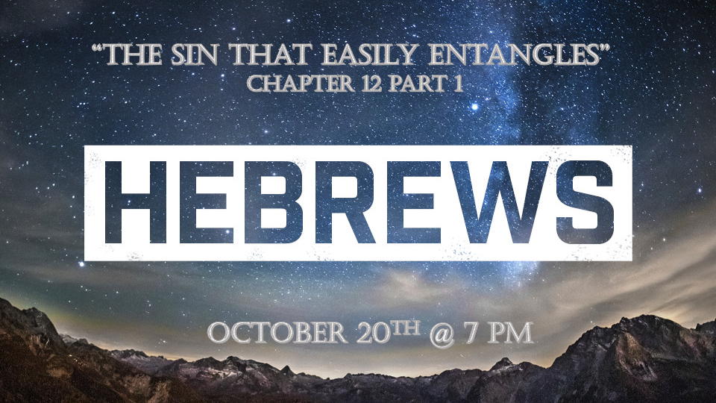

*By faith we must join the race!

*Hebrews 12:1 Therefore, since we are surrounded by such a great cloud of witnesses, let us throw off everything that hinders and the sin that so easily entangles. And let us run with perseverance the race marked out for us, 2 fixing our eyes on Jesus, the pioneer and perfecter of faith. For the joy set before him he endured the cross, scorning its shame, and sat down at the right hand of the throne of God. 3 Consider him who endured such opposition from sinners, so that you will not grow weary and lose heart. (See KJV)

*What snares are capturing Christians?

- Hebrews 2:1-4 The first warning was about drifting away from Jesus. If you exalt angels or Moses (The law) to a status of worship, you are building on a wrong foundation.

- Hebrews 3:7-4:13 To guard the condition of your heart is the 2nd warning. We are to encourage one another to purity and faith. The condition of unbelieving and hardening of the heart is sin.

- Hebrews 5:11-6:20 The 3rd warning is The danger of deformity/immaturity. When you live off the milk of the word you will have no strength for the deeper things of God.

- Hebrews 10:26-32 The 4th Warning is to Stop willfully sinning. Apostacy consumes you and blinds you that you don’t see sin as sin.

- Hebrews 12:15-29 The 5th warning is about apathy or the sin of indifference. Some are indifferent to hell, the Word of God, and even God.

*Hebrews 12:4 In your struggle against sin, you have not yet resisted to the point of shedding your blood. 5 And have you completely forgotten this word of encouragement that addresses you as a father addresses his son? It says, "My son, do not make light of the Lord's discipline, and do not lose heart when he rebukes you,

6 because the Lord disciplines the one he loves, and he chastens everyone he accepts as his son."
7 Endure hardship as discipline; God is treating you as his children. For what children are not disciplined by their father? 8 If you are not disciplined—and everyone undergoes discipline—then you are not legitimate, not true sons and daughters at all. 9 Moreover, we have all had human fathers who disciplined us and we respected them for it. How much more should we submit to the Father of spirits and live! 10 They disciplined us for a little while as they thought best; but God disciplines us for our good, in order that we may share in his holiness.

*Struggles with sin and hardships are real life. Learning restraints and sharing in holiness is also a Christian’s reality.

- *V:4-5 The power of resistance. We are not able to resist 24/7, but you still can be victorious. (www.puredesire.org )

- *V:6-10 Discipline is not punishment. Good Character and joy are achieved through the development of disciplines.

- Holiness is the reward.

*Hebrews 12:11 No discipline seems pleasant at the time, but painful. Later on, however, it produces a harvest of righteousness and peace for those who have been trained by it.

12 Therefore, strengthen your feeble arms and weak knees. 13 "Make level paths for your feet," so that the lame may not be disabled, but rather healed.

*Making level paths and continuing to move to be healed.

- V:11 The price of righteousness and peace starts with surrender and continues with new routines.
- *Hebrews 11:1-6 The cloud of witnesses are cheering you on. Who did you learn the most from in the list?

- *Hebrews 11:7-40 Reread the men and women of our faith challenges and victories.

- *V:12 What does it mean to strengthen your arms and knees? The arms & hands imply a greater grip on what is right. The knees imply greater submission before God.

- V:13 The goal is to be on a level plane and healed.

