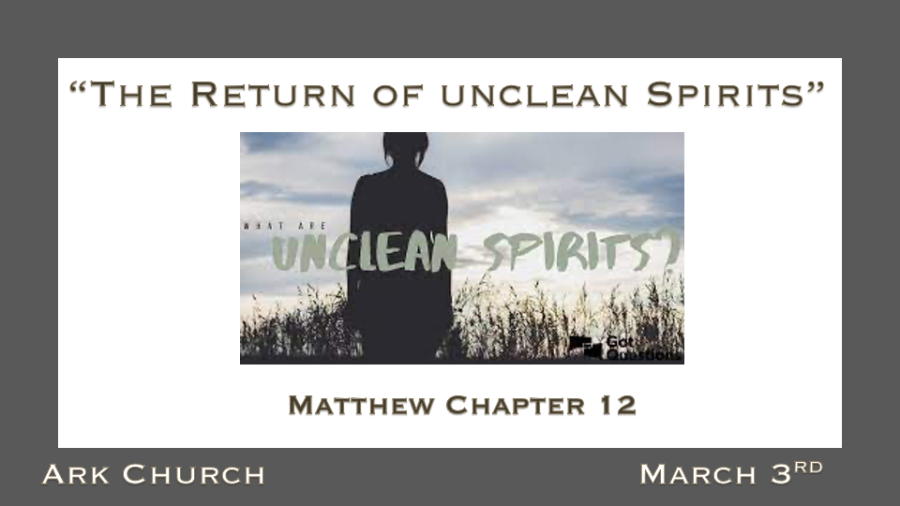
Last Week, we learned about the offended spirit.
The power & purpose of full repentance and not playing with sinful attitudes. (spirits)
Jesus prays to the Father, The Lord of Heaven and Earth. He was implying God is the Creator.
The creation that declares they won't bow to the Creator. They will never find rest.

*Legalism is not a part of who Jesus is or Christianity.

*Matthew 12:1 At that time Jesus went through the grainfields on the Sabbath. And His disciples were hungry, and began to pluck heads of grain and to eat. 2 And when the Pharisees saw it, they said to Him, "Look, Your disciples are doing what is not lawful to do on the Sabbath!"
*Matthew 12:8 For the Son of Man is Lord even of the Sabbath."
9 Now when He had departed from there, He went into their synagogue. 10 And behold, there was a man who had a withered hand. And they asked Him, saying, "Is it lawful to heal on the Sabbath?"—that they might accuse Him.
11 Then He said to them, "What man is there among you who has one sheep, and if it falls into a pit on the Sabbath, will not lay hold of it and lift it out? 12 Of how much more value then is a man than a sheep? Therefore it is lawful to do good on the Sabbath." 13 Then He said to the man, "Stretch out your hand." And he stretched it out, and it was restored as whole as the other. 14 Then the Pharisees went out and plotted against Him, how they might destroy Him.

- What is Legalism? Legalism is a religious spirit of self-righteousness.

The legalist knows the list of do's and don'ts, but they often won't trust the one who sets us free.

A whole mouthful of violations, according to the Pharisees, reaping, threshing, and preparing food on a sabbath.

Jesus never violated the Lord's command to honor the Sabbath. He broke the religious interpretation of that command.

- Those who specialize in what is lawful are needed.
The law has a purpose to reveal our need for a Savior.
The law keeps order and boundaries.

- V:8-14 The Greater law is to know the power of doing good.
When lawmakers make laws that prevent us from doing what is right or good, an evil, deceptive spirit is in control.
Which is a more significant violation of the Sabbath, healing a man's hand or going out on the Sabbath to plot and organize murder?

*The Devil and The Religious Specializes in Traps and Snares.

*Matthew 12:22 Then one was brought to Him who was demon-possessed, blind and mute; and He healed him, so that the blind and mute man both spoke and saw. 23 And all the multitudes were amazed and said, "Could this be the Son of David?"
24 Now when the Pharisees heard it they said, "This fellow does not cast out demons except by Beelzebub, the ruler of the demons."
25 But Jesus knew their thoughts, and said to them: "Every kingdom divided against itself is brought to desolation, and every city or house divided against itself will not stand. 26 If Satan casts out Satan, he is divided against himself. How then will his kingdom stand? 27 And if I cast out demons by Beelzebub, by whom do your sons cast them out? Therefore they shall be your judges. 28 But if I cast out demons by the Spirit of God, surely the kingdom of God has come upon you.

- Why did the Pharisees have a problem with Jesus casting out the demon that manifested his power in blindness and muteness?
Pharisees believed wrongly that you must know a demon's name to cast it out.

The assigning the power of doing good to an evil force is what separated Jesus from the religious for the rest of the gospel of Matthew.

Matthew 12:30-32 Jesus reveals the desperate place of those who could be hardened enough to attribute His workings to Satanic power. (The exchange calling good evil and evil good)

- The power of half-truths. 2 Timothy 2:25-26

*2 Timothy 2:25 in humility correcting those who are in opposition, if God perhaps will grant them repentance, so that they may know the truth, 26 and that they may come to their senses and escape the snare of the devil, having been taken captive by him to do his will.

- In humility, we correct those who are in opposition.
When a correction is done in another spirit other than the Holy Spirit, the listener can resist with greater intensity.

*The Snare is from the devil that keeps people from repentance. (Review the first three steps of repentance from sin)
- *Those living in sin like their sin.
- *Their spirit cannot discern the sorrow their sin causes humanity or God.
- *They are deceived; not understanding shame is NOT harmful to the sinner but a tool of repentance.

*The Wicked Generation is Seven Times More Evil.

*Matthew 12:43 "When an unclean spirit goes out of a man, he goes through dry places, seeking rest, and finds none. 44 Then he says, 'I will return to my house from which I came.' And when he comes, he finds it empty, swept, and put in order. 45 Then he goes and takes with him seven other spirits more wicked than himself, and they enter and dwell there; and the last state of that man is worse than the first. So shall it also be with this wicked generation."

- *V:43 An Unclean spirit starts with the rejection of Jesus as the Messiah and Savior.

It is a serious thing to reject the gift of God, His Son Jesus The Christ.

Being ignorant of Jesus is not a safe place, but the rejection of Jesus is a dangerous place to live.

- *V:44 People do not live without some spirit controlling them.
There are self-centered or self-righteous spirits. This is often the case for those who don't trust God.

The 1st evil spirit to attack is a deceiving spirit that brings strong delusions about reality.

The spirits of Babylon are many different sexualized spirits, bringing moral values into chaos. Read Jonathan Cahn's book The Return of the Gods.

- *V:45 The seven other spirits; the number seven represents complete dominance and control of the evil that is now working within a person or nation.

