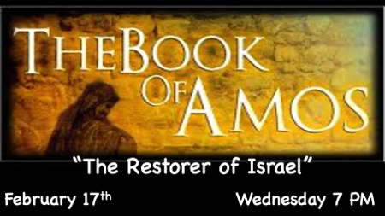

You cannot hide from God’s Wrath! (Vision of the Door Post)

*Amos 9:1 I saw the Lord standing by the altar, and he said: "Strike the tops of the pillars (the doorposts) so that the thresholds shake. Bring them down on the heads of all the people; those who are left I will kill with the sword. Not one will get away, none will escape.
2 Though they dig down to the depths below, from there my hand will take them. Though they climb up to the heavens above, from there I will bring them down.
3 Though they hide themselves on the top of Carmel, there I will hunt them down and seize them. Though they hide from my eyes at the bottom of the sea, there I will command the serpent to bite them.
4 Though they are driven into exile by their enemies, there I will command the sword to slay them. "I will keep my eye on them for harm and not for good."
5 The Lord, the LORD Almighty—he touches the earth, and it melts, and all who live in it mourn; the whole land rises like the Nile, then sinks like the river of Egypt;

8 "Surely the eyes of the Sovereign LORD are on the sinful kingdom. I will destroy it from the face of the earth. Yet I will not totally destroy the descendants of Jacob," declares the LORD.
9 "For I will give the command, and I will shake the people of Israel among all the nations as grain is shaken in a sieve and not a pebble will reach the ground.
10 All the sinners among my people will die by the sword, all those who say, 'Disaster will not overtake or meet us.'

God Judges the Nation that Became Unrighteous

- V:1 (KJV) The Doorpost is the covering of the household. A reversal of the Passover, the structure is marked for destruction. The nation was in systemic disobedience.
- V:2-5 The only escape of judgement is repentance. Sinful people seeking escape, not salvation are destroyed. Hearts that have abandoned the idea that God could be their solution are marked for destruction.
- V:8 The total destruction of their kingdom from the face of the earth. The people are scattered but they still have a chance even though the nation is gone.
- V:10 The sinners and God’s people; those who don’t seek God will be destroyed.
- What follows judgement in Amos 9 is a period-of-time the millennial reign of Christ.
*Amos 9:11 "In that day I will restore David's fallen shelter—I will repair its broken walls and restore its ruins—and will rebuild it as it used to be,
12 so that they may possess the remnant of Edom and all the nations (Gentiles) that bear my name," declares the LORD, who will do these things.
13 "The days are coming," declares the LORD, "when the reaper will be overtaken by the plowman and the planter by the one treading grapes. New wine will drip from the mountains and flow from all the hills,
14 and I will bring my people Israel back from exile. "They will rebuild the ruined cities and live in them. They will plant vineyards and drink their wine; they will make gardens and eat their fruit. LORD your God.

The Day of Restoration

- V:11 The millennial age is about God keeping His vows to Abraham and David.

- Three unconditional covenants, the 1st is Abraham’s covenant. Genesis 12

- The 2nd is the land covenant its found in Genesis 15.

- The Davidic covenant is described in 2 Samuel 7:8-17. A forever throne. Ezekiel 37:25

- The fourth is called the eternal covenant explained in Jeremiah 31:31-40.

- Revelation 20:4-6 Addresses the fulfillment of the unconditional covenants.

- Luke 1:31-33 The Annunciation declares David’s covenant will happen.

- Acts 1:6-9 The Ascension is about the restoration of the Kingdom to Israel.

- Amos 9:11-13 Is quoted by James in Acts 15:15-18. Showing the Church age connects to the gentiles and will continue until the time of the Gentiles is fulfilled. (Luke 21:24)

The Plan of God

- Amos 9:11 Reveals God’s goal is not revenge but restoration.
- Consequences are for the wicked. He rescues those who have received righteousness.
- V:13-14 He restores with great speed in the millennial age.

