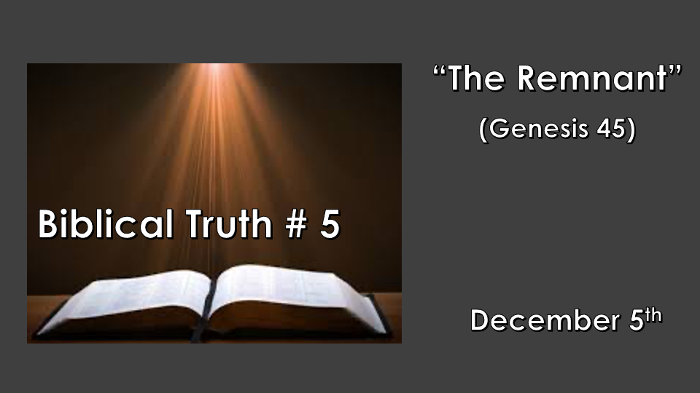

*Psalm 11: 3 When the foundations are being destroyed, what can the righteous do?"

Five Biblical truths that will determine how you view the Bible, God, and our choices.
- A place of refuge & the wrath of God. Genesis 6 & 7
- Making a name without God. (Defining deception) Genesis 10 & 11
- The Covenants of Abraham and David. Genesis 12, 2 Samuel 7:16 & Luke 1:32
- The Nation of Israel. Genesis 32:28
- *The Remnant and its role. Genesis 45:7

Tucked inside our foundational truths is the remnant.

- Noah’s family is the remnant of humanity. Genesis 6-9
- Abraham is the seed (remnant) from Noah’s generation that believed in God and it was accredited to him as righteousness. Genesis 12
- Jacob’s 12 sons become the deposit or remnant for the birth of a nation. Genesis 32:28
- Simeon & Anna the Prophetess from the tribe of Asher were a remnant waiting for the Messiah. Luke 2:25-38

*Genesis 45:5 And now, do not be distressed and do not be angry with yourselves for selling me here, because it was to save lives that God sent me ahead of you. 6 For two years now there has been famine in the land, and for the next five years there will be no plowing and reaping. 7 But God sent me ahead of you to preserve for you a remnant on earth and to save your lives by a great deliverance.

8 "So then, it was not you who sent me here, but God. He made me father to Pharaoh, lord of his entire household and ruler of all Egypt.

*The Remnant is God’s way of preserving His plans in times of turmoil.

- Genesis 45:8 In times of distress even if the time seems like the end, God has a people ready (a remnant) just for this day. (Joseph became like a father to Pharaoh and lord/ master to his entire household.)

- Joseph was a key person when a remnant was needed to save the world. Are you a key person for our day, for your family, or the Church? (The remnant who was key had already been tested and tried several times and found faithful)

- Genesis 45:7 The remnant can be sent ahead of time or be raised up during a time of crisis.

- *Genesis 45:8 God is the sending agency of the remnant. Joshua 3:5 Joshua told the people, "Consecrate yourselves, for tomorrow the LORD will do amazing things among you."
- Only two saw what God had done.

- Only two experienced what they were about to do.

*Romans 11:1 I ask then: Did God reject his people? By no means! I am an Israelite myself, a descendant of Abraham, from the tribe of Benjamin. 2 God did not reject his people, whom he foreknew. Don't you know what Scripture says in the passage about Elijah—how he appealed to God against Israel: 3 "Lord, they have killed your prophets and torn down your altars; I am the only one left, and they are trying to kill me" ? 4 And what was God's answer to him? "I have reserved for myself seven thousand who have not bowed the knee to Baal." 5 So too, at the present time there is a remnant chosen by grace. 6 And if by grace, then it cannot be based on works; if it were, grace would no longer be grace.

*The Remnant and its Role.

- Romans 11:1 – 4 The remnant as in the story of Elijah tells us we can sometimes be confused about all that God is doing. If you are the remnant in your family others are with you that you may not be aware of. I Kings 19:18 There were 7,000 who haven’t turned to the false gods.

- Romans 11:5 – 6 The remnant points to God’s Grace. The promise is the remnant is chosen by God’s grace to reveal His grace. (Remember you are not an agent of works but of God’s Grace.)

*Romans 11:7 What then? What the people of Israel sought so earnestly they did not obtain. The elect among them did, but the others were hardened, 8 as it is written: "God gave them a spirit of stupor, eyes that could not see and ears that could not hear, to this very day."
9 And David says: "May their table become a snare and a trap, a stumbling block and a retribution for them.
10 May their eyes be darkened so they cannot see, and their backs be bent forever."

11 Again I ask: Did they stumble so as to fall beyond recovery? Not at all! Rather, because of their transgression, salvation has come to the Gentiles to make Israel envious.

*The Remnant reveals God’s Power, Sovereignty, and Salvation.

- The Elect is another name for the remnant in this instant for those chosen to carry the message of God to the world. (The remnant must not become hardened in their hearts.)

- The Apostle Paul was a remnant from the tribe of Benjamin that brought the message of Salvation to us the Gentiles. ( A remnant of one from the original 12 tribes, with the assignment to the Gentiles)

