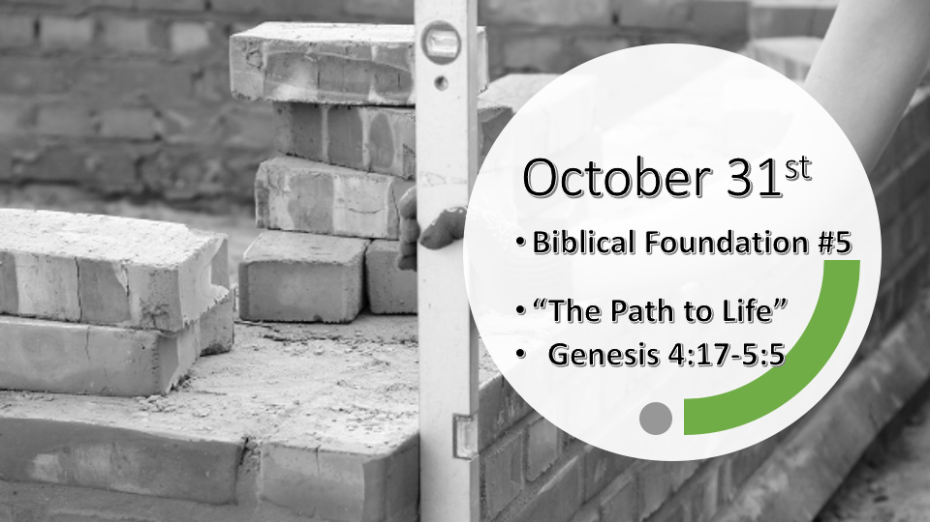

*Psalm 11: 3 When the foundations are being destroyed, what can the righteous do?"

*Genesis 4:17 Cain made love to his wife, and she became pregnant and gave birth to Enoch. Cain was then building a city, and he named it after his son Enoch. 18 To Enoch was born Irad, and Irad was the father of Mehujael, and Mehujael was the father of Methushael, and Methushael was the father of Lamech.

19 Lamech married two women, one named Adah and the other Zillah. 20 Adah gave birth to Jabal; he was the father of those who live in tents and raise livestock. 21 His brother's name was Jubal; he was the father of all who play stringed instruments and pipes. 22 Zillah also had a son, Tubal-Cain, who forged all kinds of tools out of bronze and iron. Tubal-Cain's sister was Naamah.
23 Lamech said to his wives, "Adah and Zillah, listen to me; wives of Lamech, hear my words. I have killed a man for wounding me, a young man for injuring me.
24 If Cain is avenged seven times, then Lamech seventy-seven times."

*Amazing human potential & the warning of Cain. Jude 1:11

- V:17-18 Humanity was advanced. Building a city is an awesome truth about our abilities as foundational truth about humanity.
- V:18 Humanity has always been blessed with knowledge and abilities.
- Cain (Acquire or possessions) was a farmer and Abel (Breath or gentle breeze) was a shepherd. (Genesis 4:2)
- Enoch (teaching) father of Irad (fleet/fleeting) who was the father of Mehujael (Struck/down by God) who was the father of Methushael (Who is God) who was the father Lamech (Power/despairing)

- *V:19 & 23-24 In the 4th generation from Cain one of his descendants brought polygamy into our world. His wives are Adah (ornament) and Zillah (shade.) Their children are as follows.
- Jabal (stream of water) built tents and rancher
- Jubal (river) played stringed instruments and pipes.
- Tubal-Cain made tools out of bronze and iron.

- Insight: Cain’s descendants end in despair and destruction despite all their accomplishments.

*Genesis 4: 25 Adam made love to his wife again, and she gave birth to a son and named him Seth, saying, "God has granted me another child in place of Abel, since Cain killed him." 26 Seth also had a son, and he named him Enosh. At that time people began to call on the name of the LORD.

Genesis 5:1 This is the written account of Adam's family line. When God created mankind, he made them in the likeness of God. 2 He created them male and female and blessed them. And he named them "Mankind" when they were created.
3 When Adam had lived 130 years, he had a son in his own likeness, in his own image; and he named him Seth.

*Genesis 5:4-32 Is more than a Hebrew genealogy. Maybe only eternity will reveal all of its secrets.
*Proverbs 25: 2 It is the glory of God to conceal a matter; to search out a matter is the glory of kings.

*Your family tree tells what story?

- Genesis 4:25-26 The multi-generational story is important in God’s Word. Do you know of other examples?

- Genesis 5:1-3 The appointed person and time is always a prophecy of Jesus. Jesus is concealed in these first five foundational truths in the 1st five chapters of Genesis.

- Insights into the multi-faithfulness of God and men.

*The Path of Redemption and Life.
- Adam: (adomah) “man”
- Seth: “appointed” (Genesis 4:25)
- Enosh: (from root anash, “to be incurable”) “mortal,” “frail,” “miserable”
- Kenan: “sorrow,” “dirge,” “elegy”
- Mahalal’el: “the Blessed God” – (mahalal) “blessed”; (El) the name of God
- Jared: (from the verb yaradh) “shall come down”
- Enoch: “commencement” or “teaching”
- Methuselah: “his death shall bring” – muth, a root that means “death”; shalach means “bring” or “send forth”
- Lamech: “despairing” (from which we get “lament” or “lamentation”)
- Noah: (derived from nacham) “comfort” or “rest” (Genesis 5:29)
Man (is) appointed mortal sorrow; (but) the Blessed God shall come down teaching (that) His death shall bring (the) despairing rest. ~ Biblical-Christianity.com and Chuck Missler

Insight: The descendants of the righteous end with rest. Even greater their lives together spell a message from God to us.

