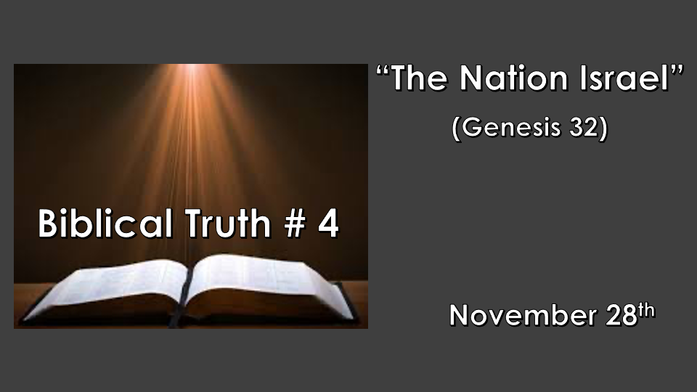

*Psalm 11: 3 When the foundations are being destroyed, what can the righteous do?"

Five Biblical truths that will determine how you view the Bible, God, and our choices.
- A place of refuge & the wrath of God. Genesis 6 & 7
- Making a name without God. (Defining deception) Genesis 10 & 11
- The Covenants of Abraham and David. Genesis 12, 2 Samuel 7:16 & Luke 1:32
- *The Nation of Israel. Genesis 32:28
- The remnant and its role. Genesis 45:7

*Genesis 32:24 So Jacob was left alone, and a man wrestled with him till daybreak. 25 When the man saw that he could not overpower him, he touched the socket of Jacob's hip so that his hip was wrenched as he wrestled with the man.
26 Then the man said, "Let me go, for it is daybreak." But Jacob replied, "I will not let you go unless you bless me."
27 The man asked him, "What is your name?" "Jacob," he answered.
28 Then the man said, "Your name will no longer be Jacob, but Israel, because you have struggled with God and with humans and have overcome."
29 Jacob said, "Please tell me your name." But he replied, "Why do you ask my name?" Then he blessed him there.
30 So Jacob called the place Peniel, saying, "It is because I saw God face to face, and yet my life was spared."

*Wrestling with God.

- *Holding on till you find yourself not willing to let go of God. Ephesians 6:12 (NKJV) For we do not wrestle against flesh and blood, but against principalities, against powers, against the rulers of the darkness of this age, against spiritual hosts of wickedness in the heavenly places.

- Holding on to God changed Jacob but, God already saw Jacob as the father of Israel. Jacob means: Deceiver. Israel means: the prince who struggles or wrestles with God.

- *Israel is the people who continue to struggle with God to this day. They will do so until they recognize Jesus as the Messiah. Romans 11:25 (NKJV) For I do not desire, brethren, that you should be ignorant of this mystery, lest you should be wise in your own opinion, that blindness in part has happened to Israel until the fullness of the Gentiles has come in.

*Romans 1:16 For I am not ashamed of the gospel, because it is the power of God that brings salvation to everyone who believes: first to the Jew, then to the Gentile.
Romans 2:9 There will be trouble and distress for every human being who does evil: first for the Jew, then for the Gentile; 10 but glory, honor, and peace for everyone who does good: first for the Jew, then for the Gentile. 11 For God does not show favoritism.

*Romans 2:28 A person is not a Jew who is one only outwardly, nor is circumcision merely outward and physical. 29 No, a person is a Jew who is one inwardly; and circumcision is circumcision of the heart, by the Spirit, not by the written code. Such a person's praise is not from other people, but from God.

*Two people and one Kingdom.

- Romans 1:16 – 2:9-11 Jews and Gentiles were the two types of people in the 1st century. The Jewish people as a whole don’t recognize the gospel’s good news. They rejected Jesus as the Messiah. (John 1:11)

- Romans 2:28-29 Those with a holy heart or an unholy heart are the two types of people in today’s world. The scariest part of our fallen world is that so many do not even know how to wrestle with their own heart.

*Ecclesiastes 1:9 What has been will be again, what has been done will be done again; there is nothing new under the sun.

*Parallels of the 1st Century and events of the last days we should all wrestle with.

- A Nation rejects Jesus. America a nation under God is now rejecting Jesus in every public forum.

- Strange and unusual cosmic activity. The Bethlehem star, blood-red moons on Jewish holidays are just a few connecting these events.

- Religious apostasy. The religious leaders knew about the Messiah yet they did not go and investigate this event. The religious leaders of the 21 century who have degrees in theology do not acknowledge obvious eschatological events of our times, like the return of Jews, which is a major sign for the return of Jesus.

- The slaying of Infants. Just as the government (Herod) of Jesus' day killed innocent children, governments around the world now order the slaying of babies in the womb.

- Those who should have embraced Jesus put him on trial and kill him. The Pharisees and religious leaders put Jesus on trial, today’s Pastors and Professors are doing the same with their “Love wins” philosophies.

- The occupation of the Holy Land. Rome occupied then, Palestinians occupy today in their government and Jerusalem.

- Those who were alive who believed they would see the Messiah did. Luke 2 and Matthew 2

