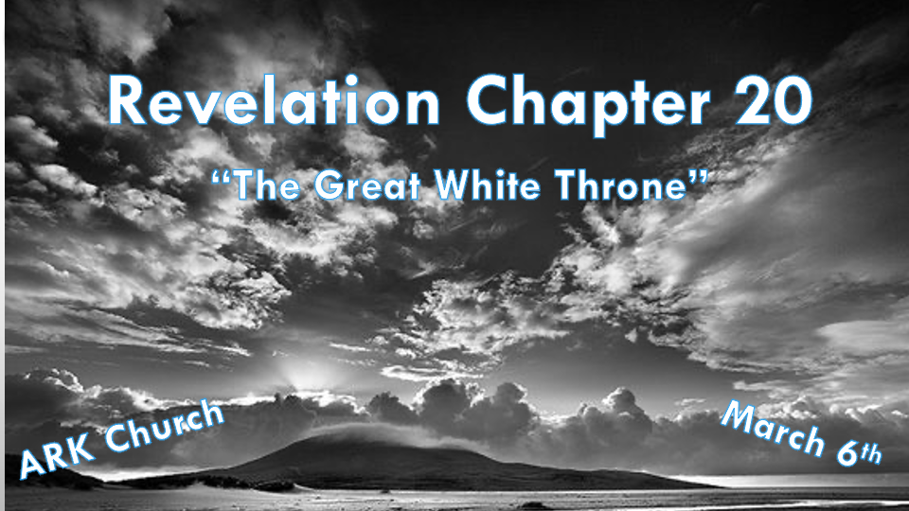

*Keys to the bottomless pit and the dragon.
*Revelation 20:1 Then I saw an angel coming down from heaven, having the key to the bottomless pit and a great chain in his hand. 2 He laid hold of the dragon, that serpent of old, who is the Devil and Satan, and bound him for a thousand years; 3 and he cast him into the bottomless pit, and shut him up, and set a seal on him, so that he should deceive the nations no more till the thousand years were finished. But after these things he must be released for a little while.

- V:1 Angels have roles and authority in heaven.

To show the position of Satan: A nameless angel comes from heaven. Not God the Father or Jesus the Son, not even Michael or Gabriel, are given the assignment.

Satan wrongly believed he could be God’s equal. Nope, he is just one of God’s creations who thought he could tell the Creator how everything is going to work.

- V:1-3 There are many names for Lucifer, the fallen angel. (4 things happen to the dragon.)
He is bound to have no ability to roam.
He is cast into the bottomless pit.
He is shut up and cannot influence anyone with his lies or talk.
He is marked with a seal, which means he was always doomed.

*Saints reign with Christ for a thousand years and the second death.

*Revelation 20:4 And I saw thrones, and they sat on them, and judgment was committed to them. Then I saw the souls of those who had been beheaded for their witness to Jesus and for the word of God, who had not worshiped the beast or his image, and had not received his mark on their foreheads or on their hands. And they lived and reigned with Christ for a thousand years. 5 But the rest of the dead did not live again until the thousand years were finished. This is the first resurrection. 6 Blessed and holy is he who has part in the first resurrection. Over such the second death has no power, but they shall be priests of God and of Christ, and shall reign with Him a thousand years.
7 Now when the thousand years have expired, Satan will be released from his prison 8 and will go out to deceive the nations which are in the four corners of the earth, Gog and Magog, to gather them together to battle, whose number is as the sand of the sea. 9 They went up on the breadth of the earth and surrounded the camp of the saints and the beloved city. And fire came down from God out of heaven and devoured them. 10 The devil, who deceived them, was cast into the lake of fire and brimstone where the beast and the false prophet are. And they will be tormented day and night forever and ever.

V:4 Special privileges for those beheaded? They are identified as those who did not worship the beast or his image and rejected the mark on their hands or foreheads. Therefore, they lived and reigned with Christ for a thousand years.

V:5-6 The rest of the dead do not live again until the thousand years.
We learn those who are in the 1st resurrection are not subjected to a second death.

V:7-10 A different look at the end of the millennial reign of Christ.
God’s covenant with Abraham and David are completed. Humanity will now have to deal with deception, the devil, and something else that those born in the millennial did not deal with: the spirit of war.

*The Books and the Lamb’s Book of Life. What is the Second Death?

*Revelation 20:11 Then I saw a great white throne and Him who sat on it, from whose face the earth and the heaven fled away. And there was found no place for them. 12 And I saw the dead, small and great, standing before God, and books were opened. And another book was opened, which is the Book of Life. And the dead were judged according to their works, by the things which were written in the books. 13 The sea gave up the dead who were in it, and Death and Hades delivered up the dead who were in them. And they were judged, each one according to his works. 14 Then Death and Hades were cast into the lake of fire. This is the second death. 15 And anyone not found written in the Book of Life was cast into the lake of fire.

- V:11-13 Things written in the books and were the those who are judged and their locations.

*The book of truth/deeds Romans 2:2 But we know that the judgment of God is according to truth against those who practice such things. 3 And do you think this, O man, you who judge those practicing such things, and doing the same, that you will escape the judgment of God?

*The book of Providence/deeds Romans 2:5 But in accordance with your hardness and your impenitent (unrepented) heart you are treasuring up for yourself wrath in the day of wrath and revelation of the righteous judgment of God, 6 who “will render to each one according to his deeds”: 7 eternal life to those who by patient continuance in doing good seek for glory, honor, and immortality.

*The book of the law Romans 2:12 For as many as have sinned without law will also perish without law, and as many as have sinned in the law will be judged by the law 13 (for not the hearers of the law are just in the sight of God, but the doers of the law will be justified;

*The book of conscience Romans 2:14 for when Gentiles, who do not have the law, by nature do the things in the law, these, although not having the law, are a law to themselves, 15 who show the work of the law written in their hearts, their conscience also bearing witness, and between themselves their thoughts accusing or else excusing them) 16 in the day when God will judge the secrets of men by Jesus Christ, according to my gospel.

*The book of remembrance Malachi 3:16 Then those who feared the LORD spoke to one another,
And the LORD listened and heard them; So a book of remembrance was written before Him for those who fear the LORD and who meditate on His name.
17 “They shall be Mine,” says the LORD of hosts, “On the day that I make them My jewels. And I will spare them as a man spares his own son who serves him.”

- V:14-15 The second death and the lake of fire.

The second death is eternal separation, eternal capital punishment, eternal separation, and eternal darkness. Is the soul alive? Is there consciousness? These are the questions that haunt us.

