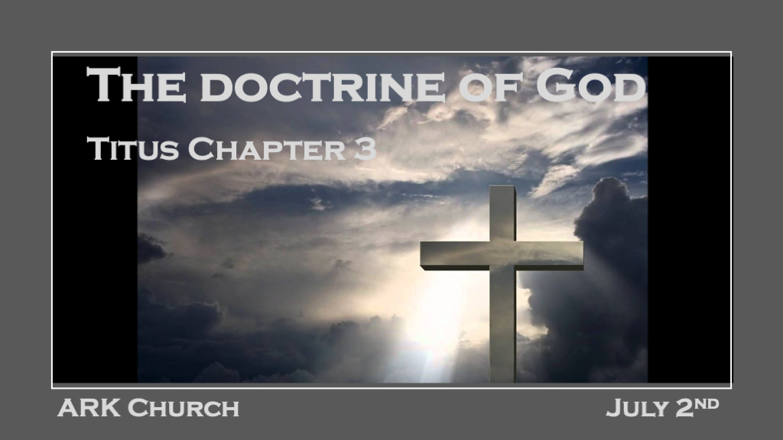
*The Doctrine of God according to Titus
Truth + Grace = Godliness

(Sound doctrine has no error mixed within the truth. Titus 2:1)

*The understanding of Grace & Mercy should not be trusted to a merely human perspective.

*Titus 3:1 Remind them to be subject to rulers and authorities, to obey, to be ready for every good work, 2 to speak evil of no one, to be peaceable, gentle, showing all humility to all men. 3 For we ourselves were also once foolish, disobedient, deceived, serving various lusts and pleasures, living in malice and envy, hateful and hating one another. 4 But when the kindness and the love of God our Savior toward man appeared, 5 not by works of righteousness which we have done, but according to His mercy He saved us, through the washing of regeneration and renewing of the Holy Spirit, 6 whom He poured out on us abundantly through Jesus Christ our Savior, 7 that having been justified by His grace we should become heirs according to the hope of eternal life.
*Titus 3:8 This is a faithful saying, and these things I want you to affirm constantly, that those who have believed in God should be careful to maintain good works. These things are good and profitable to men.

V:1-6 How and why we relate to others and the key ingredients. The model becomes Titus Men and Women.

Ready for every good work. It's easy to make the Christian life passive, but passivity is not Christianity.

Speak evil of no one. It is a reminder that we all need grace. Don't be confused; this is not telling us to be silent about evil.

Be peaceable and gentle, showing humility to all. This indicates how a Spirit-filled person operates.

*Proverbs 22:4 By humility and the fear of the LORD are riches and honor and life.

Psalm 111:10 The fear of the LORD is the beginning of wisdom; A good understanding have all those who do His commandments. His praise endures forever.

V:7 Justified by His grace, we become heirs of the hope of eternal life.

My only credential is my faith in God's Grace.

*Ephesians 2:8 For by grace you have been saved through faith, and that not of yourselves; it is the gift of God, 9 not of works, lest anyone should boast.

Because of Grace, I have hope. Hope is not optimism. It is the reality of God's promise through His Word.

Because of Grace, I have eternal life. The greatest gift to humanity is Jesus' sacrifice, death, and resurrection. Because of this, the World has an opportunity to receive eternal life. (Spread the Good News)

V:8 The Calling is to affirm constantly, that those who believe in God should be careful to maintain good works.
Let the Word of God affirm what is good works. Each part of the body has its own assignment to do good. The Word of God has humility and the fear of the Lord as the essentials to achieve them.

*A Difficult Mandate to Christianity.

*Titus 3:9 But avoid foolish disputes, genealogies, contentions, and strivings about the law; for they are unprofitable and useless. 10 Reject a divisive man after the first and second admonition, 11 knowing that such a person is warped and sinning, being self-condemned.

Avoid Foolish Disputes! The word "Avoid" means to turn around and go the other way.

Genealogies: It doesn't say you cannot learn from genealogies. Matthew 1 and Luke 3 give great insights into the Faith and God's redemptive plan for all people in the genealogies.

We learn as well from the genealogies in Genesis 5 and 10. We get the Gospel in Genesis 5 and the insights into the destructive nature of man in Genesis 10.

Avoid opinions and pushy attitudes about the law. (Unprofitable and useless)

*The Spirit of Generosity and its fruit.

*Titus 3:12 When I send Artemas to you, or Tychicus, be diligent to come to me at Nicopolis, for I have decided to spend the winter there.

*Titus 3:13 Send Zenas the lawyer and Apollos on their journey with haste, that they may lack nothing. 14 And let our people also learn to maintain good works, to meet urgent needs, that they may not be unfruitful.
15 All who are with me greet you. Greet those who love us in the faith. Grace be with you all. Amen.

Good works and meeting needs are connected. When the connection happens, the fruit will follow.

