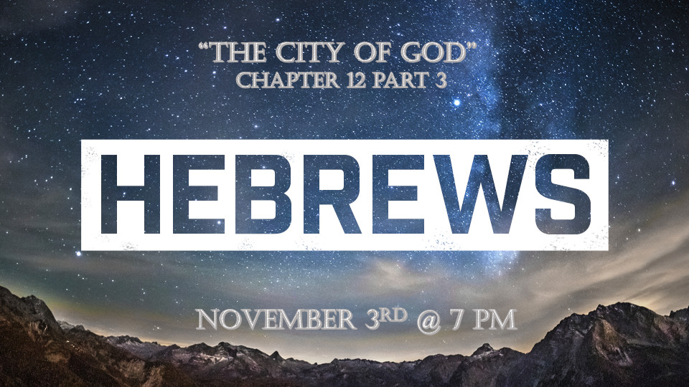

*The 5 Prophetic Warnings for every believer was to prepare us.

*The extra underlining themes in Hebrews are tuck away truths.

*Hebrews 12:22 But you have come to Mount Zion, to the city of the living God, the heavenly Jerusalem. You have come to thousands upon thousands of angels in joyful assembly, 23 to the church of the firstborn, whose names are written in heaven. You have come to God, the Judge of all, to the spirits of the righteous made perfect.

*The City and why we need to know about it.

- *John 14:2-3 Jesus spoke of it, that he is going to prepare a place for us.

- Galatians 4:26 Paul spoke of it saying; “The Jerusalem that is above is free.”

- Hebrews 11:10 & 16 Abraham looks for the city. V:16 God promised to prepare a city for the people of faith.
- Hebrews 12:22 The City of the living God, the heavenly Jerusalem.
- Hebrews 13:14 We are to be looking for the city to come.

- Revelation 21:2 & 22:3 The New Jerusalem is being prepared as a bride beautifully dressed. V:3 The throne of God & of the Lamb will be in the city. (Look for it as you would look forward to your wedding day)

- Hebrews 12:23 Names written down in heaven. (Why are names written down?)

*Hebrews 12:25 See to it that you do not refuse him who speaks. If they did not escape when they refused him who warned them on earth, how much less will we, if we turn away from him who warns us from heaven? 26 At that time his voice shook the earth, but now he has promised, "Once more I will shake not only the earth but also the heavens." 27 The words "once more" indicate the removing of what can be shaken—that is, created things—so that what cannot be shaken may remain.

28 Therefore, since we are receiving a kingdom that cannot be shaken, let us be thankful, and so worship God acceptably with reverence and awe, 29 for our "God is a consuming fire."

*12 Is the mysterious Kingdom number revealing the kingdom cannot be shaken.
- 12-year-old Jesus Luke 2:42

- 12 Tribes of Israel – 12 is the number signifying the perfection of government or rule.

- 12 Apostles that judge the 12 tribes.
  - *Matthew 19:28 Jesus said to them, "Truly I tell you, at the renewal of all things, when the Son of Man sits on his glorious throne, you who have followed me will also sit on twelve thrones, judging the twelve tribes of Israel.
  - Luke 22:29 And I confer on you a kingdom, just as my Father conferred one on me, 30 so that you may eat and drink at my table in my kingdom and sit on thrones, judging the twelve tribes of Israel.

- 12 Parables in Matthew Chapter 13 to Chapter 25:30
  - The parables are about the Church age and what its challenges will be.
  - The insights will include the rejection of Biblical end-time truths. (Matthew Chapters 22, 24,25)

- 12 Legions of angels Matthew 26:53

- 12 Foundations, 12 Gates, 12 Pearls, 12 Angels, 12 Tribes, 12 Apostles are all part of the New Jerusalem. Revelation 21:12-13 & 21

- The tree of life-bearing 12 different crops of fruit. Revelation 22:2

