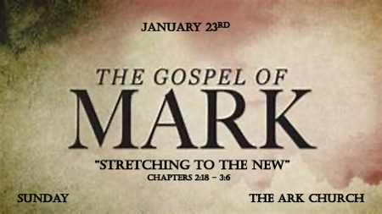

*Understanding the Holy Spirit’s agenda for your life takes time.

- New agendas can be assigned or mandated and this brings the biggest resistance.
- New agendas can be by choice, but they take time to establish.

*Mark 2:18 Now John's disciples and the Pharisees were fasting. Some people came and asked Jesus, "How is it that John's disciples and the disciples of the Pharisees are fasting, but yours are not?"

19 Jesus answered, "How can the guests of the bridegroom fast while he is with them? They cannot, so long as they have him with them. 20 But the time will come when the bridegroom will be taken from them, and on that day they will fast.
21 "No one sews a patch of unshrunk cloth on an old garment. Otherwise, the new piece will pull away from the old, making the tear worse. 22 And no one pours new wine into old wineskins. Otherwise, the wine will burst the skins, and both the wine and the wineskins will be ruined. No, they pour new wine into new wineskins."

*Rituals don’t understand the times or know what to do with a God moment.

- V:18 Jesus answers with a question. Answering a question with one is something all four Gospels note as Jesus technique.

- V:19-20 Focusing on rituals can cause you to miss the bigger picture.

- V:21-22 The importance of all things becoming new in our spiritual walk.
- We cannot mix match our spiritual process with a little new and a little of the old way of life.
- Until we learn spiritual principles, our life is more torn and instead of experiencing a new way of life, we may actually feel ruined.

*Mark 2:23 One Sabbath Jesus was going through the grainfields, and as his disciples walked along, they began to pick some heads of grain. 24 The Pharisees said to him, "Look, why are they doing what is unlawful on the Sabbath?"
25 He answered, "Have you never read what David did when he and his companions were hungry and in need? 26 In the days of Abiathar the high priest, he entered the house of God and ate the consecrated bread, which is lawful only for priests to eat. And he also gave some to his companions."
27 Then he said to them, "The Sabbath was made for man, not man for the Sabbath. 28 So the Son of Man is Lord even of the Sabbath."

*When you're focusing on religion, a single need could have 4 violations.

- V:23-24 Religious Teachers were right when it came to law. They were wrong when came to understanding God’s heart.
- Reaping
- Threshing
- Sifting
- Food preparations

- V:25-28 Jesus answers the religious with two principles. When we are steeped in tradition we put to practice our ritual before relationships.
- 1st principle Human need is more important than religious rituals.
- 2nd principle The Sabbath was made for man, and not man for the Sabbath.

*Mark 3:1 Another time Jesus went into the synagogue, and a man with a shriveled hand was there. 2 Some of them were looking for a reason to accuse Jesus, so they watched him closely to see if he would heal him on the Sabbath. 3 Jesus said to the man with the shriveled hand, "Stand up in front of everyone."

4 Then Jesus asked them, "Which is lawful on the Sabbath: to do good or to do evil, to save life or to kill?" But they remained silent.
5 He looked around at them in anger and, deeply distressed at their stubborn hearts, said to the man, "Stretch out your hand." He stretched it out, and his hand was completely restored. 6 Then the Pharisees went out and began to plot with the Herodians how they might kill Jesus.

*Things you won’t understand if you know about Jesus but you don’t know him.

- *V:1 The man with the withered hand. Still used his feet to go to the synagogue to worship God.

- *V:2 When you have a reputation of following God. Others will be watching you and they know the tradition, cultural norms, and the laws of man, but they don’t know how to follow God.

- V:3-5 Hardness of heart was the deeper need at the synagogue on that day.
- *Why was Jesus angry? Because it was a perfect chance for those who had the greater need a hard heart to be touched but they were not open to Jesus.

- *Who were the Herodians? They were Jews that enjoyed the perspective of the Pharisees and the Politics of Herod.

