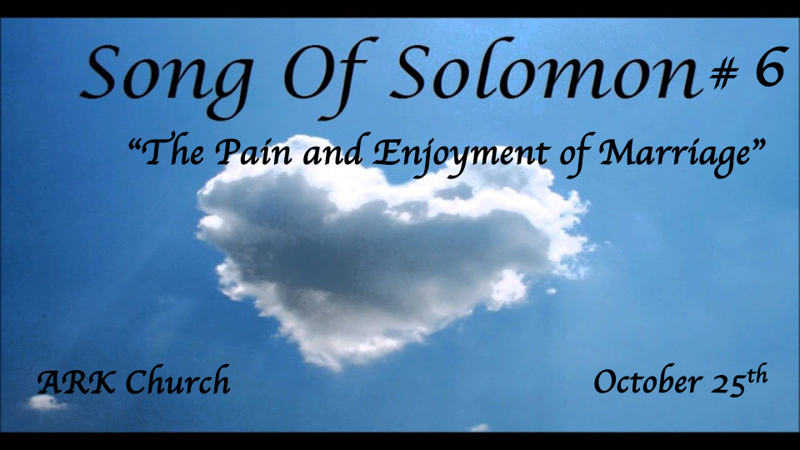
Reflections:
- Preparing for the Wedding feast
- At the Wedding banquet
- In the Bridal chambers (Shulamite)
- Courtship & the pain of separation
- The Wedding Procession (Shulamite)
- The Wedding Night (The Beloved)
- The Dream of Rejecting the Bridegroom
- The Return of the King
- The Dance of the Two Camps

*The Seventh Reflection Continues with the Question: where is the Beloved?
*Song of Solomon 6:1-3

The Daughters of Jerusalem
1 Where has your beloved gone,
O fairest among women?
Where has your beloved turned aside,
That we may seek him with you?
The Shulamite
2 My beloved has gone to his garden,
To the beds of spices,
To feed his flock in the gardens,
And to gather lilies.
3 I am my beloved’s,
And my beloved is mine.
He feeds his flock among the lilies.

Insights V:1 While the Beloved is gone, others will seek him.

The bride’s job is to draw others to seek the King before His return.

Insights V:2 He has gone to his garden?
Jesus' grave was in a garden. This is a literal place, unlike the allegory of the woman’s garden being part of her sexuality.

Jesus will feed His flocks among the gardens. There is a place where the flock gathers to worship and honor the death and resurrection of Jesus. We call that gathering the Church.

Insights V:3 A hidden acrostic in the first four words. The phrase “I am my beloved’s.”

The 1st four letters in Hebrew or Greek Septuagint spelled out “Elul.”

The month Elul is preparation for the high Jewish days of the calendar. The three-fall feast begins in the month of Tishrei with the feast of Trumpets, the Day of Atonement, and The feast of Tabernacles.

*Colossians 2: 16-17 So let no one judge you in food or drink, or regarding a festival or a new moon or sabbaths, 17 which are a shadow of things to come, but the substance is of Christ.

The phrase “I am my beloved’s and my beloved is mine” occurs three times. Is this a hidden connection to the last three feasts?

*The Eight Reflection: The Return of the King (Beloved)
*Song of Solomon 6:4-10 & 11-13 The ninth reflection

The Beloved
4 O my love, you are as beautiful as Tirzah,
Lovely as Jerusalem,
Awesome as an army with banners!
5 Turn your eyes away from me,
For they have overcome me.
Your hair is like a flock of goats
Going down from Gilead.
6 Your teeth are like a flock of sheep
Which have come up from the washing;
Every one bears twins,
And none is barren among them.
7 Like a piece of pomegranate
Are your temples behind your veil.
8 There are sixty queens
And eighty concubines,
And virgins without number.
9 My dove, my perfect one,
Is the only one,
The only one of her mother,
The favorite of the one who bore her.
The daughters saw her
And called her blessed,
The queens and the concubines,
And they praised her.
10 Who is she who looks forth as the morning,
Fair as the moon,
Clear as the sun,
Awesome as an army with banners?
The Shulamite
11 I went down to the garden of nuts
To see the verdure of the valley,
To see whether the vine had budded
And the pomegranates had bloomed.
12 Before I was even aware,
My soul had made me
As the chariots of my noble people.
The Beloved and His Friends
13 Return, return, O Shulamite;
Return, return, that we may look upon you!
The Shulamite
What would you see in the Shulamite—
As it were, the dance of the two camps?

Insight V:4 The King’s first words to His bride on His return.
*Tirzah is the word for delightful. The King's first words are words of praise and delight.

The King sees the bride as a beautiful army with many banners.

His banner over me is love. Song of Solomon 2:4

Insights V:5-7 The King continues to praise the bride, impressed with her beauty and character.

- *V:5 Eyes are the windows to the soul. The Bride is insightful.
Literal the woman’s eyes again are a key to the attraction.

- *V:5 The Hair is again the bride’s glory, consecration, and submissiveness.

- *V:6 The teeth symbolize maturity to eat the strong meat of the word. Hebrews 5:12-14

- *V:7 Are your temples behind your veil? Pomegranate is a wordplay for the temple of God. The King sees in her face the presence of God.

The bride is presented to the King as spotless, beautiful, and mighty.

Insights V:8-10 The timing of Solomon writing this song and more.

Literally,

(Allegory)

The Timing of the song.

Insights V:11-13 The ninth reflection. (“The Dance Between Two Camps.”)

V:11 The Bride is looking for a specific time. (Allegory) The timing of grapes can be associated with the return of the King.

V:12 A spiritual or literal carried away of the bride?

V:13 Who is the Beloved telling to return? The dance of the two camps suggests those who aren’t ready and aren’t looking for His return.

