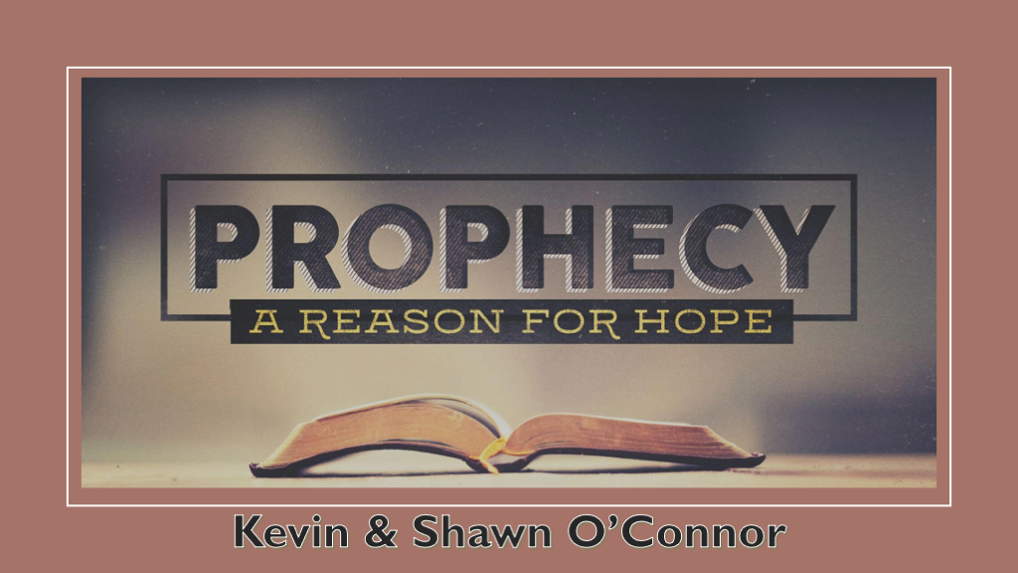
*Every generation needs the anchor of Hope Jesus provides. However, hope is vital in this age of deception when everyone wants Christianity only to dispense a message of optimism.

*The Church that disappoints God and the Church that does not disappoint.

*Romans 5:1Therefore, having been justified by faith, we have peace with God through our Lord Jesus Christ, 2 through whom also we have access by faith into this grace in which we stand, and rejoice in hope of the glory of God.

V:1-2 The Church must distribute a faith that is not sugar-coated.

Many churches and believers feel peace should be the highest goal. So what's wrong with that concept?

Justified by Faith is a legal term. I trust God and His Word, and my guilty sentence was changed through Jesus. Abraham believed in God, and it was accredited as righteousness.

*What is your Church doing that it takes Faith in God to get done?

V:2 Faith to stand or take a stand is our call. Does the lack of it mark Churches afraid to take a stand on anything?

*Romans 5:3 And not only that, but we also glory in tribulations, knowing that tribulation produces perseverance; 4 and perseverance, character; and character, hope. 5 Now hope does not disappoint, because the love of God has been poured out in our hearts by the Holy Spirit who was given to us.

V:3-5 Why would we also glory in tribulation? The Holy Spirit uses strong language in saying, "Glory in Tribulation." God is not referring to minor inconveniences or uncomfortable situations.

Tribulation produces three things that are imperative for every Christian.

Perseverance is developed in times of tribulation, as we will not learn how to have endurance, resolve, or determination.

Character is having integrity outwardly and inwardly as we follow God.

Hope is not attached to the immediate outcome. Yet, according to the scripture, we hope it does not disappoint us.

*Jesus' letters to the Church of Compromise, Corruption, Dead, and Lukewarm Churches.

*Revelation 2:14 But I have a few things against you, because you have there those who hold the doctrine of Balaam, who taught Balak to put a stumbling block before the children of Israel, to eat things sacrificed to idols, and to commit sexual immorality. 15 Thus you also have those who hold the doctrine of the Nicolaitans, which thing I hate. 16 Repent, or else I will come to you quickly and will fight against them with the sword of My mouth. (Pergamos and their Compromise)

Revelation 2:14-16 How do churches today compromise as Pergamos did?

False Teaching/Prophets

Idols in the Church?

Sexual immorality: Why is the church quiet about sexuality? Is it just an uncomfortable subject? They commit sexual sin. They know it's wrong.

*Revelation 2:20 a few things against you, because you allow that woman Jezebel, who calls herself a prophetess, to teach and seduce My servants to commit sexual immorality and eat things sacrificed to idols. 21 And I gave her time to repent of her sexual immorality, and she did not repent. 22 Indeed I will cast her into a sickbed, and those who commit adultery with her into great tribulation, unless they repent of their deeds. (Thyatira and their corruption)

Jezebel and her prophetess role. This is her demonic spirit, called Ishtar, active in the Church, and this is the Catholic Church.

God gave them time to repent, and the Catholic is the oldest Church in the World that believes Jesus is The Christ.

*Revelation 3:1 I know your works, that you have a name that you are alive, but you are dead. 2 Be watchful, and strengthen the things which remain, that are ready to die, for I have not found your works perfect before God. 3 Remember therefore how you have received and heard; hold fast and repent. Therefore if you will not watch, I will come upon you as a thief, and you will not know what hour I will come upon you. 4 You have a few names even in Sardis who have not defiled their garments; and they shall walk with Me in white, for they are worthy. (Sardis The Dead Church denominational)

Why would a Church think it's alive, and God says it's dead?

The consequence is missing the rapture. Can a Christian miss the rapture? They believe in Jesus, but they haven't made Him Lord.

*Revelation 3:15 "I know your works, that you are neither cold nor hot. I could wish you were cold or hot. 16 So then, because you are lukewarm, and neither cold nor hot, I will vomit you out of My mouth. 17 Because you say, I am rich, have become wealthy, and have
need of nothing'—and do not know that you are wretched, miserable, poor, blind, and naked— (Laodicea the Lukewarm Church)

Why is it better to be an extreme, either hot or cold, than to choose the middle?

Why does this church think it's rich or has become wealthy and needed nothing? Is God blessing them?

The Hope within Prophecy is discovered when we see who Jesus reveals Himself to be in each situation.

- *Revelation 2:1, the angel of the church in Pergamos writes, 'These things says He who has the sharp two-edged sword. (The Compromised Church)

- *Revelation 2:18, the angel of the church in Thyatira writes, These things says the Son of God, who has eyes like a flame of fire, and His feet like fine brass. (The Corrupted Church)

- *Revelation 3:1, the angel of the church in Sardis writes, 'These things says He who has the seven Spirits of God and the seven stars. (The Dead Church who thought they were alive)

- *Revelation 3:14, the angel of the church of the Laodiceans writes, These things says the Amen, the Faithful and True Witness, the Beginning of the creation of God. (The Lukewarm Church)

