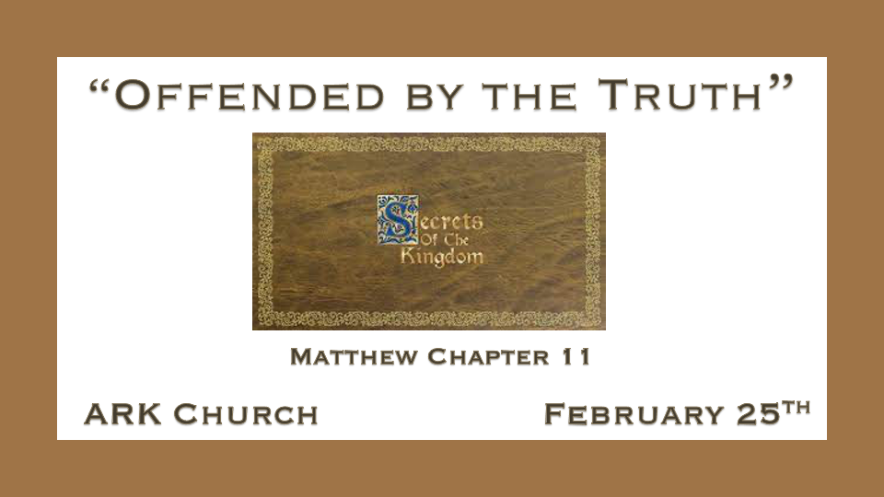
Last Week, we learned how to prepare for persecution.
Hatred deceives everyone, which allows it to control them.

Foolishness is accepting what God declares in His Word to be unacceptable.

Persecuted People are not to mediate or prepare an answer. We must allow the Holy Spirit to speak through us as God's testimony to them.

*Prepare for times of persecution, and don't be offended.

*Matthew 11:1 Now it came to pass, when Jesus finished commanding His twelve disciples, that He departed from there to teach and to preach in their cities.
2 And when John had heard in prison about the works of Christ, he sent two of his disciples 3 and said to Him, "Are You the Coming One, or do we look for another?"
4 Jesus answered and said to them, "Go and tell John the things which you hear and see: 5 The blind see and the lame walk; the lepers are cleansed and the deaf hear; the dead are raised up and the poor have the gospel preached to them. 6 And blessed is he who is not offended because of Me."

- Question: Why is John the Baptist, of all people, asking, "Are you the Coming One, or do we look for another?
- Is Jesus Lord only when He does what we expect Him to do?
- John the Baptist has been in prison since Matthew 4:12, right after Jesus' temptation.
- A year or more later, John was in prison because Herod was afraid to kill John because of his popularity as a prophet.
- On Herod's birthday, Herodias' daughter danced at the birthday party. Herod offered her any request. She asked for John the Baptist's head on a platter, for her mother hated John's confrontation of their sin.

- Jesus knows John's time was short. Jesus told his disciples to tell John what they heard and saw.
(Put Verse 5 back on screen)The blind see, the lame walk, the lepers are cleansed, and the deaf hear; the dead are raised up.
John had not had the benefit of witnessing the Messiah's power.

- Jesus declares, "Blessed is the person who is not offended and falls away because of Him."
False religion is when the creation demands the Creator acts on their behalf, and if He doesn't, they reject Him.

*"Great Persecution" may make you question the truth you've known your whole life.

*Luke 1:39 Now Mary arose in those days and went into the hill country with haste, to a city of Judah, 40 and entered the house of Zacharias and greeted Elizabeth. 41 And it happened, when Elizabeth heard the greeting of Mary, that the babe leaped in her womb; and Elizabeth was filled with the Holy Spirit. 42 Then she spoke out with a loud voice and said, "Blessed are you among women, and blessed is the fruit of your womb! 43 But why is this granted to me, that the mother of my Lord should come to me? 44 For indeed, as soon as the voice of your greeting sounded in my ears, the babe leaped in my womb for joy. 45 Blessed is she who believed, for there will be a fulfillment of those things which were told her from the Lord."

- Mary visited her cousin Elizabeth to hear about her miraculous pregnancy.
God does the supernatural often in clusters at certain critical times.

- While in the womb, John the Baptist acknowledges the presence of the Lamb of God.
What John could understand as a babe in the womb because of persecution, he now questions it as an adult.

*The Hidden Things Will be Revealed to the Babes in Christ

*Matthew 11:25 At that time Jesus answered and said, "I thank You, Father, Lord of heaven and earth, that You have hidden these things from the wise and prudent and have revealed them to babes. 26 Even so, Father, for so it seemed good in Your sight. 27 All things have been delivered to Me by My Father, and no one knows the Son except the Father. Nor does anyone know the Father except the Son, and the one to whom the Son wills to reveal Him. 28 Come to Me, all you who labor and are heavy laden, and I will give you rest. 29 Take My yoke upon you and learn from Me, for I am gentle and lowly in heart, and you will find rest for your souls. 30 For My yoke is easy and My burden is light."

- *V:25-27 Jesus wants you to learn the secrets of the Kingdom of God.
Did Jesus say verse 25 because He knew the wise and prudent (sensible) would quit depending on the truth of God's word, and they live more by sight?

Jesus addresses His Father as Lord of heaven and earth. Implying God is our Creator.

Jesus said, "Father of heaven and earth" is the fundamental truth the 21st century rejects.
A generation that doesn't believe God is the Creator is doomed.
They like to believe that the creation sets the rules for humanity, not the Creator.
The Christian who accepts the truth of God as the Creator is safe with the secrets of the Kingdom of God.

Accepting Jesus Christ as your Savior, you must accept The Triune God as the Creator who sets the rules for creation.

- *V:28 Being under a great burden or a heavy load is our most incredible opportunity.
Accepting Jesus is the only path to true rest and peace.

- *V:29 Attach to Jesus, and He will teach you true contentment.
When we take Jesus' yoke, we become coupled and harnessed to His qualities.

His gentleness is the most evident and lowly (humble) in heart, with a special blessing that you rest in Him no matter what you face.

Being attached (Yoke) to Jesus is easy if your eyes are on Him.

For me, this is a profound verse about what Jesus offers. My burden is light.

