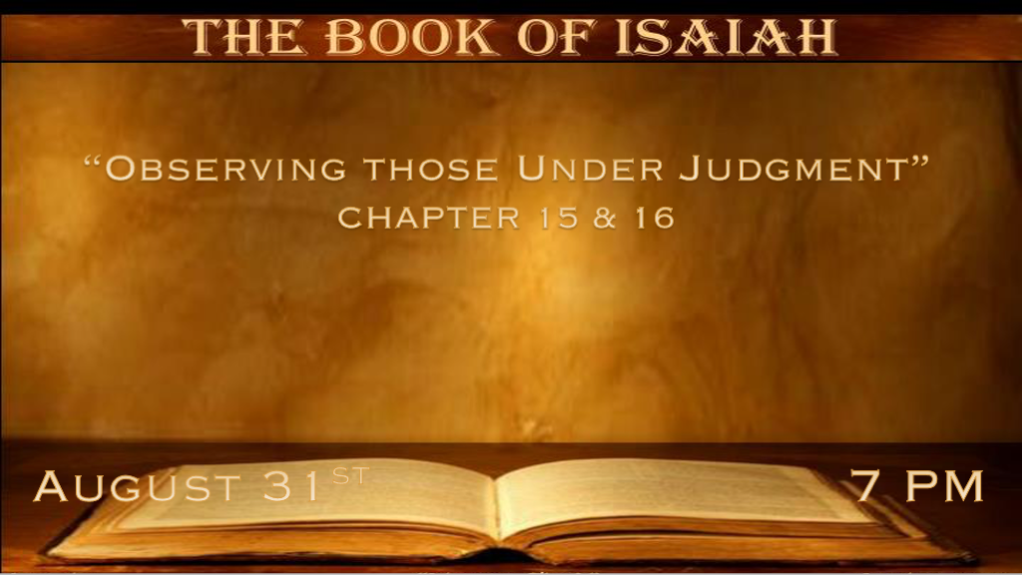

*God’s justice will not let wickedness go unpunished.

*God judges the nations of the world.

*Isaiah 15:1 The burden against Moab. Because in the night Ar of Moab is laid waste and destroyed, Because in the night Kir of Moab is laid waste And destroyed, 2 He has gone up to the temple and Dibon, to the high places to weep. Moab will wail over Nebo and over Medeba; On all their heads will be baldness, And every beard cut off. 3 In their streets they will clothe themselves with sackcloth; On the tops of their houses And in their streets Everyone will wail, weeping bitterly. 4 Heshbon and Elealeh will cry out, Their voice shall be heard as far as Jahaz; Therefore the armed soldiers of Moab will cry out; His life will be burdensome to him. 5 “My heart will cry out for Moab; His fugitives shall flee to Zoar, Like a three-year-old heifer. For by the Ascent of Luhith They will go up with weeping; For in the way of Horonaim
They will raise up a cry of destruction, 6 For the waters of Nimrim will be desolate, For the green grass has withered away;
The grass fails, there is nothing green. 7 Therefore the abundance they have gained, And what they have laid up, They will carry away to the Brook of the Willows. 8 For the cry has gone all around the borders of Moab, It's wailing to Eglaim And its wailing to Beer Elim. 9 For the waters of Dimon will be full of blood; Because I will bring more upon Dimon, Lions upon him who escapes from Moab, And on the remnant of the land.”

- What do we know about the nation of Moab?
- *Genesis 19:37 A nation birthed out of incest from Lot and his oldest daughter.
- *Numbers 22 The king of Moab Balak sends the prophet Balaam to oppose Israel.
- *2 Samuel 8 Under king David the nation of Moab is conquered and serves Israel.
- *Ruth 1 Ruth the Gentile bride is a Moabite who is rescued by Boaz the kinsman redeemer.
- *Daniel 11:41 Three nations escape the control of the Anti-Christ and Moab is one of them.
Israel’s greatest King was ¼ Moabite, King David. In addition Deut. 2:9 they were told not to destroy the country.

- A night attack against Moab is a futuristic look at a judgment that has a root in the past.
- *Though there is weeping, wailing, and anguish there is no sign of a repented heart.
- *Their abundance is gone. All that we have in life is fleeting. Only what God gives is eternal.
- *Those that try to flee from judgment are chased down by a lion.

*Several time periods including the millennial reign of Christ.

*Isaiah 16:1 Send the lamb to the ruler of the land, From Sela (Petra) to the wilderness, To the mount of the daughter of Zion. 2 For it shall be as a wandering bird thrown out of the nest; So shall be the daughters of Moab at the fords of the Arnon. 3 “Take counsel, execute judgment; Make your shadow like the night in the middle of the day; Hide the outcasts, Do not betray him who escapes. 4 Let My outcasts dwell with you, O Moab; Be a shelter to them from the face of the spoiler. For the extortioner is at an end, Devastation ceases, The oppressors are consumed out of the land.
5 In mercy the throne will be established; And One will sit on it in truth, in the tabernacle of David, Judging and seeking justice and hastening righteousness.” 6 We have heard of the pride of Moab—He is very proud—Of his haughtiness and his pride and his wrath; But his lies shall not be so. 7 Therefore Moab shall wail for Moab; Everyone shall wail.
For the foundations of Kir Hareseth you shall mourn; Surely they are stricken. 8 For the fields of Heshbon languish,
And the vine of Sibmah; The lords of the nations have broken down its choice plants, Which have reached to Jazer
And wandered through the wilderness. Her branches are stretched out, They are gone over the sea. 9 Therefore I will bewail the vine of Sibmah, With the weeping of Jazer; I will drench you with my tears, O Heshbon and Elealeh; For battle cries have fallen Over your summer fruits and your harvest.

- There was a time in the past when Moab sent lambs to Jerusalem as a tribute. 2 Kings 3:4-5
The suggestion in the passage is saying it’s time for Moab to submit to God again.
Like a bird thrown out of the nest. This could point to a time of confusion and helplessness under God’s judgment.
It’s time to submit to the King.

- Moab will be a place of shelter, and Sela/Petra will be a place that the Jewish people will flee to during the great tribulation. The Moabites will then in the millennial reign need a place of refuge.
Moab is prophesied to give shelter to Israel during the Great Tribulation in Revelation 12:6 for 3 ½ years.
When we are in trouble we need to find the narrow way, the rock of protection that God has prepared for us.
Those that gave shelter will find in Jesus. In this story, Moab will shelter in Jerusalem the home of our King.

- The millennial reign is described as Jesus sitting on the throne of David. He is also hastening justice and righteousness in this time period.
*Matthew 25:31“When the Son of Man comes in His glory, and all the holy angels with Him, then He will sit on the throne of His glory. 32 All the nations will be gathered before Him, and He will separate them one from another, as a shepherd divides his sheep from the goats.

- Moab though a small nation still fell prey to the sin of pride. Their vineyards were a source of their pride and that’s why they are attacked.
This probably happened to them by the Assyrians before Assyria was destroyed.

*A double application for then and now plus could our gladness be taken away?

*Isaiah 16:10 Gladness is taken away, And joy from the plentiful field; In the vineyards there will be no singing,
Nor will there be shouting; No treaders will tread out wine in the presses; I have made their shouting cease. 11 Therefore my heart shall resound like a harp for Moab, And my inner being for Kir Heres. 12 And it shall come to pass, When it is seen that Moab is weary on the high place, That he will come to his sanctuary to pray; But he will not prevail. 13 This is the word which the LORD has spoken concerning Moab since that time. 14 But now the LORD has spoken, saying, “Within three years, as the years of a hired man, the glory of Moab will be despised with all that great multitude, and the remnant will be very small and feeble.”

- When gladness is stripped away on that day, seek God and ask why. There are many reasons for sadness verse ten has a spiritual connotation to it.

- Moab’s judgment is a lesson to Israel and us.
The key to learning from someone’s else mistake is to stay humble.
Is there a pattern from Moab that we should take to heart?
- What started as a night invasion in Chapter 15 for Moab grows to 3 years of judgment in Chapter 16.
- Moab is not the last nation that will come under judgment. It’s the 1st nation to come under judgment we will see this pattern again and again.

