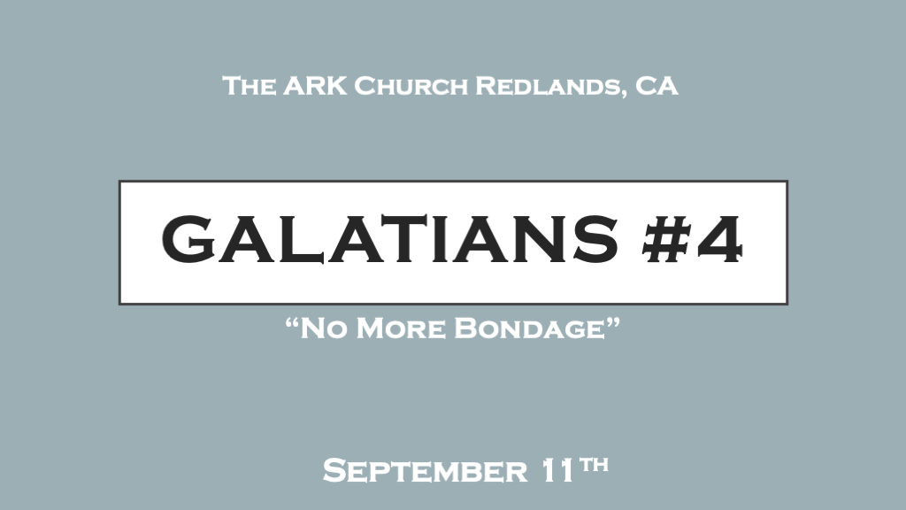

Sound doctrine relies on scripture interpreting scripture.

*Spiritual maturity comes at an appointed time. (There’s less evidence of bondage)
*Galatians 4:1 Now I say that the heir, as long as he is a child, does not differ at all from a slave, though he is master of all, 2 but is under guardians (Tutors) and stewards until the time appointed by the father. 3 Even so we, when we were children, were in bondage under the elements of the world. 4 But when the fullness of the time had come, God sent forth His Son, born of a woman, born under the law, 5 to redeem those who were under the law, that we might receive the adoption as sons.
6 And because you are sons, God has sent forth the Spirit of His Son into your hearts, crying out, “Abba, Father!” 7 Therefore you are no longer a slave but a son, and if a son, then an heir of God through Christ.

- V:1-3 There is a deeper meaning to being called a child. Paul was referring to a well-known understanding of those times. Even though a child will at an appointed time inherit the status of their inheritance. Yet, while they are an infant they are no different than a slave because people have total say over their lives.
Let’s move this to the spiritual realm. If you are still drawn more by your old nature (The Flesh) you are still a baby spiritually. If you’re under the influence of worldly thinking, and legalistic nature, then you have not grown spiritually. In this season no freedom of decision-making power is granted to the child this is what makes him equivalent to a slave.

- V:4-6 Maturation becomes obvious because you’re listening to and obeying your heavenly father and acting like His child.
If you listen more to the culture your neither. A.) Not born again. B.) Still a baby and still in bondage to your immaturity. Your heart calls Him Father.

- V:7 A person who believes their actions (work) justify their freedom. Still lives in bondage.
A free person in Christ knows and experiences the joy of doing because it represents the family they belong to.
When they have the freedom to make decisions they do it seeking the Father, the Word, and Tutors.
“Abba” is the same word Jesus uses in the Garden of Gethsemane. “Daddy” shows intimacy and trust.

*The weaker element of the flesh always replace truth. (A bondage stronghold)

*Galatians 4:8 But then, indeed, when you did not know God, you served those which by nature are not gods. 9 But now after you have known God, or rather are known by God, how is it that you turn again to the weak and beggarly elements, to which you desire again to be in bondage? 10 You observe days and months and seasons and years. 11 I am afraid for you, lest I have labored for you in vain.
12 Brethren, I urge you to become like me, for I became like you. You have not injured me at all. 13 You know that because of physical infirmity I preached the gospel to you at the first. 14 And my trial which was in my flesh you did not despise or reject, but you received me as an angel of God, even as Christ Jesus. 15 What then was the blessing you enjoyed? For I bear you witness that, if possible, you would have plucked out your own eyes and given them to me. 16 Have I therefore become your enemy because I tell you the truth?
17 They zealously court you, but for no good; yes, they want to exclude you, that you may be zealous for them. 18 But it is good to be zealous in a good thing always, and not only when I am present with you. 19 My little children, for whom I labor in birth again until Christ is formed in you, 20 I would like to be present with you now and to change my tone; for I have doubts about you.

- V:8-11 Our humanity has been trained by the things that keep us in bondage. Just because it feels natural doesn’t mean it’s right or good.
A dysfunctional relationship with God will keep you functioning as a slave to sin. (A wrong view of the father)
Do you know you’re strongholds? They manifest themselves in times of stress.
I identify my strongholds as the places I hunger for the power of God to transform me into my manhood spiritually.

- V:12-16 The blessings of grace will stretch us and challenge us beyond ourselves.
The gospel of grace isn’t my license to sin. It has become the anchor to my transformation!

- V:17-20 The world will passionately try to move your heart to good things but not necessarily to the godly things of the Kingdom of God.
Don’t waste your zealous energy on temporal issues or the traditions of humanity.
Paul was a zealot in his’ destroying the Church Jesus birthed. His religion drove him to do so.

*Who says; “Just leave me in my bondage?”

*Galatians 4:21 Tell me, you who desire to be under the law, do you not hear the law? 22 For it is written that Abraham had two sons: the one by a bondwoman, the other by a freewoman. 23 But he who was of the bondwoman was born according to the flesh, and he of the freewoman through promise, 24 which things are symbolic. For these are the two covenants: the one from Mount Sinai which gives birth to bondage, which is Hagar— 25 for this Hagar is Mount Sinai in Arabia and corresponds to Jerusalem which now is, and is in bondage with her children— 26 but the Jerusalem above is free, which is the mother of us all. 27 For it is written:
“Rejoice, O barren,
You who do not bear!
Break forth and shout,
You who are not in labor!
For the desolate has many more children than she who has a husband.”
28 Now we, brethren, as Isaac was, are children of promise. 29 But, as he who was born according to the flesh then persecuted him who was born according to the Spirit, even so it is now. 30 Nevertheless what does the Scripture say? “Cast out the bondwoman and her son, for the son of the bondwoman shall not be heir with the son of the freewoman.” 31 So then, brethren, we are not children of the bondwoman but of the free.

- V:21-26 Dysfunctional Christians teach laws. Those freed from their bondages teach the freedom of the life in the Spirit.
The covenant of the Spirit will guide into the relationship with a person. The covenant of Mount Sinai will cause you to focus on correcting the person.
- I covenant to speak the truth with grace and mercy!
- I covenant to address the path that is healthy spiritually. This is the discipline and painful path.
- I covenant to point to the Father, Jesus the Son, and the Holy Spirit not a denominational stance.
Discipline is essential but its purpose is to lead them into a greater promise of a deeper relationship.

- V:27-31 The allegory of the flesh vs the promise.
- Abraham was trying to help himself and in his mind even helping God sleeps with Hagar.
- Isaac represents what comes by us trusting God and the promise of the miracle of transformation.
The barren woman represents the one who should be shouting because what you will experience is the promise. Because of the covenant of promise we are children of the promise. We shout this message!
“I am free”

