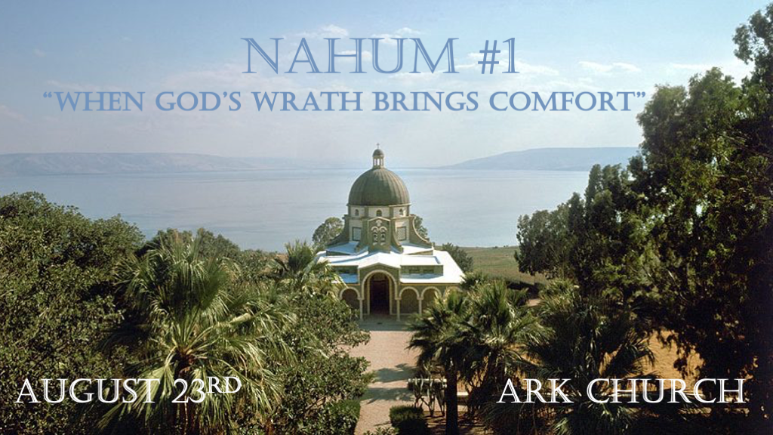
*Nahum is one of the three prophets to the Gentiles.

*Characteristics of God most Churches don't teach.
*Nahum 1:1 The burden against Nineveh. The book of the vision of Nahum the Elkoshite.
2 God is jealous, and the LORD avenges; The LORD avenges and is furious. The LORD will take vengeance on His adversaries, and He reserves wrath for His enemies; 3 The LORD is slow to anger and great in power, and will not at all acquit the wicked.
The LORD has His way in the whirlwind and in the storm, and the clouds are the dust of His feet.

V:1 What is a vision?

The vision for Nahum was a burden—the biblical commitment of a heavy word from God to a people.

Nahum saw this vision as John the apostle's vision on the island of Patmos, where he wrote Revelation.

When the Pharisees said no prophet had ever come from Galilee, they were wrong. Nahum was from Galilee.

V:2-3 Why does God have Jealous, vengeful wrath toward wickedness?

The focus of God is against wickedness. Nineveh was a city founded by Nimrod. He was the ancient prototype of the Lawless One or Anti-Christ.

A jealous God: The Creator won't share the human heart with any rival. God's jealousy knows what others will do to destroy your heart and life.

A vengeful God: Anyone who sets themselves up against God or His creation will reap God's vengeance.

A God of wrath: God is slow to anger, but He will not be an unjust judge. God always punishes wickedness.

Historically, God has used other Nations to bring punishment and wind, water, and fire when dealing with iniquity.
We must not assume all such things are from God, but only when wrath has been used on those who hate God and are evil.

*One Will Come Forth to Plot Wickedness Against God.
*Nahum 1:4 He rebukes the sea and makes it dry, and dries up all the rivers. Bashan and Carmel wither, and the flower of Lebanon wilts. 5 The mountains quake before Him, the hills melt, and the earth heaves at His presence, Yes, the world and all who dwell in it. 6 Who can stand before His indignation? And who can endure the fierceness of His anger? His fury is poured out like fire, and the rocks are thrown down by Him. 7 The LORD is good, a stronghold in the day of trouble; And He knows those who trust in Him.
8 But with an overflowing flood He will make an utter end of its place, and darkness will pursue His enemies. 9 What do you conspire against the LORD? He will make an utter end of it. Affliction will not rise up a second time. 10 For while tangled like thorns, and while drunken like drunkards, they shall be devoured like stubble fully dried.
11 From you comes forth one who plots evil against the LORD, a wicked counselor.

V:4-5 God's great power is known by nature. The earth heaves at His presence.

Every knee will bow, and every tongue will confess that Jesus is Lord. Philippians 2:10-11

V:6-7 The Lord is Good, and His Might.

Who can stand before his indignation? No one, not even the devil.

- God is good in his very being – it is His very nature to be good.
- God is good independently – no one must help Him be good.
- God is eternal and unchangeably good.
- God is good in each aspect of His Trinity.
- God is good in all His plans and purposes of life.

V:8-10 Those who conspire against God in the past or the future will not succeed.

God's promises are one of our sources of comfort.

V:11 The Assyrian who comes forth will be the Lawless one. (Anti-Christ)

Suddenly, what happened over 2,600 years ago became relevant to us in 2023.

The lawless one is both a person and a system in today's world. Micah 5:5-6 & Isaiah 10:5-11

*The Judgment of the Gentile and the End of the Wicked.
*Nahum 1:12 Thus says the LORD: "Though they are safe, and likewise many, yet in this manner they will be cut down
When he passes through. Though I have afflicted you, I will afflict you no more; 13 For now I will break off his yoke from you,
and burst your bonds apart." 14 The LORD has given a command concerning you: "Your name shall be perpetuated no longer. Out of the house of your gods I will cut off the carved image and the molded image. I will dig your grave, for you are vile." 15 Behold, on the mountains the feet of him who brings good tidings, Who proclaims peace! O Judah, keep your appointed feasts, perform your vows. For the wicked one shall no more pass through you; He is utterly cut off.

V:12-13 When wickedness seems to succeed.

Remembering God's promise is a comfort that the wicked will be destroyed.

The burden that wickedness brings will be broken off of us. But when?

V:14 The names of the wicked will cease.
Wicked names in the here and now have been made notorious.

Wickedness, their deeds, and their identities will not be eternal. They will be buried and remembered no more.

V:15 Why is the wicked being destroyed? Good News?

Comfort: If the wicked prevail, we lose hope. Hope is a trustworthy source of spiritual comfort.

