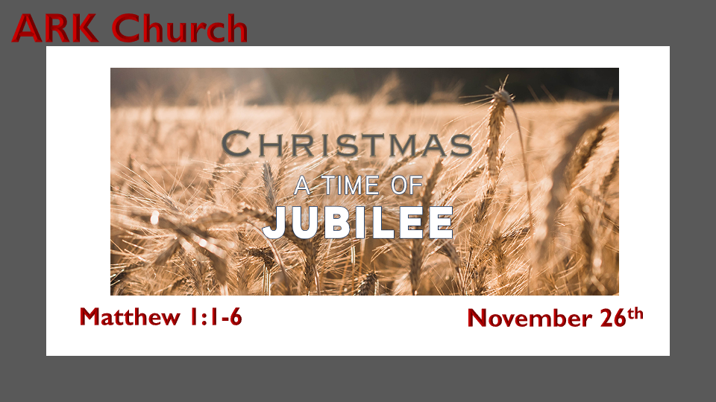

A Time of Jubilee

Jesus came into the world to declare the year of Jubilee.

*Luke 4:16 So He came to Nazareth, where He had been brought up. And as His custom was, He went into the synagogue on the Sabbath day, and stood up to read. 17 And He was handed the book of the prophet Isaiah. And when He had opened the book, He found the place where it was written:
18 "The Spirit of the LORD is upon Me, because He has anointed Me to preach the gospel to the poor; He has sent Me to heal the brokenhearted, to proclaim liberty to the captives and recovery of sight to the blind, to set at liberty those who are oppressed;19 To proclaim the acceptable year of the LORD."
20 Then He closed the book, and gave it back to the attendant and sat down. And the eyes of all who were in the synagogue were fixed on Him. 21 And He began to say to them, "Today this Scripture is fulfilled in your hearing."

Insights for Luke 4:16-21

- Jesus 1st advent was to heal the brokenhearted, as in saving the heart in salvation. He made this proclamation in His hometown.
Captives are freed, and a sight to the blind is both physical and spiritual.

- The reason the Jews did not accept Jesus as the Messiah was they were looking for a military deliverance; they wanted liberty.
The 1st advent was liberty from our sins.

- To proclaim Liberty and give freedom to The Oppressed.
God raised a Nation under Him to be a Jubilee nation to speak about liberty.

- In Jesus' 2nd Advent, He will bring total liberty/deliverance and much more.

We must always connect Jesus' 1st Advent with His 2nd Advent. Our redemption and Israel's is the reason for the season.

- Jesus declared He is the fulfillment of the Jubilee.
The Jubilee occurs after 49 years. 7X7 = 49

*Isaiah 61:2 To proclaim the acceptable year of the LORD and the day of vengeance of our God.

The day of vengeance will be at the end of the seven years known as the great tribulation.

Jubilee represents the ultimate signature of God. When seven is maximized in 7X7 or 49 years, the 50th year is the Jubilee.

Only God can change the jot and the tittle from a comma in Isaiah 61 to a period in Luke 4:19. In order to show Jesus' 1st Advent completed everything it was supposed to finish.
*The Bloodline of Christ-Tree Genealogy

*Matthew 1:1 The book of the genealogy of Jesus Christ, the Son of David, the Son of Abraham:
2 Abraham begot Isaac, Isaac begot Jacob, and Jacob begot Judah and his brothers. 3 Judah begot Perez and Zerah by Tamar, Perez begot Hezron, and Hezron begot Ram. 4 Ram begot Amminadab, Amminadab begot Nahshon, and Nahshon begot Salmon. 5 Salmon begot Boaz by Rahab, Boaz begot Obed by Ruth, Obed begot Jesse, 6 and Jesse begot David the king. David the king begot Solomon by her who had been the wife of Uriah.
*Matthew 1:17 So all the generations from Abraham to David are fourteen generations, from David until the captivity in Babylon are fourteen generations, and from the captivity in Babylon until the Christ are fourteen generations.

Insights for V:1 The Covenant Bloodline. The Bloodline is part of the Heptadic code of God.
The 42 generations leading to Jesus' birth. (Note the signature of The Christ 6X7) This number is a message; six is the number of man, and Jesus is fully man. Seven is the signature of God and completion.

The Davidic and Abraham covenant is why verse one starts the Christ-Tree of genealogy with them.

Insights for V:2-6 The path of Jesus' royal bloodline came through many unlikely twists.

Jacob is transformed into Israel; it's more than a name change. His twelve sons are the 12 tribes of Israel.

Judah is the royal path that will supply the ingredient of Jesus being both royalty from heaven and earth.

Tamar Judah lost two sons who were unfaithful to God and Tamar. God replaces the two sons with twins from Tamar. (A Gentile who dressed herself as a prostitute to sleep with Judah)

Perez means to breakout or to burst out. His brother Zerah's hand came out first. Perez pulled his brother's hand back and was born first. One without the scarlet thread was declared 1st born.

Salmon was one of the two spies hidden in Rahab, the prostitute's house. He returns and redeems her and marries her. This is the continuation of the redemption story before Jesus the Redeemer is born.

Rahab, the Prostitute, has a terrible title as she is known for hiding the spies and tying a scarlet thread on her window so they would remember and see her redemption by faith.

Boaz has a mixture of Gentile and Jewish blood, and God chooses him to be a foreshadowing of our Kinsman Redeemer

Ruth is the Gentile Moabite who finds her Kinsman redeemer.
Read the book of Ruth, where the blessing of Perez is prayed upon her mother-in-law, Naomi. The breakout happened as her personal redemption.

Obed has a mixture again of Gentile and Jewish blood.

Jesse's sons were examined to see if they were the future king, but David, the youngest tending the flock, was the one the Lord had Samuel anoint.

David is the shepherd who becomes King, and Jesus is the Great Shepherd who was born King.

Solomon's mother was the wife of Uriah. At this point, the genealogy splits to lead us to Joseph, the stepdad of Jesus.
Bathsheba is in Joseph's genealogy, but David's actual bloodline will pass through his son Nathan.

The Five Women of Christ-Tree reveals the greatest truth. Liberty came for men and women before the world could grasp the concept. God's truth will always teach humanity all that it needs to know.

