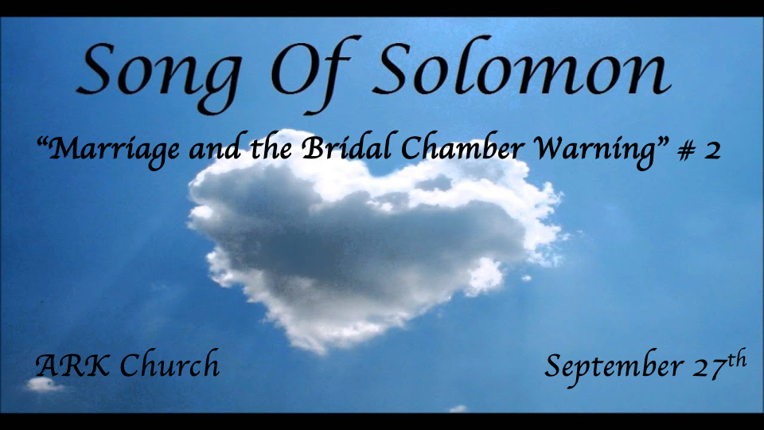

Three reflections: Preparing for the Wedding feast
At the Wedding banquet
In the Bridal chambers

Solomon: I Kings 10:23 & 1 Kings 4:32

The fourth reflection: Back to Courtship

*Marriage changes everything and warnings to the unmarried.
*Song of Solomon 2:1-7

1 I am the rose of Sharon,
And the lily of the valleys.
The Beloved
2 Like a lily among thorns,
So is my love among the daughters.
The Shulamite
3 Like an apple tree among the trees of the woods,
So is my beloved among the sons.
I sat down in his shade with great delight,
And his fruit was sweet to my taste.
The Shulamite to the Daughters of Jerusalem
4 He brought me to the banqueting house,
And his banner over me was love.
5 Sustain me with cakes of raisins,
Refresh me with apples,
For I am lovesick.
6 His left hand is under my head,
And his right hand embraces me.
7 I charge you, O daughters of Jerusalem,
By the gazelles or by the does of the field,
Do not stir up nor awaken love
Until it pleases.

Insights V:1-2: Love changes the bride’s self-image radically from chapter one.

V:1 Literally, marriage changes us. Allegorically, it, too, is applied to Jesus, who makes us in His image.
God’s love transforms us.
Healthy marital love will satisfy beyond the physical realm.

V:2 The bridegroom compliments the bride; in comparison, He describes all the others like thorns.
Marriage won’t make you blind to others. But it will give a proper insight into how to adore each other.

Insights V3-6: Fulfilling passion within the marriage bed without consummation.

V:3 In the midst love…
V:3 is what most scholars describe as martial foreplay.
She is experiencing feelings of protection, safety, and delight. She is not a woman at the mercy of man. It is a mutual interchange of delightful passions. There’s no goal of intercourse at this point.

It’s vital that this is the proper use of the term making love. Only the marriage bed should use this term. Those having sex outside the marriage union are not making love. They are either fornicating or committing adultery.

V:4-5 Who may we tell about our marriage relationship?
She tells her sisters in the faith—the Daughters of Jerusalem.

V:7 A warning to the daughter of Jerusalem.
Don’t stir up passions outside of the boundaries of married life. She is warning against pre-martial or extra-material sex.
*Hebrews 13:4 Marriage is honorable among all, and the bed undefiled; but fornicators and adulterers God will judge.

*A Fourth Reflection: Springtime Courtship and Another Warning.
*Song of Solomon 2:8-17

The Shulamite
8 The voice of my beloved!
Behold, he comes
Leaping upon the mountains,
Skipping upon the hills.
9 My beloved is like a gazelle or a young stag.
Behold, he stands behind our wall;
He is looking through the windows,
Gazing through the lattice.
10 My beloved spoke, and said to me:
“Rise up, my love, my fair one,
And come away.
11 For lo, the winter is past,
The rain is over and gone.
12 The flowers appear on the earth;
The time of singing has come,
And the voice of the turtledove
Is heard in our land.
13 The fig tree puts forth her green figs,
And the vines with the tender grapes
Give a good smell.
Rise up, my love, my fair one,
And come away!
14 “O my dove, in the clefts of the rock,
In the secret places of the cliff,
Let me see your face,
Let me hear your voice;
For your voice is sweet,
And your face is lovely.”
Her Brothers
15 Catch us the foxes,
The little foxes that spoil the vines,
For our vines have tender grapes.
The Shulamite
16 My beloved is mine, and I am his.
He feeds his flock among the lilies.
(To Her Beloved)
17 Until the day breaks
And the shadows flee away,
Turn, my beloved,
And be like a gazelle
Or a young stag
Upon the mountains of Bether.

*2 Timothy 3:16 All Scripture is given by inspiration of God, and is profitable for doctrine, for reproof, for correction, for instruction in righteousness, 17 that the man of God may be complete, thoroughly equipped for every good work.

The song of songs from 2:8 – 3:5 will focus on courtship. This is the 4th major reflection.

Insights literal V:8-14 Our voice and our distinction/stature. Men, are you the gazelle type or gorilla?
Our courtship voice needs to be found again in marriage. We must learn to manage our tones and control the volume. The setting is springtime, possibly because we all fall in love in the springtime of life.

The plus of springtime. Strength, agility, and a flair for enjoyment. He is approaching her parents’ home.

The season of loneliness is gone, and the voice of spring (turtle doves) is here.

Springtime is described as a tender time and a time of great smells.

V:14 Allegory insight about the cleft of the rock. What’s your place of refuge?
Isaiah 2:21 Israel is to hide in the cleft of the rock as the glory of the Lord comes and shakes the world with His second coming.

*Obadiah 1:3 The pride of your heart has deceived you, you who dwell in the clefts of the rock, whose habitation is high, who says in his heart, 'Who will bring me down to the ground?'

V:15 The Warning of the Little Foxes is an idiom. Uncontrolled desires and emotions that destroy.
Literally, don’t let the little things we have no control over rob you of your intimacy.
She is asking her man to solve the little problems that arise that could harm their relationship.

Insights V:16-17: The call is to bring strength and virility to our future marriage through commitment. Commitment is more potent than love. (Agape love is commitment)

