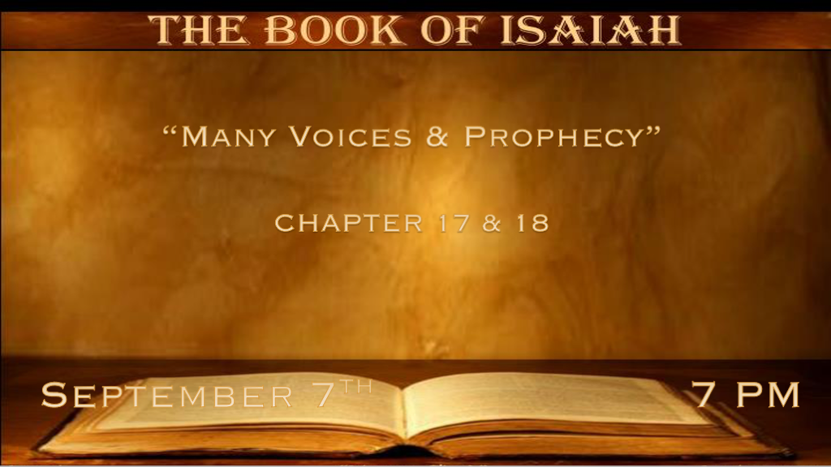

*Is a Gentile city about to be destroyed?

*In That Day, …

*Isaiah 17:1 The burden against Damascus. “Behold, Damascus will cease from being a city, and it will be a ruinous heap. 2 The cities of Aroer are forsaken; They will be for flocks which lie down, and no one will make them afraid.
3 The fortress also will cease from Ephraim, The kingdom from Damascus, and the remnant of Syria; They will be as the glory of the children of Israel,” Says the LORD of hosts.
4 “In that day it shall come to pass that the glory of Jacob will wane, and the fatness of his flesh grow lean.
5 It shall be as when the harvester gathers the grain and reaps the heads with his arm; It shall be as he who gathers heads of grain In the Valley of Rephaim. 6 Yet gleaning grapes will be left in it, like the shaking of an olive tree, two or three olives at the top of the uppermost bough, four or five in its most fruitful branches,” Says the LORD God of Israel.
7 In that day a man will look to his Maker, and his eyes will have respect for the Holy One of Israel.
8 He will not look to the altars, the work of his hands; He will not respect what his fingers have made, nor the wooden images nor the incense altars. 9 In that day his strong cities will be as a forsaken bough and an uppermost branch, which they left because of the children of Israel; And there will be desolation. 10 Because you have forgotten the God of your salvation, and have not been mindful of the Rock of your stronghold, therefore you will plant pleasant plants and set out foreign seedlings;
11 In the day you will make your plant to grow, and in the morning you will make your seed to flourish; But the harvest will be a heap of ruins In the day of grief and desperate sorrow. 12 Woe to the multitude of many people who make a noise like the roar of the seas, and to the rushing of nations that make a rushing like the rushing of mighty waters! 13 The nations will rush like the rushing of many waters; But God will rebuke them and they will flee far away, and be chased like the chaff of the mountains before the wind, like a rolling thing before the whirlwind. 14 Then behold, at eventide, trouble! And before the morning, he is no more. This is the portion of those who plunder us and the lot of those who rob us.

- V:1-6 Damascus will cease to be a city and Israel acting like Jacob in the last days.
Damascus ceased being the capital of the Northern Kingdom when the Assyrians attack it in 722 B.C.
Many believe this is an end-time prophecy that could occur with the Gog and Magog war of Ezekiel 38-39
In That Day, could be a prophecy of Israel becoming very fleshly before Jesus' return. The temporary prime minister spent a high priority affirming the LGBTQ movements of their civil rights.

- V:7-10 A proper respect for God establishing nothing less will be tolerated in the millennial reign.
A second reference to “In That Day”. Desolation is the result of forgetting God's important message of salvation.

- V:11 God’s judgment will bring humanity’s accomplishments into proper perspective.
The harvest is always a gift from God. When we think we accomplish anything with God in that day it will show how much the role God plays in life. The third reference to “In That Day.”

- V:12-14 Woe to those who listen to the many voices. This reveals the many false messages that are coming from the world to deceive those who should know the voice of God.
This is also probably speaking to those who look to plunder Israel in the Gog and Magog war that God does have the final say.

*A special gift from Ethiopia during the millennial reign of Christ.

*Isaiah 18:1 Woe to the land shadowed with buzzing wings, which is beyond the rivers of Ethiopia, 2 Which sends ambassadors by sea, even in vessels of reed on the waters, saying, “Go, swift messengers, to a nation tall and smooth of skin, to a people terrible from their beginning onward, a nation powerful and treading down, whose land the rivers divide.” 3 All inhabitants of the world and dwellers on the earth: When he lifts up a banner on the mountains, you see it;
and when he blows a trumpet, you hear it. 4 For so the LORD said to me, “I will take My rest, and I will look from My dwelling place like clear heat in sunshine, like a cloud of dew in the heat of harvest.” 5 For before the harvest, when the bud is perfect and the sour grape is ripening in the flower, he will both cut off the sprigs with pruning hooks and take away and cut down the branches. 6 They will be left together for the mountain birds of prey and for the beasts of the earth; The birds of prey will summer on them, and all the beasts of the earth will winter on them. 7 In that time a present will be brought to the LORD of hosts From a people tall and smooth of skin, and from a people terrible from their beginning onward, a nation powerful and treading down, whose land the rivers divide—To the place of the name of the LORD of hosts, to Mount Zion.

- V:1-3 Tall and smooth skin people of Ethiopia are warned not to threaten God’s people.
History of Ethiopian connections with Israel: Queen of Sheba honors Solomon more than any other world leader.
Pharoah Necho of Egypt is an Ethiopian.

- V:4-6 Pruning before a harvest.
Historically this was Assyria's destruction. It also has strong implications that it is end times revelation that it’s Jesus' return cutting off the enemies of Israel.

- V:7 A special gift or present is given to Jesus from the Ethiopian people.

Is the present “The Ark of the Covenant?” Six theories on the Ark of the Covenant
- *During Solomon’s apostasy it was taken to Ethiopia, and he is married to Queen Sheba.
(No Biblical reference to this being true)
- *2 Chronicles 12:9 So Shishak king of Egypt came up against Jerusalem, and took away the treasures of the house of the LORD and the treasures of the king’s house; he took everything. He also carried away the gold shields which Solomon had made.
- *Hidden by Jeremiah on Mount Nebo 2 Maccabees 2:4-5
- *Hidden under the Temple Mount. (Rabbinical view)
- *Taken by the Babylonians when they destroyed the temple in 586 BC.
- *Taken to Egypt during King Manasseh’s atrocities by the Levites and is verified by King Josiah. 2 Kings 21:2-16, 2 Chronicles 35:3 & 20-25
History: Manasseh 686 B.C. tries to destroy any remembrance of Judaism. His son Josiah will restore it.

Pharaoh Necho of Egypt was an Ethiopian who was sent to fight the Assyrians and Josiah chooses to fight against Egypt even though the Assyrians are the enemy of Israel. Pharaoh Necho declares he is fighting the Assyrians because God has told him. King Josiah dies as he goes to battle against Necho. All of Israel mourns this death. The theory is reinforced by Zephaniah 3:10.

It may be possible the Ark of the Covenant is not the main issue as we read Jeremiah 3:16-17. It could be the present is the throne that Jesus sits on during the millennial reign is the gift. The seat/throne could be the Mercy Seat which is a separate part that sits on top of the Ark of the Covenant.

