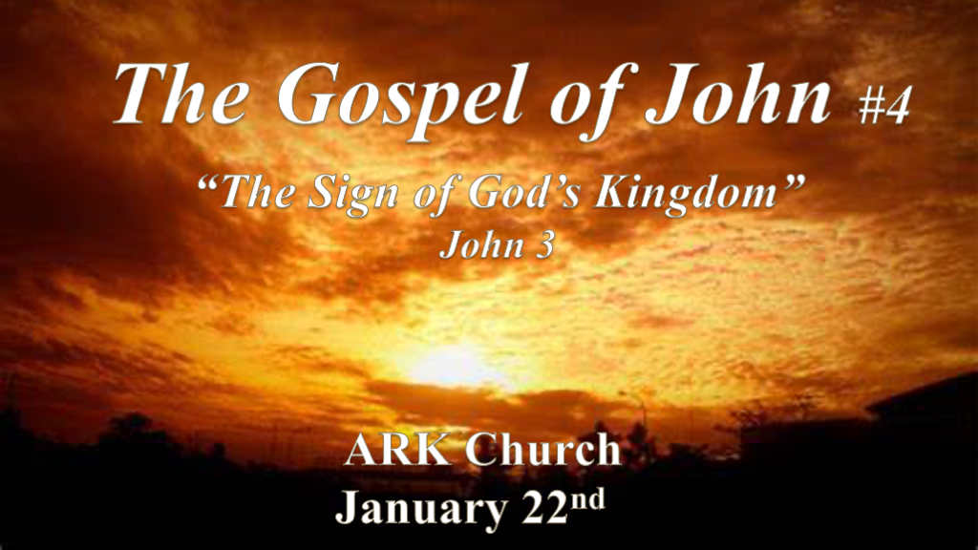

*Jesus teaches the deepest truth of the Gospels.

*John 3:1 There was a man of the Pharisees named Nicodemus, a ruler of the Jews. 2 This man came to Jesus by night and said to Him, “Rabbi, we know that You are a teacher come from God; for no one can do these signs that You do unless God is with him.”
3 Jesus answered and said to him, “Most assuredly, I say to you, unless one is born again, he cannot see the kingdom of God.”
4 Nicodemus said to Him, “How can a man be born when he is old? Can he enter a second time into his mother’s womb and be born?” 5 Jesus answered, “Most assuredly, I say to you, unless one is born of water and the Spirit, he cannot enter the kingdom of God. 6 That which is born of the flesh is flesh, and that which is born of the Spirit is spirit. 7 Do not marvel that I said to you, ‘You must be born again.’ 8 The wind blows where it wishes, and you hear the sound of it, but cannot tell where it comes from and where it goes. So is everyone who is born of the Spirit.”

- V:1-2 Nicodemus knows Jesus came from God because of the creation sign.
Jesus reveals His ministry is salvation and being born of The Holy Spirit. Nicodemus was a man in the dark.
The Pharisees believed in a coming Messiah, miracles, and the resurrection. The Sadducees did not believe in them.

- V:3-5 Seeing The Kingdom of God is not the same as entering into it. (To see is implied as discernment)
God’s greatest work is redemption. How can we know this? Look at how much the Bible is about redemption and how much is about creation. What did creation cost God? What did redemption cost God?

*Birth is our mode of entrance into this world and brings with it the potential equipment to adjust to this world. ~Missler

Being born again is a transformation and is our mode of entrance into the Kingdom of God. The equipment is the Holy Spirit's presence on the inside and His Word in our hands.

- V:6-8 What’s the difference between a Christian and a Spirit-filled Christian?
Christians that aren’t spirit-filled make most choices out of their intellect or some other mode of process. The Spirit-filled person allows a Spiritual & Biblical process to be part of their decision process.

*No matter how gifted, moral, & intelligent the natural person is they cannot see or enter the Kingdom of God.

*To Live Forever is what everyone desires.

*John 3:9 Nicodemus answered and said to Him, “How can these things be?”
10 Jesus answered and said to him, “Are you the teacher of Israel, and do not know these things? 11 Most assuredly, I say to you, We speak what We know and testify what we have seen, and you do not receive Our witness. 12 If I have told you earthly things and you do not believe, how will you believe if I tell you heavenly things?
13 No one has ascended to heaven but He who came down from heaven, that is, the Son of Man who is in heaven. 14 And as Moses lifted up the serpent in the wilderness, even so must the Son of Man be lifted up, 15 that whoever believes in Him should not perish but have eternal life. 16 For God so loved the world that He gave His only begotten Son, that whoever believes in Him should not perish but have everlasting life. 17 For God did not send His Son into the world to condemn the world, but that the world through Him might be saved.
18 “He who believes in Him is not condemned; but he who does not believe is condemned already, because he has not believed in the name of the only begotten Son of God. 19 And this is the condemnation, that the light has come into the world, and men loved darkness rather than light, because their deeds were evil. 20 For everyone practicing evil hates the light and does not come to the light, lest his deeds should be exposed. 21 But he who does the truth comes to the light, that his deeds may be clearly seen, that they have been done in God.”

- V:9-12 The how questions of the faith. (John 7:50-52 & John 19:39-42)
The fountain of youth fable is the secular hope of living forever. The river of life is the Christian truth that we hold on to.

Kingdom questions can only be answered through the Word of God. (Nicodemus defends Jesus & buries Him.)

- V:13-15 The world has been snake bitten by sin. The Solution: “Taste and See” that the Lord is good. Ps. 34:8
*Blessed is the one who takes refuge in Him.

- V:16-21 Humanity loves darkness therefore they are condemned. Leaving the gift of salvation unopened.

*Keys to The Kingdom of God.

*John 3:22 After these things Jesus and His disciples came into the land of Judea, and there He remained with them and baptized. 23 Now John also was baptizing in Aenon near Salim, because there was much water there. And they came and were baptized. 24 For John had not yet been thrown into prison.
25 Then there arose a dispute between some of John’s disciples and the Jews about purification. 26 And they came to John and said to him, “Rabbi, He who was with you beyond the Jordan, to whom you have testified—behold, He is baptizing, and all are coming to Him!”
27 John answered and said, “A man can receive nothing unless it has been given to him from heaven. 28 You yourselves bear me witness, that I said, I am not the Christ,’ but, I have been sent before Him.’ 29 He who has the bride is the bridegroom; but the friend of the bridegroom, who stands and hears him, rejoices greatly because of the bridegroom’s voice. Therefore this joy of mine is fulfilled. 30 He must increase, but I must decrease. 31 He who comes from above is above all; he who is of the earth is earthly and speaks of the earth. He who comes from heaven is above all. 32 And what He has seen and heard, that He testifies; and no one receives His testimony. 33 He who has received His testimony has certified that God is true. 34 For He whom God has sent speaks the words of God, for God does not give the Spirit by measure. 35 The Father loves the Son, and has given all things into His hand. 36 He who believes in the Son has everlasting life; and he who does not believe the Son shall not see life, but the wrath of God abides on him.”

- V:22-26 John the Baptist is faithful in ministry.
*1st Key Surrendering to the Holy Spirit.

- V:27-30 Amazing testimony: God must increase and I must decrease and when that happens I am happy.
*2nd Key Testimony that exalts God, not me.

- V:31-33 We testify even if no one receives this truth.
*3rd Key The Truth is the truth even if no one believes it.

- V:34-36 Two outcomes: Eternal life and peace or…
*4th Key Eternal life is always a gift I can never earn it.

The second outcome is confusion about the truth.

Anger about God absolutes because you’ve believed the lie that nothing is absolute.

Wrath from God.

Life and death are before you today. Choose life.

