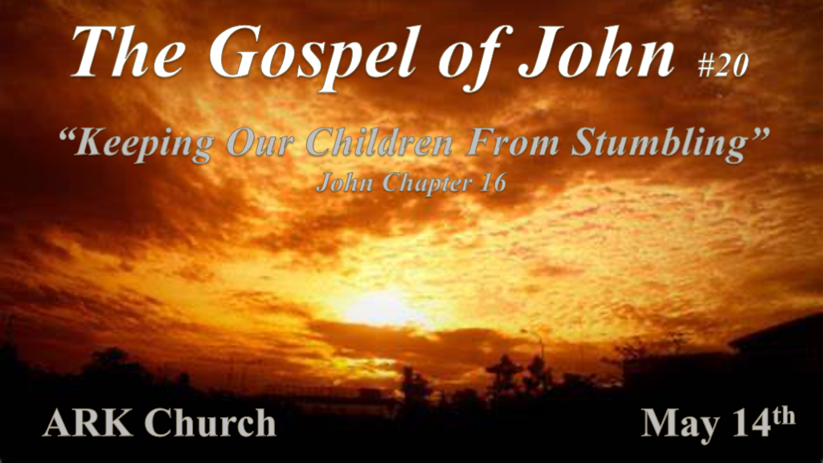
*Stumbling: John 16:1 "These things I have spoken to you, that you should not be made to stumble. 2 They will put you out of the synagogues; yes, the time is coming that whoever kills you will think that he offers God service. 3 And these things they will do to you because they have not known the Father nor Me. 4 But these things I have told you, that when the time comes, you may remember that I told you of them. "And these things I did not say to you at the beginning, because I was with you.

- What's the main thing that makes us stumble? The World!
*John 15:19 If you were of the world, the world would love its own. Yet because you are not of the world, but I chose you out of the world, therefore the world hates you.
Don't be caught by the trap, and stumbling is described as a trap that is set that makes you want to give up—trapped by others' words, actions, or accusations.

- Persecution will have great deception attached to it. The surprise is it's often within the religious community.
Remember Jesus' Words and the whole counsel of God's Word when these things come.

*The Holy Spirit the Gift to Humanity.

*John 16:5 "But now I go away to Him who sent Me, and none of you asks Me, 'Where are You going?' 6 But because I have said these things to you, sorrow has filled your heart. 7 Nevertheless I tell you the truth. It is to your advantage that I go away; for if I do not go away, the Helper will not come to you; but if I depart, I will send Him to you. 8 And when He has come, He will convict the world of sin, and of righteousness, and of judgment: 9 of sin, because they do not believe in Me; 10 of righteousness, because I go to My Father and you see Me no more; 11 of judgment, because the ruler of this world is judged.
12 "I still have many things to say to you, but you cannot bear them now. 13 However, when He, the Spirit of truth, has come, He will guide you into all truth; for He will not speak on His own authority, but whatever He hears He will speak; and He will tell you things to come. 14 He will glorify Me, for He will take of what is Mine and declare it to you. 15 All things that the Father has are Mine. Therefore I said that He will take of Mine and declare it to you.
16 "A little while, and you will not see Me; and again a little while, and you will see Me, because I go to the Father."
17 Then some of His disciples said among themselves, "What is this that He says to us, 'A little while, and you will not see Me; and again a little while, and you will see Me'; and, 'because I go to the Father'?" 18 They said therefore, "What is this that He says, 'A little while'? We do not know what He is saying."

- V:5-11 God with us and in us. The Holy Spirit is our gift and our Helper.
- V:7 The Advantage that Jesus spoke of comes in the Holy Spirit's omnipresence.
- V:8-10 The Holy Spirit lives inside us, and the work of the Spirit becomes our transformation.
The Spirit is convicting us and empowering us by giving us gifts and fruits.
The rejection of the Holy Spirit makes our world vulnerable to unrighteousness, sin, and judgment.

- V:12-15 The Holy Spirit and the work He does.
There isn't a heresy that the Holy Spirit and the Word of God don't anticipate.

Who is the author of the Bible? The Holy Spirit wrote the truth in the Bible.
The scripture that was going to be written by the apostles and Paul, as well as all the O.T., are under the umbrella of Truth of the Spirit.

- V:16-18 What to do when confused by the many voices of this world?
*Allow The Holy Spirit to comfort you.
*Accept The Holy Spirit's guidance.

*Grant The Holy Spirit's power to empower you.
*Permit The Holy Spirit to lead you into all truth.

*The Holy Spirit and His Spirit of Expectancy.

*John 16:19 Now Jesus knew that they desired to ask Him, and He said to them, "Are you inquiring among yourselves about what I said, 'A little while, and you will not see Me; and again a little while, and you will see Me'? 20 Most assuredly, I say to you that you will weep and lament, but the world will rejoice; and you will be sorrowful, but your sorrow will be turned into joy. 21 A woman, when she is in labor, has sorrow because her hour has come; but as soon as she has given birth to the child, she no longer remembers the anguish, for joy that a human being has been born into the world. 22 Therefore you now have sorrow; but I will see you again and your heart will rejoice, and your joy no one will take from you.
23 "And in that day you will ask Me nothing. Most assuredly, I say to you, whatever you ask the Father in My name He will give you. 24 Until now you have asked nothing in My name. Ask, and you will receive, that your joy may be full. 25 "These things I have spoken to you in figurative language; but the time is coming when I will no longer speak to you in figurative language, but I will tell you plainly about the Father.

- V:19-22 The figurative language of childbirth and our hope in Christ.
Labor pains represent short-term sorrow. The birth is the joy that takes away the pain.
The sorrow is directly connected to the joy. The process of sorrows in life bonds us to our joy of deliverance.

- V:22-25 Ask, and you will receive. Jesus desires that our joy may be complete.

*Your joy no one will take from you! So, don't give away your joy. Our expectations are the joy stealers.

*Tribulation and Overcoming the World.

*John 16:26 In that day you will ask in My name, and I do not say to you that I shall pray the Father for you; 27 for the Father Himself loves you, because you have loved Me, and have believed that I came forth from God. 28 I came forth from the Father and have come into the world. Again, I leave the world and go to the Father."
29 His disciples said to Him, "See, now You are speaking plainly, and using no figure of speech! 30 Now we are sure that You know all things, and have no need that anyone should question You. By this we believe that You came forth from God."
31 Jesus answered them, "Do you now believe? 32 Indeed the hour is coming, yes, has now come, that you will be scattered, each to his own, and will leave Me alone. And yet I am not alone, because the Father is with Me. 33 These things I have spoken to you, that in Me you may have peace. In the world you will have tribulation; but be of good cheer, I have overcome the world."

- V:26-28 Important message the Father loves you!
The most significant trouble a Christian has is the false belief that no one is in charge.
The Father's love is the most healing aspect every Christian needs.

- V:29-31 Do you now believe?
We should all believe that what Jesus says will happen will come to pass.

- V:32-33 The hour of good cheer is coming!
Trouble or Tribulation has always been here!
The hour of great tribulation is coming upon us.

The time of trouble should be the signal that our trial is coming to an end. Jesus is coming soon.

