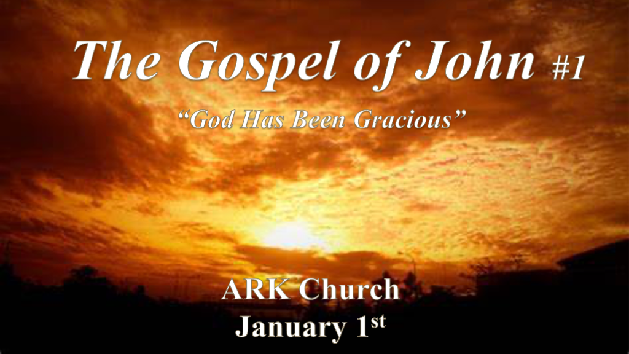

*The New Testament in the Old Testament concealed. While the Old Testament is in the New Testament revealed.~ Missler

*The four Gospels reveal Christ to our world.
Matthew: Jesus as the Messiah (Savior)
Mark: Jesus as the Servant of God (The Last Adam obedient to the Father)
Luke: Jesus as the Son of Man (Shows Jesus’ humanity)
John: Jesus as the Son of God (Divine, Fully God)

*God cannot be separated from His Word & its Purpose. (John 20:30-31)

*John 1:1 In the beginning was the Word, and the Word was with God, and the Word was God. 2 He was in the beginning with God. 3 All things were made through Him, and without Him nothing was made that was made. 4 In Him was life, and the life was the light of men. 5 And the light shines in the darkness, and the darkness did not comprehend it.

- V:1-3 The Word of God. It is God!
God Yahweh has been gracious. The good news or the Gospel of John’s name is a message in itself.

*Then Jonathan said to the young man who bore his armor, “Come, let us go over to the garrison of these uncircumcised; it may be that the Lord will work for us. For nothing restrains the Lord from saving by many or by few” (1 Samuel 14:6).

- V:4-5 Darkness will never comprehend the light. God’s light comprehends everything.
*Humanism is a system that attaches to humanity instead of God, this system is great darkness!
*God’s divine nature is what brings humanity to the light.

*John is the witness for the 1st generation. Who is the witness to the last generation?

*John 1:6 There was a man sent from God, whose name was John. 7 This man came for a witness, to bear witness of the Light, that all through him might believe. 8 He was not that Light, but was sent to bear witness of that Light. 9 That was the true Light which gives light to every man coming into the world.
10 He was in the world, and the world was made through Him, and the world did not know Him. 11 He came to His own, and His own did not receive Him. 12 But as many as received Him, to them He gave the right to become children of God, to those who believe in His name: 13 who were born, not of blood, nor of the will of the flesh, nor of the will of man, but of God.

- V:6-8 We are not the light. But it does live in us as a witness to our soul first and then as a testimony to the world.

- V:9 Parallel mission with a twist. The light is in the world and we testify that Jesus did come.

- V:10-13 Everything you should be able to tell someone about Jesus.
The world was made by Jesus, He gave us the right to become children of God. Fully human and fully God.
*The combination of grace and truth.

*John 1:14 And the Word became flesh and dwelt among us, and we beheld His glory, the glory as of the only begotten of the Father, full of grace and truth.
15 John bore witness of Him and cried out, saying, “This was He of whom I said, He who comes after me is preferred before me, for He was before me.’ ”
16 And of His fullness we have all received, and grace for grace. 17 For the law was given through Moses, but grace and truth came through Jesus Christ. 18 No one has seen God at any time. The only begotten Son, who is in the bosom of the Father, He has declared Him.

- V:14 Jesus is this combination. He will never give you grace without truth.

- V:15 Our warning is there is a day coming from Sword of Truth without grace. (Revelation 19:15)

- V:16-18 The Double portion of Grace.
Grace for grace is why we’ve received freely, so we are to give freely.

*Will Christians learn who they are in Christ?

*John 1:19 Now this is the testimony of John, when the Jews sent priests and Levites from Jerusalem to ask him, “Who are you?”
20 He confessed, and did not deny, but confessed, “I am not the Christ.”
21 And they asked him, “What then? Are you Elijah?” He said, “I am not.” “Are you the Prophet?” And he answered, “No.”
22 Then they said to him, “Who are you, that we may give an answer to those who sent us? What do you say about yourself?”
23 He said: “I am the voice of one crying in the wilderness: “Make straight the way of the LORD,” ’ as the prophet Isaiah said.”
24 Now those who were sent were from the Pharisees. 25 And they asked him, saying, “Why then do you baptize if you are not the Christ, nor Elijah, nor the Prophet?” 26 John answered them, saying, “I baptize with water, but there stands One among you whom you do not know. 27 It is He who, coming after me, is preferred before me, whose sandal strap I am not worthy to loose.”
28 These things were done in Bethabara beyond the Jordan, where John was baptizing.

- V:19-20 We are not Jesus to the world.
*We are not the world’s judge; we are not to point to law. We are to point to Jesus and His Word.

The hope is always in Jesus' ability to transform us and lead us to the light.

- V:21-23 We are the messengers of Jesus. Prepare your life for Jesus' return.
*Make a straight path to Jesus is our message in a crooked/zig-zag world that is ready for the Lawless One.

- V:24-25 John had answers for the religious leaders.
We are to have an answer for the religious people of this world.

- V:26-28 Stay humble if God chooses to use you in 2023 it comes with great responsibility.
God always sends His power when there is a job to do.

