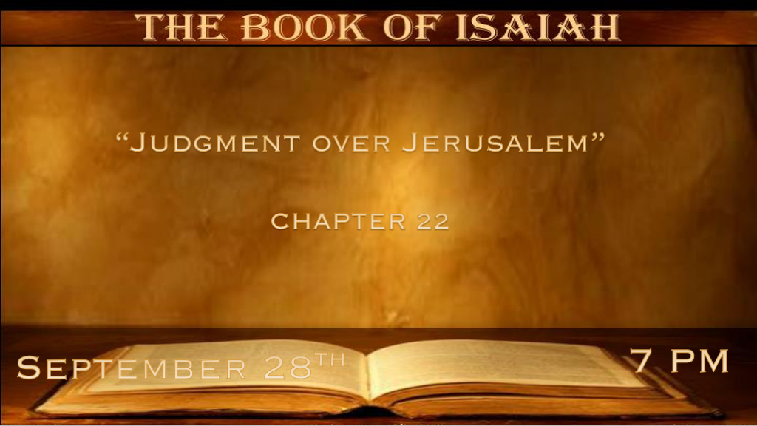

*When God Removes His Protection.
*Isaiah 22:1 The burden against the Valley of Vision. What ails you now, that you have all gone up to the housetops,
2 You who are full of noise, a tumultuous city, a joyous city? Your slain men are not slain with the sword, nor dead in battle.
3 All your rulers have fled together; They are captured by the archers. All who are found in you are bound together; They have fled from afar. 4 Therefore I said, “Look away from me, I will weep bitterly; Do not labor to comfort me because of the plundering of the daughter of my people.” 5 For it is a day of trouble and treading down and perplexity by the Lord GOD of hosts In the Valley of Vision—Breaking down the walls and of crying to the mountain. 6 Elam bore the quiver with chariots of men and horsemen, and Kir uncovered the shield. 7 It shall come to pass that your choicest valleys shall be full of chariots,
and the horsemen shall set themselves in array at the gate. 8 He removed the protection of Judah. You looked in that day to the armor of the House of the Forest; 9 You also saw the damage to the city of David, that it was great; and you gathered together the waters of the lower pool. 10 You numbered the houses of Jerusalem, and the houses you broke down to fortify the wall. 11 You also made a reservoir between the two walls for the water of the old pool. But you did not look to its Maker,
nor did you have respect for Him who fashioned it long ago. 12 And in that day the Lord GOD of hosts called for weeping and for mourning, for baldness and for girding with sackcloth. 13 But instead, joy and gladness, slaying oxen and killing sheep, eating meat and drinking wine: “Let us eat and drink, for tomorrow we die!” 14 Then it was revealed in my hearing by the LORD of hosts, “Surely for this iniquity there will be no atonement for you, even to your death,” says the Lord GOD of hosts.

- V:1-4 Jerusalem is a city under siege. Prophesied by Ezekiel 24:2 as part of the 70 years of captivity. Then Rome destroys the temple in 70 A.D. Matthew 24:2 and laid a siege against the city. Historians record 23 different types and times a siege took place.
Will there be another siege in its future?

- V:5-7 An army from the east coming against Jerusalem. This was fulfilled by Babylonian Empire. 606 B.C. 586 B.C.
V:5 Saying there will be perplexity by the Lord God of Host in Jerusalem this could be pointing to a future connotation and events that are happening today.

Today many see arrows as missiles, and chariots as tanks.

- V:8-11 King Hezekiah dug underground waterways. 2 Chronicles 32:4-23
V:8 But, God removed his protection.

They needed water supplies to help during a coming siege but, didn’t look to the Maker of the water.

If you are an end-time-prepper and you have underground storage, water, and ammo but, don’t look to your maker you won’t be any better off.

- V:12-14 In that day there is a call to weeping and mourning. Those who go on eating and drinking with the attitude for in the morning we shall die.
Shaving your head and sackcloth are signs of remorse and repentance. Instead, you are partying like nothing is about to happen.

I Corinthians 15:32 Paul borrows this term from Isaiah and says if there is no promise of the resurrection then we should eat, drink, and be merry for tomorrow we will die.

V:14 Tells me this is a quenching of the Holy Spirit attitude. The consequence is no hope for this generational sin. It’s the training of the way you should not go.

*Will you take a position of honor or disdain?

*Isaiah 22:15 Thus says the Lord GOD of hosts: “Go, proceed to this steward, to Shebna, who is over the house, and say: 16 ‘What have you here, and whom have you here, that you have hewn a sepulcher here, as he who hews himself a sepulcher on high, who carves a tomb for himself in a rock? 17 Indeed, the LORD will throw you away violently, O mighty man, and will surely seize you. 18 He will surely turn violently and toss you like a ball into a large country; there you shall die, and there your glorious chariots shall be the shame of your master’s house. 19 So I will drive you out of your office,
and from your position he will pull you down. 20 ‘Then it shall be in that day, that I will call My servant Eliakim the son of Hilkiah; 21 I will clothe him with your robe and strengthen him with your belt; I will commit your responsibility into his hand.
He shall be a father to the inhabitants of Jerusalem and to the house of Judah. 22 The key of the house of David I will lay on his shoulder; So he shall open, and no one shall shut; And he shall shut, and no one shall open. 23 I will fasten him as a peg (nail) in a secure place, and he will become a glorious throne to his father’s house.
24 ‘They will hang on him all the glory of his father’s house, the offspring, and the posterity, all vessels of small quantity, from the cups to all the pitchers. 25 In that day,’ says the LORD of hosts, ‘the peg (nail) that is fastened in the secure place will be removed and be cut down and fall, and the burden that was on it will be cut off; for the LORD has spoken. ”

- V:15-19 Putting yourself in a place of honor. Reveals a spirit of pride and haughtiness.
Was there an absence of leadership? Hezekiah is King and Shebna is a real person did take advantage of his position during the time of Hezekiah's illness?

- V:20-23 A righteous servant in the spirit of the Messiah. Fasten by a nail in a secure place.
*Revelation 3:7 “And to the angel of the church in Philadelphia write,
‘These things says He who is holy, He who is true, “He who has the key of David, He who opens and no one shuts and shuts and no one opens”: 8 “I know your works.

- He is a holy and true servant. Jesus came for the 1st time as a servant. He is coming soon as the bridegroom and king.
*Holy and true are not tendencies of Jesus they are his essence.
The righteous servants of the Church of Philadelphia.

*Rev. 3:10 Because you have kept My command to persevere, I also will keep you from the hour of trial which shall come upon the whole world, to test those who dwell on the earth.

- Jesus holds the key of David. The mystery of the Davidic covenant and Christ reigning from David’s throne.
This has been one of the more disputed subjects in orthodox Christianity. Jesus' reign on earth is scripturally confirmed in Isaiah 9:6-7 and Luke 1:32

- Jesus opened the door of salvation. Jesus opened access to heaven.

- Jesus shuts what no one can open. The shut door is still a great mystery to many, could it be pointing to the parable of 10 virgins in Matthew 25:10-13

- V:24-25 In that day... The nail that had been fastened and secured is removed.
My speculative thinking is this could be those that believed they are servants of God. Yet, they have removed the gospel of the cross and replaced it with a woke, social, and progressive gospel

The great falling away is the crucial key to the end times.
*2 Thess. 2:3 Let no one deceive you by any means; for that Day will not come unless the falling away comes first, and the man of sin is revealed, the son of perdition,

