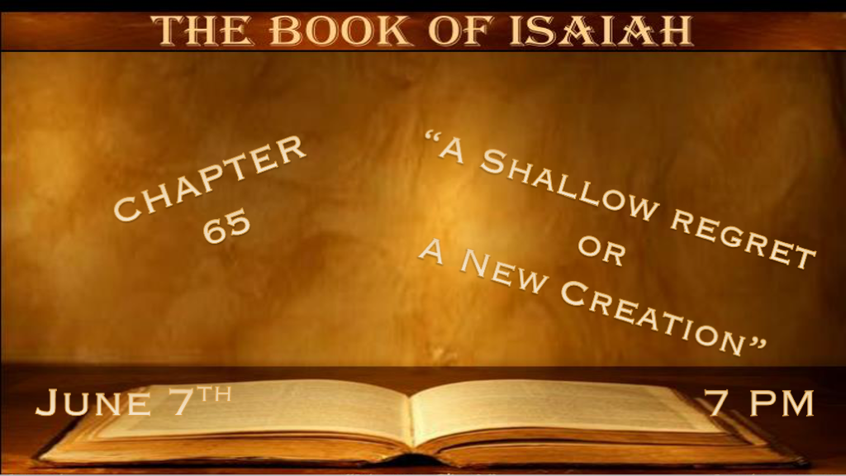

*While Israel remains shallow, Gentiles will seek God.

*Isaiah 65:1 “I was sought by those who did not ask for Me; I was found by those who did not seek Me. I said, ‘Here I am, here I am,’ To a nation that was not called by My name. 2 I have stretched out My hands all day long to a rebellious people, who walk in a way that is not good, according to their own thoughts; 3 A people who provoke Me to anger continually to My face; Who sacrifice in gardens, and burn incense on altars of brick; 4 Who sit among the graves, and spend the night in the tombs; Who eat swine’s flesh,
and the broth of abominable things is in their vessels; 5 Who say, ‘Keep to yourself, do not come near me, for I am holier than you!’
These are smoke in My nostrils, a fire that burns all the day.
6 “Behold, it is written before Me: I will not keep silence, but will repay—Even repay into their bosom—7 Your iniquities and the iniquities of your fathers together,” Says the LORD, “Who have burned incense on the mountains and blasphemed Me on the hills;
Therefore I will measure their former work into their bosom.”

V:1-2 What nation was not called by God’s name but had a relationship with God? Romans 10:20-21

- V:1 Two men seek covenant with God as a new nation is birthed.
John Winthrop, on the ship Arabella during his passage to New England in 1630, made a covenant with God. He was a Puritan.
William Bradford of the Mayflower. The Pilgrims fled from England to Holland in search of religious freedom. But in July of 1620, a community of Christian believers left Holland to plant a new church in America. Blown off course, they land in Plymouth. Their covenant was known as the Mayflower Compact. President John Quincy Adams praised the Mayflower Compact. In 1802 he said that this agreement was “the only instance in human history of that positive, original, social compact.”

- V:2-4 Israel and USA could be included in God’s account of a holy nation. Yet, they pretend to be religious.
They walk in the way that honors their own thoughts—in blatant opposition to God’s ways.
They were sitting among the graves. This phrase implies they honor the corrupted dead things in spiritual realms.

- V:5-7 Boastful and proud people. While this describes humanity, it has a twist to why they are this way.
I am holier than you.
This spirit/attitude moves God to action against this generation.
Judgment is God’s promise.

*Blessings to the true servant and Chastisement to the false.
*Isaiah 65:8 Thus says the LORD: “As the new wine is found in the cluster, and one says, ‘Do not destroy it, for a blessing is in it,’ So will I do for My servants’ sake, that I may not destroy them all. 9 I will bring forth descendants from Jacob, and from Judah an heir of My mountains; My elect shall inherit it, and My servants shall dwell there. 10 Sharon shall be a fold of flocks, and the Valley of Achor a place for herds to lie down, for My people who have sought Me. 11 “But you are those who forsake the LORD,
who forget My holy mountain, who prepare a table for Gad, and who furnish a drink offering for Meni. 12 Therefore I will number you for the sword, and you shall all bow down to the slaughter; Because, when I called, you did not answer; When I spoke, you did not hear, but did evil before My eyes, and chose that in which I do not delight.” 13 Therefore thus says the Lord GOD: “Behold, My servants shall eat, but you shall be hungry; Behold, My servants shall drink, but you shall be thirsty; Behold, My servants shall rejoice, but you shall be ashamed; 14 Behold, My servants shall sing for joy of heart, but you shall cry for sorrow of heart, and wail for grief of spirit. 15 You shall leave your name as a curse to My chosen; For the Lord GOD will slay you, and call His servants by another name; 16 So that he who blesses himself in the earth shall bless himself in the God of truth; And he who swears in the earth shall swear by the God of truth; Because the former troubles are forgotten, and because they are hidden from My eyes.

- V:8-10 In the midst of rebellion, God finds a few righteous that He blesses.
What an amazing God we serve. Even as God would have spared Sodom for ten righteous. He now shows His desire to encourage the remnant.
God’s followers seek Him and will inherit and dwell in His promises.

- V:11-12 The sin of offering to Gad and Meni, the false gods of…
Gad and Meni are the gods of Fortune and Destiny. Has our country focused on these two things more than anything else?
Those who forsake God are not numbered among His servants.

- V:13-16 The difference between provision and need, honor or shame, joy and sorrow, blessings or curses, are all tied to the God of Truth.
How important does the truth play in your life?

*The New Heaven and Earth. Plus, the state of the millennial earth.
Isaiah 65:17 “For behold, I create new heavens and a new earth; And the former shall not be remembered or come to mind.
18 But be glad and rejoice forever in what I create; For behold, I create Jerusalem as a rejoicing, and her people a joy. 19 I will rejoice in Jerusalem, and joy in My people; The voice of weeping shall no longer be heard in her, nor the voice of crying.
20 “No more shall an infant from there live but a few days, nor an old man who has not fulfilled his days; For the child shall die one hundred years old, but the sinner being one hundred years old shall be accursed. 21 They shall build houses and inhabit them; They shall plant vineyards and eat their fruit. 22 They shall not build and another inhabit; They shall not plant and another eat; For as the days of a tree, so shall be the days of My people, and My elect shall long enjoy the work of their hands.
23 They shall not labor in vain, nor bring forth children for trouble; For they shall be the descendants of the blessed of the LORD, and their offspring with them. 24 “It shall come to pass that before they call, I will answer; And while they are still
speaking, I will hear. 25 The wolf and the lamb shall feed together, the lion shall eat straw like the ox, and dust shall be the serpent’s food. They shall not hurt nor destroy in all My holy mountain,” Says the LORD.

- V:17-19 The New Heaven, Jerusalem and Earth take place after the thousand-year reign of Christ on earth.
The complete picture of righteousness. No more penalty, power, or presence of sin in the New Creation.
Sin is still possible in the millennial reign of Christ, yet it hides in the four corners until the devil is released from the lake of fire for a short period to see who he can deceive.

- V:20-21 The earth is redeemed from the curse but not death.
Death is not done, but longevity is the norm. If you die at 100, you are considered accursed/ill-fated.
Those that are alive will have homes, careers, and agriculture.

- V:22-25 The Garden of Eden order is restored to humanity and nature.

Work wasn’t a curse in the garden, and it won’t be in the millennial. The enjoyment of work is promised.
The millennial is the time for Israel’s descendants to be blessed by the Abraham covenant.
Nature will be at peace as a sign the lion/wolf and lamb will feed together.

