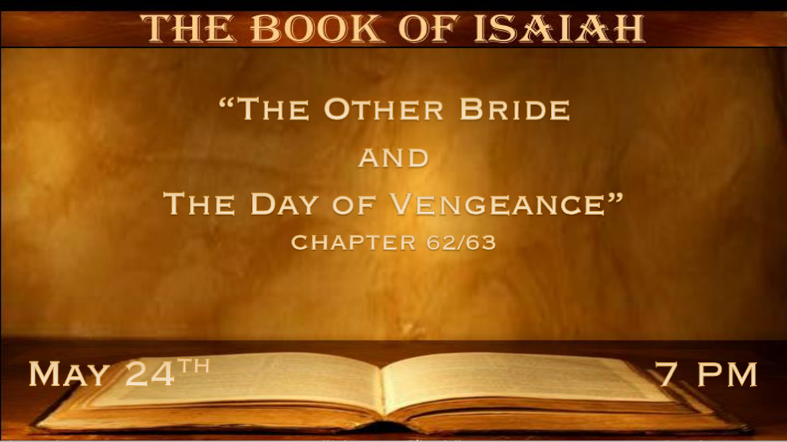
Prophetic Update: Why a pre-tribulation rapture?
Jesus words: Matt. 24:37-39 But as the days of Noah were, so also will the coming of the Son of Man be. 38 For as in the days before the flood, they were eating and drinking, marrying and giving in marriage, until the day that Noah entered the ark, 39 and did not know until the flood came and took them all away, so also will the coming of the Son of Man be.

*Jerusalem shall be called by a new name.

*Isaiah 62:1 For Zion’s sake I will not hold My peace, and for Jerusalem’s sake I will not rest, until her righteousness goes forth as brightness, and her salvation as a lamp that burns. 2 The Gentiles shall see your righteousness, and all kings your glory. You shall be called by a new name, which the mouth of the LORD will name. 3 You shall also be a crown of glory In the hand of the LORD, and a royal diadem in the hand of your God. 4 You shall no longer be termed Forsaken, nor shall your land any more be termed Desolate; But you shall be called Hephzibah, and your land Beulah; For the LORD delights in you, and your land shall be married. 5 For as a young man marries a virgin, so shall your sons marry you; And as the bridegroom rejoices over the bride, So shall your God rejoice over you. 6 I have set watchmen on your walls, O Jerusalem; They shall never hold their peace day or night. You who make mention of the LORD, do not keep silent, 7and give Him no rest till He establishes and till He makes Jerusalem a praise in the earth. 8 The LORD has sworn by His right hand and by the arm of His strength: “Surely I will no longer give your grain as food for your enemies; And the sons of the foreigner shall not drink your new wine, for which you have labored. 9 But those who have gathered it shall eat it, and praise the LORD; Those who have brought it together shall drink it in My holy courts.” 10 Go through, go through the gates! Prepare the way for the people; Build up, build up the highway! Take out the stones, lift up a banner for the peoples! 11 Indeed the LORD has proclaimed to the end of the world: “Say to the daughter of Zion, ‘surely your salvation is coming; Behold, His reward is with Him, and His work before Him.’ ” 12 And they shall call them The Holy People, The Redeemed of the LORD; And you shall be called Sought Out, a City Not Forsaken.

V:1-12 The promise of Jerusalem’s righteousness shining bright.

- V:1 God will not rest until Jerusalem is redeemed.
What is the relationship God has with Jerusalem?

- V:2-4 The Gentiles will witness this transformation of Jerusalem. A new name is given to Jerusalem.
V:4 God takes names very seriously. They hold meaning and value. God will assign names as He chooses to change names. Abraham, Sarah, in the O.T. and Peter and Paul in the N.T.

The tradition is the bride gets a name change. God did this before as He has named all the stars.
Revelation 2:17 & 3:12 New names are a part of the New Creation.

- V:4-5 Hephzibah means, I delight in her. Beulah means married.
God’s faithfulness to Jerusalem and transforming it brings Him glory. Like the bride’s purity/beauty/commitment brings glory to the groom.
God is the groom the people are the bride.

- V:6-9 God is the protector of Jerusalem. He also has watchmen over it.
What are the watchmen doing? They are praying over Jerusalem and the nation of Israel.

- V:10-12 The promise of Jesus coming to Jerusalem.
A city is not forsaken. This promise is coming to fulfillment. God’s people will not be forsaken.

*The Bloodstained Warrior is coming to Edom and Bozrah.

*Isaiah 63:1 Who is this who comes from Edom, with dyed garments from Bozrah, this One who is glorious in His apparel, traveling in the greatness of His strength?—“I who speak in righteousness, mighty to save.” 2 Why is Your apparel red, and Your garments like one who treads in the winepress? 3 “I have trodden the winepress alone, and from the peoples no one was with Me. For I have trodden them in My anger, and trampled them in My fury; Their blood is sprinkled upon My garments, and I have stained all My robes. 4 For the day of vengeance is in My heart, and the year of My redeemed has come. 5 I looked, but there was no one to help, and I wondered that there was no one to uphold;
Therefore My own arm brought salvation for Me; And My own fury, it sustained Me. 6 I have trodden down the peoples in My anger, made them drunk in My fury, and brought down their strength to the earth.”

- V:1-3 Jesus second coming, why is He coming to Edom?
Edom took advantage of Israel during the Babylonian captivity, and Bozrah is the grape capital (blood), the ancient capital of Edom.

*The Day of Vengeance: Hosea 5:15 I will return again to My place till they acknowledge their offense.
Then they will seek My face; In their affliction, they will earnestly seek Me.”

- V:4-6 The Day of Vengeance is in Jesus' heart, really?
Jesus doesn’t love vengeance. On the contrary, it’s in His heart because He loves to bring vindication on behalf of those who have been hurt.

*God’s Mercy and Lovingkindness.

Isaiah 63:7 I will mention the lovingkindnesses of the LORD and the praises of the LORD, according to all that the LORD has bestowed on us, and the great goodness toward the house of Israel, which He has bestowed on them according to His mercies, according to the multitude of His lovingkindnesses. 8 For He said, “Surely they are My people, children who will not lie.” So He became their Savior. 9 In all their affliction He was afflicted, and the Angel of His Presence saved them; In His love and in His pity He redeemed them; And He bore them and carried them all the days of old. 10 But they rebelled and grieved His Holy Spirit; So He turned Himself against them as an enemy, and He fought against them. 11 Then he remembered the days of old, Moses and his people, saying: “Where is He who brought them up out of the sea with the shepherd of His flock? Where is He who put His Holy Spirit within them, 12 Who led them by the right hand of Moses, with His glorious arm, dividing the water before them to make for Himself an everlasting name, 13 Who led them through the deep, as a horse in the wilderness, That they might not stumble?” 14 As a beast goes down into the valley, and the Spirit of the LORD causes him to rest, so You lead Your people, to make Yourself a glorious name.
- V:7-8 Lovingkindness is the word associated with God’s faithfulness to His covenant.
Jesus, our Savior, can never be removed from the covenant language.

- V:9-10 This could be a reference to Exodus 3:2, And the Angel of the LORD appeared to him in a flame of fire from the midst of a bush. So he looked, and behold, the bush was burning with fire, but the bush was not consumed.
Malachi 3:1, there is a promise the messenger (angel) will come to the temple.

- V:11-14 The past rebellion against God’s Spirit with implications this is futuristic too.
Sadly, they had forgotten all that God had done for them. Unfortunately, this is true for this generation also.

*Isaiah 63:15 Look down from heaven, and see from Your habitation, holy and glorious. Where are Your zeal and Your strength, the yearning of Your heart and Your mercies toward me? Are they restrained? 16 Doubtless You are our Father, though Abraham was ignorant of us, and Israel does not acknowledge us. You, O LORD, are our Father; Our Redeemer from Everlasting is Your name. 17 O LORD, why have You made us stray from Your ways, and hardened our heart from Your fear? Return for Your servants’ sake, the tribes of Your inheritance. 18 Your holy people have possessed it but a little while; Our adversaries have trodden down Your sanctuary. 19 We have become like those of old, over whom You never ruled, those who were never called by Your name.

- V:15-16 Missing is their zeal, strength, and connection to God’s past faithfulness.
The spirit of doubt will play a decisive role in the last days.

- V:17-19 Hard hearts is another sign that this age is upon us.

What will keep our hearts tender toward God?

