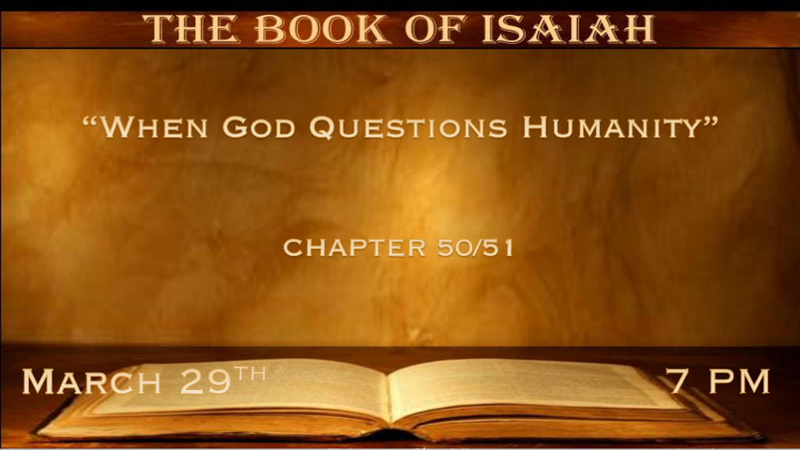

*The Messiah in Isaiah is the Shadow of the Gospel of Matthew.

*Isaiah 50:1 Thus says the LORD: “Where is the certificate of your mother’s divorce, Whom I have put away? Or which of My creditors is it to whom I have sold you? For your iniquities you have sold yourselves, and for your transgressions your mother has been put away.
2 Why, when I came, was there no man? Why, when I called, was there none to answer? Is My hand shortened at all that it cannot redeem? Or have I no power to deliver? Indeed with My rebuke I dry up the sea, I make the rivers a wilderness; Their fish stink because there is no water, and die of thirst. 3 I clothe the heavens with blackness, and I make sackcloth their covering.” 4 “The Lord GOD has given Me The tongue of the learned, that I should know how to speak A word in season to him who is weary. He awakens Me morning by morning, He awakens My ear to hear as the learned. 5 The Lord GOD has opened My ear; And I was not rebellious, nor did I turn away.
6 I gave My back to those who struck Me, and My cheeks to those who plucked out the beard; I did not hide My face from shame and spitting. 7 “For the Lord GOD will help Me; Therefore I will not be disgraced; Therefore I have set My face like a flint, and I know that I will not be ashamed. 8 He is near who justifies Me; Who will contend with Me? Let us stand together. Who is My adversary? Let him come near Me. 9 Surely the Lord GOD will help Me; Who is he who will condemn Me? Indeed they will all grow old like a garment; The moth will eat them up. 10 “Who among you fears the LORD? Who obeys the voice of His Servant? Who walks in darkness And has no light? Let him trust in the name of the LORD And rely upon his God. 11 Look, all you who kindle a fire, who encircle yourselves with sparks:
Walk in the light of your fire and in the sparks you have kindled—This you shall have from My hand: You shall lie down in torment.

- V:1-3 The Holy Spirit in Isaiah does what Jesus in the Gospels did by asking a question to answer a question.
Israel complains to God they feel divorced from Him. His answer is to which creditor has the bill of sale or the decree of divorce?

God hasn’t divorced Israel they are experiencing the consequences of transgressions and their iniquities.

We too need to answer some of these questions. Is God’s hand shortened, and is His power diminished today?

- V:4-7 Prophesies of Jesus as Messiah. The Gospel of Mark fulfills these verses with the message of a Servant Messiah. Exodus 21:5-6 A servant that has an ear to hear.
V:4-5 Prophesied Jesus would give all the credit to the Father for what He knows and how He speaks as a learned Messiah.

V:6-7 Prophecy They will strike Jesus pull out His beard and spit on Him. What most don’t catch is Jesus voluntarily gave His back to be whipped and His face to be struck.

- V:8-11 Two key N.T. questions. Who fears the Lord? Who walks in darkness and has no light?
These are echoes from the future Gospels of Luke and John.

*Promises of the Past Lead to Blessings in the Future. Plus Warnings

*Isaiah 51:1 “Listen to Me, you who follow after righteousness, you who seek the LORD: Look to the rock from which you were hewn,
and to the hole of the pit from which you were dug. 2 Look to Abraham your father, and to Sarah who bore you; For I called him alone,
and blessed him and increased him.” 3 For the LORD will comfort Zion, He will comfort all her waste places; He will make her wilderness like Eden, and her desert like the garden of the LORD; Joy and gladness will be found in it, thanksgiving and the voice of melody.
4 “Listen to Me, My people; And give ear to Me, O My nation: For law will proceed from Me, and I will make My justice rest as a light of the peoples. 5 My righteousness is near, My salvation has gone forth, and My arms will judge the peoples; The coastlands will wait upon Me,
and on My arm they will trust. 6 Lift up your eyes to the heavens, and look on the earth beneath. For the heavens will vanish away like smoke, the earth will grow old like a garment, and those who dwell in it will die in like manner; But My salvation will be forever, and My righteousness will not be abolished. 7 “Listen to Me, you who know righteousness, you people in whose heart is My law: Do not fear the reproach of men, nor be afraid of their insults. 8 For the moth will eat them up like a garment, and the worm will eat them like wool; But My righteousness will be forever, and My salvation from generation to generation.”

- V:1-4 The Warning is “listen to God” it’s given to the righteous to remember where to look for help.
We are to Look to the foundation (rock) of the O.T. Abraham believed in God and to see Jesus through it. He is the that sets Rahab to marry and give birth to the Kinsman Redeemer Boaz.

How many Churches have rendered the O.T. into an allegory? How many have stopped preaching the prophetic truth tucked within it?

V:4 The promise is there is light and it’s coming forth from the O.T.

- V:5-8 Prophecy is Jesus righteousness is near! The coastlands (America?) and the spirit of fear.
V:5 The coastlands will be an arm of God! Is this the USA?
V:7-8 The reproach/criticism of men (Spirit of Fear) Will be eaten up like moths attacking clothes.

Continuation of promises & warnings
9 Awake, awake, put on strength, O arm of the LORD! Awake as in the ancient days, in the generations of old. Are You not the arm that cut Rahab apart, and wounded the serpent? 10 Are You not the One who dried up the sea, the waters of the great deep; That made the depths of the sea a road for the redeemed to cross over? 11 So the ransomed of the LORD shall return, and come to Zion with singing, with everlasting joy on their heads. They shall obtain joy and gladness; Sorrow and sighing shall flee away. 12 “I, even I, am He who comforts you. Who are you that you should be afraid of a man who will die, and of the son of a man who will be made like grass?
13 And you forget the LORD your Maker, Who stretched out the heavens and laid the foundations of the earth; You have feared continually every day because of the fury of the oppressor, when he has prepared to destroy. And where is the fury of the oppressor? 14 The captive exile hastens, that he may be loosed, that he should not die in the pit, and that his bread should not fail. 15 But I am the LORD your God, Who divided the sea whose waves roared—The LORD of hosts is His name. 16 And I have put My words in your mouth; I have covered you with the shadow of My hand, that I may plant the heavens, Lay the foundations of the earth, and say to Zion, ‘You are My people.’ ”

- V:9-15 The Church is asleep, Awake is said three times to the arm of the Lord.
V:11-12 Once again fear and sorrow has overtaken, (Yes this does apply also to Israel/Zion in the future.) but before then it will be the arm of the Lord, the people of the coastlands who are overtaken with fear and sorrow.

The promise is the covering from the shadow of Jesus' hand.

*Awake, Put on the Strength of the Lord. You’ll need it!

*Isaiah 51:17 Awake, awake! Stand up, O Jerusalem, you who have drunk at the hand of the LORD The cup of His fury; You have drunk the dregs of the cup of trembling and drained it out. 18 There is no one to guide her among all the sons she has brought forth; Nor is there any who takes her by the hand among all the sons she has brought up. 19 These two things have come to you; Who will be sorry for you?—Desolation and destruction, famine and sword—By whom will I comfort you? 20 Your sons have fainted, they lie at the head of all the streets, like an antelope in a net; They are full of the fury of the LORD, the rebuke of your God. 21 Therefore please hear this, you afflicted, and drunk but not with wine. 22 Thus says your Lord, The LORD and your God, Who pleads the cause of His people: “See, I have taken out of your hand the cup of trembling, the dregs of the cup of My fury; You shall no longer drink it. 23
But I will put it into the hand of those who afflict you, Who have said to you, ‘Lie down, that we may walk over you.’ And you have laid your body like the ground, and as the street, for those who walk over.”

- V:17-20 Two more warnings to Awake messages and to also Stand up, but this is for Jerusalem.
V:17 The leadership of Jerusalem. This more than anything could be applied to our day and what’s happening in Jerusalem right this week of March 2023.

- The cup of fury: The cup of God’s wrath is full or the blood cup is full in some scriptures.
- The dregs of the cup: This is the bottom of the cup with all crude that sunk to the bottom. Three things are at the bottom of this cup destruction, famine, and the sword.

The sons of Israel are in full rebuke at this point in time.

- V:21-23 Deliverance from these cups comes from Jesus.
The timing of the deliverance is the end of the tribulation.

