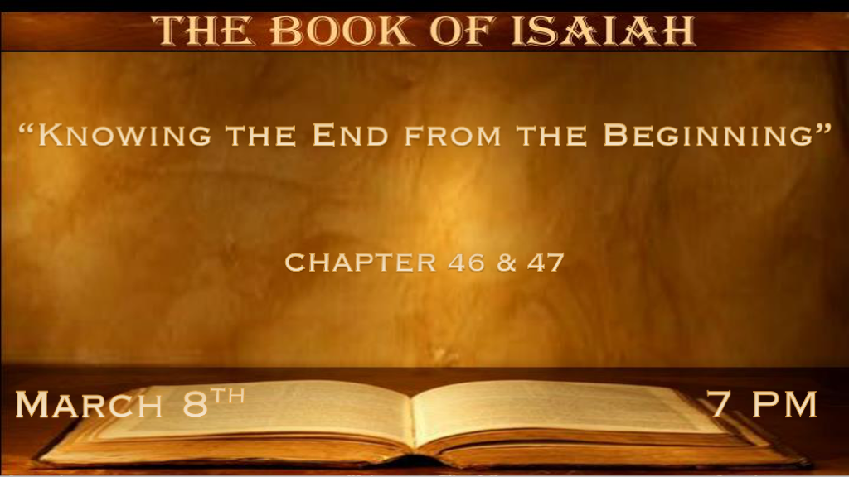

*What Do Transgressors Need to Remember? Matthew 24:9-14

*Isaiah 46:1 Bel bows down, Nebo stoops; Their idols were on the beasts and on the cattle. Your carriages were heavily loaded,
a burden to the weary beast. 2 They stoop, they bow down together; They could not deliver the burden, but have themselves gone into captivity. 3 “Listen to Me, O house of Jacob, and all the remnant of the house of Israel, who have been upheld by Me from birth, who have been carried from the womb: 4 Even to your old age, I am He, and even to gray hairs I will carry you! I have made, and I will bear; Even I will carry and will deliver you. 5 “To whom will you liken Me, and make Me equal and compare Me, that we should be alike? 6 They lavish gold out of the bag, and weigh silver on the scales; They hire a goldsmith, and he makes it a god; They prostrate themselves, yes, they worship. 7 They bear it on the shoulder, they carry it and set it in its place, and it stands; From its place it shall not move. Though one cries out to it, yet it cannot answer nor save him out of his trouble. 8 “Remember this, and show yourselves men; Recall to mind, O you transgressors. 9 Remember the former things of old, For I am God, and there is no other; I am God, and there is none like Me, 10 Declaring the end from the beginning, and from ancient times things that are not yet done, saying, My counsel shall stand, and I will do all My pleasure,’ 11 Calling a bird of prey from the east, the man who executes My counsel, from a far country. Indeed I have spoken it; I will also bring it to pass. I have purposed it; I will also do it. 12 “Listen to Me, you stubborn-hearted, who are far from righteousness: 13 I bring My righteousness near, it shall not be far off; My salvation shall not linger. And I will place salvation in Zion, for Israel My glory.

- V:1-2 Don’t carry your false god into a life of captivity.
We are free to choose but our choices have consequences. The god of money, sex, food, pleasure, or anything that you value higher than God. Takes you Captive by your own desires.

- V:3-7 Stop going between a false god and the true God remember only one can save you.
A double-minded person is unstable in all they do.

- V:8-9 Remember sin leads unto death and transgressors know what they are doing.
The former lesson of God’s judgment should never be forgotten. Why? He is the same God today.

Modern man’s idols could be considered more insulting. Nothingness, randomness, and humanism are the worship of ourselves or our intellect.

- V:10-13 The All-Knowing God and His counsel will stand. How can He be so sure?
He lives outside of time.

Because there isn’t anything that He can’t understand or know that is coming.

Living in eternity is more than a home-field advantage. It’s knowing every alternative you could choose.
Our minds cannot comprehend this knowledge. God lays out the genealogy of Jesus thousands of years before His birth. When you live outside of time itself you can impose on it at your pleasure.

Think this properly through God grants free will, choices, and consequences.
The God haters say they don’t agree with His wisdom and how it all works. This is the clay arguing with the Potter. (There is going to be an END because God says so!)

*The Vision of the Future and its Full of Pride.

*Isaiah 47:1 “Come down and sit in the dust, O virgin daughter of Babylon; Sit on the ground without a throne, O daughter of the Chaldeans! For you shall no more be called tender and delicate. 2 Take the millstones and grind meal. Remove your veil, take off the skirt, uncover the thigh, pass through the rivers. 3 Your nakedness shall be uncovered, yes, your shame will be seen; I will take vengeance, and I will not arbitrate with a man.” 4 As for our Redeemer, the LORD of hosts is His name, The Holy One of Israel. 5 “Sit in silence, and go into darkness, O daughter of the Chaldeans; For you shall no longer be called The Lady of Kingdoms. 6 I was angry with My people; I have profaned My inheritance, and given them into your hand. You showed them no mercy; On the elderly you laid your yoke very heavily. 7 And you said, ‘I shall be a lady forever,’ So that you did not take these things to heart, nor remember the latter end of them. 8 “Therefore hear this now, you who are given to pleasures, who dwell securely, who say in your heart, ‘I am, and there is no one else besides me; I shall not sit as a widow, nor shall I know the loss of children’;

- V:1-3 Babylon won’t be an empire that takes Israel into captivity for one hundred years. What futuristic time are we looking at?

Rev. 17 & 18 The Harlot She sits on the seven hills which are seven Kings (Kingdoms) five have fallen 1. Egypt, 2. Assyria, 3. Babylon, 4. Medes/Persian, 5. Greece and one is Rome (6) and the other has not yet come (7?.) And when he comes, he must continue a short time. The beast that was, and is not, is himself also the eighth, and is of the seven, and is going to perdition.

God declares He will not intercede on behalf of a man.

- V:4-8 Is this a timeline? Do Acts 17:11 and you decide.
- God’s abandonment or 1st stage of wrath they will sit in silence. V:4-5
V:4 The Word Redeemer is the Kinsman-redeemer.

- The spirit of the Harlot is stealing the inheritance of God’s people. V:6-7
V:6 The evil spirit that is unleashed is especially harsh with the elderly. (Covid was a heavy yoke on the elderly)

- V:8 Strange verse about the role of women.
Women will be known for their pleasure and who dwell securely. Do modern women who are career oriented have this attitude? I won’t be without a man and I can have a career and children. The empowerment of women is the identity of this age.

*Multitudes Under the Counsel of Sorcery

*Isaiah 47: 9 But these two things shall come to you in a moment, in one day: The loss of children, and widowhood. They shall come upon you in their fullness because of the multitude of your sorceries, for the great abundance of your enchantments.
10 “For you have trusted in your wickedness; You have said, ‘No one sees me’; Your wisdom and your knowledge have warped you; And you have said in your heart,
‘I am, and there is no one else besides me.’ 11 Therefore evil shall come upon you; You shall not know from where it arises. And trouble shall fall upon you; You will not be able to put it off. And desolation shall come upon you suddenly, which you shall not know. 12 “Stand now with your enchantments and the multitude of your sorceries, in which you have labored from your youth—Perhaps you will be able to profit, perhaps you will prevail. 13 You are wearied in the multitude of your counsels; Let now the astrologers, the stargazers, and the monthly prognosticators stand up and save you from what shall come upon you. 14 Behold, they shall be as stubble, the fire shall burn them; They shall not deliver themselves from the power of the flame; It shall not be a coal to be warmed by, nor a fire to sit before!
15 Thus shall they be to you with whom you have labored, your merchants from your youth; They shall wander each one to his quarter.
No one shall save you.

- V:9-10 The abundance of your enchantments and sorceries this is a people led by the demonic.
Your wisdom and knowledge have warped you and your heart speaks lies to you.

V:1 Gave us a clue that women would no longer be called tender and delicate.

- V:11-15 A society totally surrendered to the other gods.
The list of evil includes sorceries, enchantments, astrologers, stargazers, and monthly prognosticators (Climate change/false news)

The power of flame they won’t be delivered from it.

This generation should not underestimate God’s judgment.

