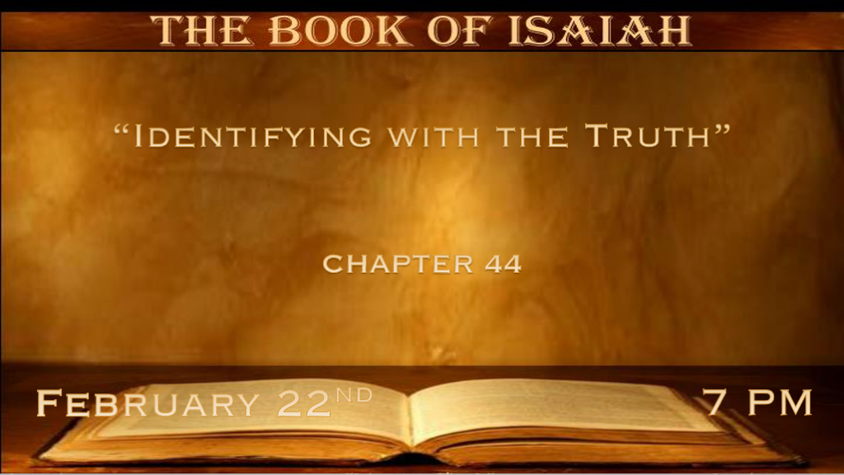

*God’s cleansing power and His Spirit poured gives us the Spirit of Truth.

*Isaiah 44:1 “Yet hear now, O Jacob My servant, and Israel whom I have chosen. 2 Thus says the LORD who made you and formed you from the womb, who will help you: ‘Fear not, O Jacob My servant; and you, Jeshurun, whom I have chosen. 3 For I will pour water on him who is thirsty, and floods on the dry ground; I will pour My Spirit on your descendants, and My blessing on your offspring; 4 They will spring up among the grass like willows by the watercourses.’ 5 One will say, ‘I am the LORD’s’; Another will call himself by the name of Jacob; Another will write with his hand, ‘The LORD’s,’ and name himself by the name of Israel.
6 “Thus says the LORD, the King of Israel, and his Redeemer, the LORD of hosts: I am the First and I am the Last; Besides Me there is no God. 7 And who can proclaim as I do? Then let him declare it and set it in order for Me, since I appointed the ancient people. And the things that are coming and shall come, let them show these to them. 8 Do not fear, nor be afraid; Have I not told you from that time, and declared it? You are My witnesses. Is there a God besides Me? Indeed there is no other Rock; I know not one.’ ”

- V:1-4 The God who has chosen you... Deut. 32:15 & 33:5 & 26
V:2 Call Israel Jeshurun the upright one. Deut. 33:26 Who rides on the clouds of the sky?
V:3 To cleanse us and wash us from our sins.
V:3 To pour His Spirit on us and our offspring.

- The God who made you in the womb. Identify the truth about a baby in the womb he/she is more than a human being or our children they are creations/gifts from God.
- He chose us before we were worthy.
- His choice was to reveal His glory through the transformation of humanity through His Spirit.
- The God who knows the outcome.

- V:5-7 The Lord alone is God who is outside of time.
God appointed the things that are to come even the rapture. Acts 1:7

*The deception from our own hands & Identifying with it.

*Isaiah 44:9 Those who make an image, all of them are useless, and their precious things shall not profit; They are their own witnesses;
They neither see nor know, that they may be ashamed. 10 Who would form a god or mold an image that profits him nothing? 11 Surely all his companions would be ashamed; And the workmen, they are mere men. Let them all be gathered together, let them stand up; Yet they shall fear, they shall be ashamed together. 12 The blacksmith with the tongs works one in the coals, fashions it with hammers, and works it with the strength of his arms. Even so, he is hungry, and his strength fails; He drinks no water and is faint. 13 The craftsman stretches out his rule, he marks one out with chalk; he fashions it with a plane, he marks it out with the compass, and makes it like the figure of a man, according to the beauty of a man, that it may remain in the house. 14 He cuts down cedars for himself, and takes the cypress and the oak; He secures it for himself among the trees of the forest. He plants a pine, and the rain nourishes it. 15 Then it shall be for a man to burn, for he will take some of it and warm himself; Yes, he kindles it and bakes bread; Indeed he makes a god and worships it; He makes it a carved image, and falls down to it. 16 He burns half of it in the fire; With this half he eats meat; He roasts a roast, and is satisfied. He even warms himself and says, “Ah! I am warm, I have seen the fire.” 17 And the rest of it he makes into a god, his carved image. He falls down before it and worships it, prays to it, and says, “Deliver me, for you are my god!” 18 They do not know nor understand; For He has shut their eyes, so that they cannot see, and their hearts, so that they cannot understand. 19 And no one considers in his heart, nor is there knowledge nor understanding to say, “I have burned half of it in the fire, yes, I have also baked bread on its coals; I have roasted meat and eaten it; And shall I make the rest of it an abomination? Shall I fall down before a block of wood?” 20 He feeds on ashes; A deceived heart has turned him aside; And he cannot deliver his soul, nor say, “Is there not a lie in my right hand?”

- V:9-11 The rejection of God is the beginning of an acceptance of false gods.
I am my own man or woman. This simply means you are a false god unto yourself.

Our arrogance gains us nothing. While some admire the boldness of the defiant need of God. Others understand the depths of this kind of foolish thinking.

- V:12-16 The rejection of truth because of own accomplishments.
How much more is this generation enamored with their intellect?

Artificial intelligence will never replace the knowledge of the Lord of Host but is being worshipped.

- V:17-19 God gives humanity over to their darkness. (Romans 1:18-32)
The suppression of truth leads to the replacement of God and false gods take over.

- V:20 Is this a hint to how great the identification with falsehood & how it will happen?
Zechariah 11:17 “Woe to the worthless shepherd, who leaves the flock! A sword shall be against his arm
and against his right eye; His arm shall completely wither, and his right eye shall be totally blinded.”

Revelation 13 is the identity of the Anti-Christ who demands the world to have his identifying marks.

*The Spirit of Truth says Remember.

*Isaiah 44:21 “Remember these, O Jacob, and Israel, for you are My servant; I have formed you, you are My servant; O Israel, you will not be forgotten by Me! 22 I have blotted out, like a thick cloud, your transgressions, and like a cloud, your sins. Return to Me, for I have redeemed you.” 23 Sing, O heavens, for the LORD has done it! Shout, you lower parts of the earth; Break forth into singing, you mountains, O forest, and every tree in it! For the LORD has redeemed Jacob, and glorified Himself in Israel. Judah Will Be Restored
24 Thus says the LORD, your Redeemer, and He who formed you from the womb: “I am the LORD, who makes all things, Who stretches out the heavens all alone, Who spreads abroad the earth by Myself; 25 Who frustrates the signs of the babblers, and drives diviners mad;
Who turns wise men backward, and makes their knowledge foolishness; 26 Who confirms the word of His servant, and performs the counsel of His messengers; Who says to Jerusalem, ‘You shall be inhabited,’ To the cities of Judah, ‘You shall be built,’ and I will raise up her waste places; 27 Who says to the deep, ‘Be dry! And I will dry up your rivers’; 28 Who says of Cyrus, ‘He is My shepherd, and he shall perform all My pleasure, Saying to Jerusalem, “You shall be built,” And to the temple, “Your foundation shall be laid.” ’

- V:21-22 Remembering the work God has done.
He formed you. (Creation power)

He has blotted out our transgression the willful disobedience. (Cleansing power)

He has bought us out of our sins. The redemption cost was paid in full.

- V:23-24 Praising God for His redemption from deception (Jacob) and giving us deliverance from our foolishness.
The connection with our lives being created in the womb becomes the theme. We must identify with the truth of the child in the womb. (This scripture was written for a time such as this.)

- V:25 God deals with the falsehoods personally.
Jesus will personally deal with the Anti-Christ.

- V:26-28 The God who speaks and confirms what He has said in advance.
What has God spoken about Jerusalem? It’s the eternal city and will be a part of the new creation.

What has God prophesied about the rivers? The Euphrates will dry up isn’t this happening now?

What did God prophesy about Cyrus? We see more of this prophecy next week in Chapter 45

