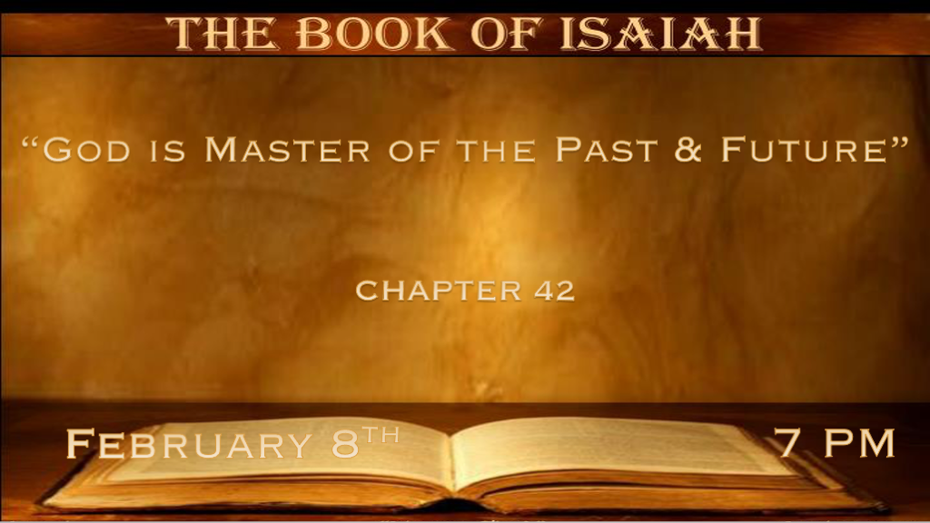

*The Servant is Jesus and he is The Lord.

*Isaiah 42:1 “Behold! My Servant whom I uphold, My Elect One in whom My soul delights! I have put My Spirit upon Him; He will bring forth justice to the Gentiles. 2 He will not cry out, nor raise His voice, nor cause His voice to be heard in the street. 3 A bruised reed He will not break, and smoking flax He will not quench; He will bring forth justice for truth. 4 He will not fail nor be discouraged, till He has established justice in the earth; And the coastlands shall wait for His law.” 5 Thus says God the LORD, who created the heavens and stretched them out, who spread forth the earth and that which comes from it, who gives breath to the people on it, and spirit to those who walk on it: 6 “I, the LORD, have called You in righteousness, and will hold Your hand; I will keep you and give you as a covenant to the people, as a light to the Gentiles, 7 to open blind eyes, to bring out prisoners from the prison, those who sit in darkness from the prison house. 8 I am the LORD, that is My name; and My glory I will not give to another, nor My praise to carved images. 9 Behold, the former things have come to pass, and new things I declare; Before they spring forth I tell you of them.”

- V:1-4 The power of God’s prophecies is revealed to this generation. (Quoted in Matt. 12:17-21)
- The reason: The Jew rejected these words and Jesus in Matt 12. Jesus started a fire that will not be quenched. (What did Pharisees say about Jesus in Matt. 12?)
- The insight: Our generation are the people of the coastlands, Gentiles that received His law and that law is Grace. The Grace of God keeps Jesus from ever being discouraged.

- V:5-7 The credentials of the one who is Master over the promise.
- V:5 He is the Creator and the sustainer of life. (Our DNA is a digital code this generation discovered it)
- V:6 He is the covenant and the light to the Gentiles. Breath & Spirit to those who walk in truth.
- V:7 Healer and deliverer. Jesus set the prisoners free.
These are spiritual prisons as well as those who sit in darkness.

- V:8-9 Being Master over the future and the past and God declares new things.
Before they spring forth I tell you of them. God is the revealer of the future. He writes History before it happens!
*God’s source of knowledge is outside of time.~ Missler

*The Day of God’s Restraint is Coming to an End.
*Isaiah 42:10 Sing to the LORD a new song, and His praise from the ends of the earth, you who go down to the sea, and all that is in it,
you coastlands and you inhabitants of them! 11 Let the wilderness and its cities lift up their voice, the villages that Kedar inhabits. Let the inhabitants of Sela sing, let them shout from the top of the mountains. 12 Let them give glory to the LORD, and declare His praise in the coastlands. 13 The LORD shall go forth like a mighty man; He shall stir up His zeal like a man of war. He shall cry out, yes, shout aloud;
He shall prevail against His enemies. 14 “I have held My peace a long time, I have been still and restrained Myself. Now I will cry like a woman in labor, I will pant and gasp at once. 15 I will lay waste the mountains and hills, And dry up all their vegetation; I will make the rivers coastlands, and I will dry up the pools. 16 I will bring the blind by a way they did not know; I will lead them in paths they have not known. I will make darkness light before them, and crooked places straight. These things I will do for them, and not forsake them. 17 They shall be turned back, they shall be greatly ashamed, who trust in carved images, who say to the molded images, ‘You are our gods.’

- V:10-13 New Worship songs from those living in the coastlands.
- The United States produces more music than any other world country.
- We have for over a century led the world in new worship songs.
- We are to shout the praises of God. More than that we are to communicate Jesus' might, like a man of war. It is our generation that is seeing this come to fruition.

- V:14 The end of Grace. (God will not curb His wrath.)
- Jesus will become vocal through signs like a woman in labor.
- This signals a countdown has begun. The wrath of abandonment.
The beginning of birth pains wars and rumors of war, earthquakes in various places, and a great falling way.

- V:15-16 Jesus lays waste to the mountains and land. Are we witnessing these warnings?
A warning to let go of your idols and your trust in other things.

*This Generation Has Seen More Than Any Other, But We Are Not Understanding.

*Isaiah 42:18 “Hear, you deaf; And look, you blind, that you may see. 19 Who is blind but My servant, or deaf as My messenger whom I send? Who is blind as he who is perfect, and blind as the LORD’s servant? 20 Seeing many things, but you do not observe; Opening the ears, but he does not hear.”
21 The LORD is well pleased for His righteousness’ sake; He will exalt the law and make it honorable. 22 But this is a people robbed and plundered; All of them are snared in holes, and they are hidden in prison houses; They are for prey, and no one delivers; For plunder, and no one says, “Restore!” 23 Who among you will give ear to this? Who will listen and hear for the time to come? 24 Who gave Jacob for plunder, and Israel to the robbers? Was it not the LORD, He against whom we have sinned? For they would not walk in His ways, nor were they obedient to His law. 25 Therefore He has poured on him the fury of His anger and the strength of battle; It has set him on fire all around, yet he did not know; And it burned him, yet he did not take it to heart.

- V:18-20 The blindness and deafness of the last generation. Yes, this does apply to the nation of Israel as well.
- Blind servants: This is a spiritual blindness and is caused by?
Blindness to the truth leaves you as prey and will allow you to accept a way of life that dishonors God.

- Deaf messengers: Again, this is deaf spiritual to the voice of the Holy Spirit and the lack of hearing the Word of God.
The noise of the last generation will be louder and bolder than any other generation.

- V:21-22 Restoration of the Law. Could this be the law of biology? The law of marriage?
Everyone is plundering. Sounds like California laws promoting stealing. They are predators of our children’s and youth's futures.

- V:23-25 Those who will not walk in the ways of God.
God is against those who continue in their sins.

His wrath is described as fury and to say it correctly His righteous anger.

The smoking flax from verse 3 represented the smoldering or grace period. This period will be known for its fire.

