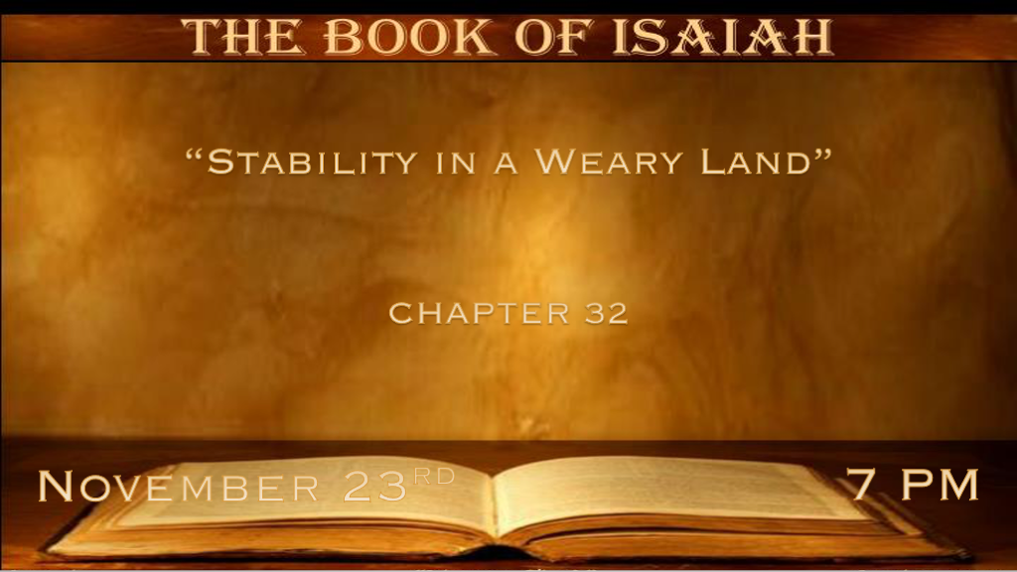

*The Righteous One is the only answer to our weariness.

*Isaiah 32:1 Behold, a king will reign in righteousness, and princes will rule with justice. 2 A man will be as a hiding place from the wind, and a cover from the tempest, as rivers of water in a dry place, as the shadow of a great rock in a weary land. 3 The eyes of those who see will not be dim, and the ears of those who hear will listen. 4 Also the heart of the rash will understand knowledge, and the tongue of the stammerers will be ready to speak plainly. 5 The foolish person will no longer be called generous, nor the miser said to be bountiful; 6 For the foolish person will speak foolishness, and his heart will work iniquity: To practice ungodliness, to utter error against the LORD, to keep the hungry unsatisfied, and he will cause the drink of the thirsty to fail. 7 Also the schemes of the schemer are evil; He devises wicked plans to destroy the poor with lying words, even when the needy speaks justice. 8 But a generous man devises generous things, and by generosity he shall stand.

- V:1 In some sense Hezekiah or even his grandson Josiah could have been the fulfillment of this verse. But what if this is referring to Jesus?
If the verse points to Jesus then his princes are?
1Peter 2:9 A royal priesthood
Revelation 5:10 You have made us kings and priests and we shall reign on earth.

- V:2-4 The protection, provision, and promises are in a weary land only when the righteous king is established in the land.
- Israel is a weary land. So is every nation that doesn’t have God’s law over them.

- The Transformation of people will be the evidence of a land that is following Jesus.

Who wouldn’t want this king? Bringing Insight, hearing properly, and hearts that instead of being rash will have knowledge and understanding. Speaking powerfully with clarity.

- V:5-8 A time when life makes sense, where wickedness is recognizable and foolishness is never mistaken for anything else.
Bad hearts will work in sin (iniquity) and good hearts will make a stand.

*Consequences of complacency.

*Isaiah 32:9 Rise up, you women who are at ease, hear my voice; You complacent daughters, give ear to my speech.
10 In a year and some days you will be troubled, you complacent women; For the vintage will fail, the gathering will not come. 11 Tremble, you women who are at ease; Be troubled, you complacent ones; Strip yourselves, make yourselves bare, and gird sackcloth on your waists. 12 People shall mourn upon their breasts for the pleasant fields, for the fruitful vine.
13 On the land of my people will come up thorns and briers, yes, on all the happy homes in the joyous city; 14 Because the palaces will be forsaken, the bustling city will be deserted. The forts and towers will become lairs forever, a joy of wild donkeys, a pasture of flocks—15 Until the Spirit is poured upon us from on high, and the wilderness becomes a fruitful field,
And the fruitful field is counted as a forest.

- V:9-12 A call to women before the return of Jesus and the Spirit is poured out from on high.
- Tremble you women who are ill-prepared. (Matthew 25:1-13)

- The failures in harvests are meant to trouble us so that we snap out of our stupor.
Complacency is the spirit of Laodicea. The lukewarm spirit.
The call is to repent.

- V:13-14 The intensity of weariness is increased in places that are being forsaken.
The 1st stage of God’s wrath is abandonment. A city or nation that is rebelling against God will experience this stage.

- V:15 The promise of the outpouring of the Spirit of God comes to combat the spirit of complacency. Prophetic scriptures: Joel 2:28 & Amos 8:11-13

*The Five-Fold Work of our Righteousness King.

*Isaiah 32:16 Then justice will dwell in the wilderness, and righteousness remain in the fruitful field. 17 The work of righteousness will be peace, and the effect of righteousness, quietness, and assurance forever. 18 My people will dwell in a peaceful habitation, in secure dwellings, and in quiet resting places, 19 though hail comes down on the forest, and the city is brought low in humiliation. 20 Blessed are you who sow beside all waters, who send out freely the feet of the ox and the donkey.

- Dwelling in Justice: Isaiah 30:18 Therefore the LORD will wait, that He may be gracious to you;
And therefore He will be exalted, that He may have mercy on you. For the LORD is a God of justice;

.
- Being at peace: Because our Prince of Peace is The Lord.

- *Quietness: A place of refuge in the Lord and confidence. Proverbs 14:26 In the fear of the LORD there is strong confidence and His children will have a place of refuge. (A promise in Isaiah 30)

- *Assurance: Hebrews 6:18 Our assurance is in the resurrection and it is the fact that God cannot lie therefore we are comforted.

- *Blessed: Isaiah 30:18 Therefore the LORD will wait, that He may be gracious to you; And therefore He will be exalted, that He may have mercy on you. For the LORD is a God of justice;
Blessed are all those who wait for Him.
19 For the people shall dwell in Zion at Jerusalem; You shall weep no more. He will be very gracious to you at the sound of your cry; When He hears it, He will answer you. 20 And though the Lord gives you the bread of adversity and the water of affliction, Yet your teachers will not be moved into a corner anymore, but your eyes shall see your teachers. 21 Your ears shall hear a word behind you, saying, “This is the way, walk in it,” Whenever you turn to the right hand or whenever you turn to the left.

