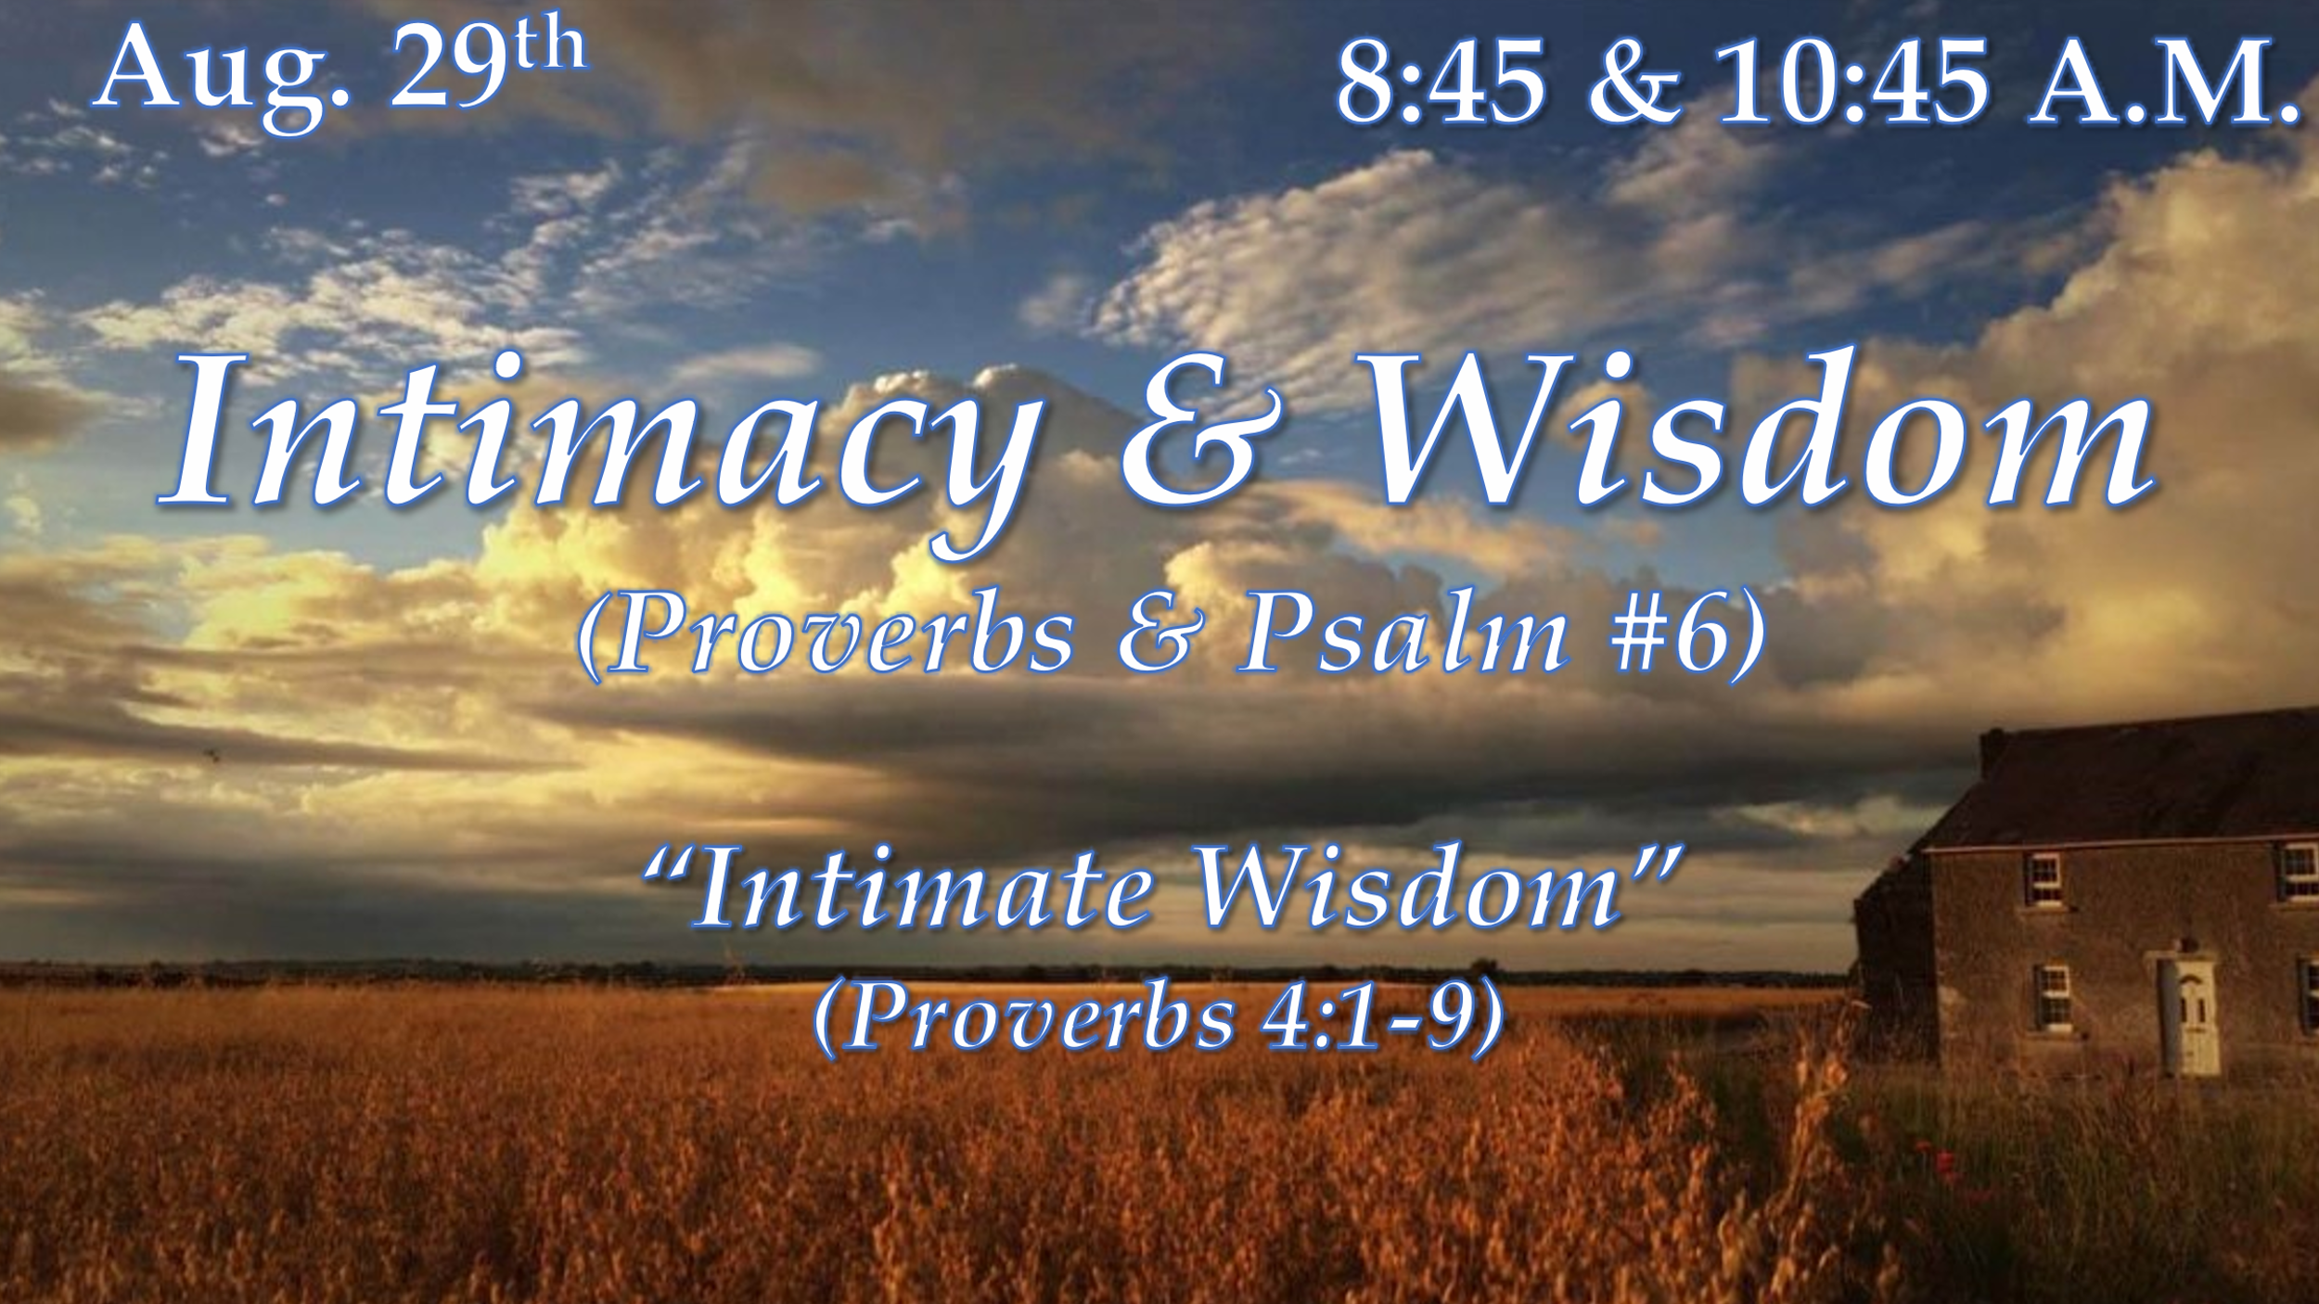

Intimate - marked by a warm friendship developing through long association; of a very personal or private nature; marked by very close association, contact, or familiarity.

- “The heart of the matter is the matter of the heart” - (I Chronicles 28:9-10)

- Get wisdom!!!... was David’s instruction to Solomon (Proverbs 2:1-6; NKJV)

Part of “working out our own salvation” (Phil. 2:12) and “making our calling and election sure” (II Peter 1:10) as the scripture encourages, is the life of due diligence that is expected of the true disciple of Christ. Seeking godly wisdom as a miner seeks hidden treasure is the poetic picture shown here.

- Author and Time of Writing - The book of Proverbs bears the inspired title: "Proverbs of Solomon, son of David" (chapter 1:1). Solomon is also mentioned as poet in chap. 10:1 and 25:1. (I Kings 4:29-34)

- Purpose of Writing - Proverbs contains a gold mine of biblical theology, reflecting themes of Scripture brought to the level of practical righteousness, by addressing man’s ethical choices, calling into question how he thinks, lives, and manages his daily life in light of divine truth. More specifically, Proverbs calls man to live as the Creator intended him to live when He created him.

- Peculiarities –
  - The Fear of the Lord - The fear of the Lord is the key word of this book (Eighteen times).
  - The Name of God – Yahweh – (JHWH) The self-existent One. He has always existed and will always exist. You can always rely on Him because He is your eternal source of strength.
  - Poetical Form - The book of Proverbs is written in poetical form

Here are four points from chapter 4 that summarize this theme of intimacy in the book of Proverbs…1) Admonition, 2) Implementation, 3) Acquisition, 4) Application

- ADMONITION – (Verses 1-2) - There is no wisdom but that which is linked to good doctrine, which should be the focal point of ALL instruction!!!!

- Admonition - gentle of friendly reproof; counsel or warning against fault or oversight.
- Understanding - the capacity to apprehend general relations of particulars; the power to make experience intelligible by applying concepts and categories

- IMPLIMENTATION – (Verses 3-4) (Proverbs 24:3-4; NKJV)
Mentor – a trusted counselor or guide

- ACQUISITION – (Verses 5-7) - Getting wisdom was one thing. But getting understanding is quite another.

- APPLICATION – (Verses 8-9) –

- One commentator that I read put it like this; “The more highly one esteems wisdom, the more highly wisdom lifts that person.”

CONCLUSION

Solomon came to the throne with great promise, privilege, and opportunity. God had granted his request for understanding, and his wisdom exceeded all others. However, the shocking reality is that he failed to live out the truths that he knew and even taught his son Rehoboam, who subsequently rejected his instruction.

