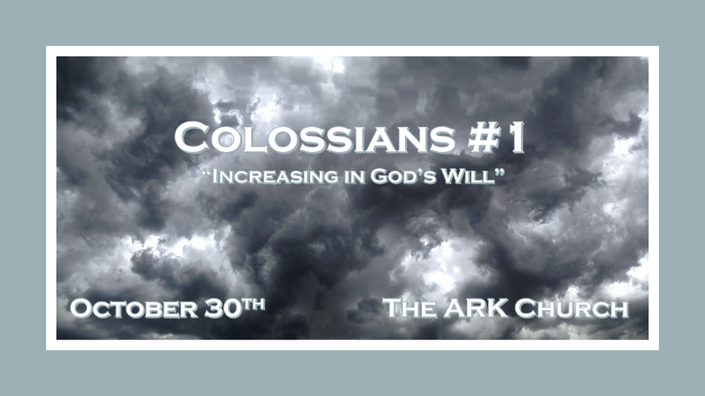

God’s will for His Church.

*Ephesians 4:11 And He Himself gave some to be apostles, some prophets, some evangelists, and some pastors and teachers, 12 for the equipping of the saints for the work of ministry, for the edifying of the body of Christ, 13 till we all come to the unity of the faith and of the knowledge of the Son of God, to a perfect man, to the measure of the stature of the fullness of Christ; 14 that we should no longer be children, tossed to and fro and carried about with every wind of doctrine, by the trickery of men, in the cunning craftiness of deceitful plotting, 15 but, speaking the truth in love, may grow up in all things into Him who is the head—Christ.

- God sets aside those who equip others.

- Until the fullness of Christ and we are no longer tossed around by every wind of doctrine.

Seven Churches
Jesus: Paul:
- Ephesus Ephesus
- Smyrna Philippians
- Pergamos Corinthians
- Thyatira Galatians
- Sardis Romans
- Philadelphia Thessalonians
- Laodicea Colossians. ~ Koinonia House chart

Has the church missed God’s will?

- *Ephesus: The desired one. They missed his will by leaving their first love, Jesus.
- *Smyrna: Myrrh/Death. They did not miss God’s will. Rev. 2:11 To listen to what the Holy Spirit is saying to the Churches and they won’t be hurt by the second death.
- *Pergamos: Mixed marriage. Constantine made the Church world acceptable to the world.
- *Thyatira: Semiramis queen of Assyrians. The Catholic church, worship Jezebel & idols.
- *Sardis: Remnant. This is the denominational church and replacement theology is taught.
- *Philadelphia: Brotherly love. They like Smyrna did miss God’s Will. This is the church in the last days that goes back to God’s mission and teaches on His return.
- *Laodicea: People rule. This is the Church that is lukewarm and God desires to spit them out.

*Colossians the letter is to correct the Church about God’s will.

- The connection between the church in Colosse and Laodicea is deep. Colossians 4:13
They are only a mile apart from each other and the Gnostics are embedded in both.

- If the seven churches of Revelation included a view of Church history, where are we now?

*Allowing the word of truth to anchor you in the Holy Spirit & God’s Will.

*Colossians 1:1 Paul, an apostle of Jesus Christ by the will of God, and Timothy our brother,
2 To the saints and faithful brethren in Christ who are in Colosse: Grace to you and peace from God our Father and the Lord Jesus Christ.
3 We give thanks to the God and Father of our Lord Jesus Christ, praying always for you, 4 since we heard of your faith in Christ Jesus and of your love for all the saints; 5 because of the hope which is laid up for you in heaven, of which you heard before in the word of the truth of the gospel, 6 which has come to you, as it has also in all the world, and is bringing forth fruit, as it is also among you since the day you heard and knew the grace of God in truth; 7 as you also learned from Epaphras, our dear fellow servant, who is a faithful minister of Christ on your behalf, 8 who also declared to us your love in the Spirit.

- V:1-2 An epistle/letter to Colossians/Laodicea: Both churches need to step up in their passion for Jesus.
Lukewarmness is a precursor to an apostate spirit taking hold.
To the saints and faithful brethren. There were unfaithful brethren in Colosse.

- V:3-5 The word of truth is the gospel of grace in Jesus and confirms He is the Messiah & Savior.
Any teaching that starts somewhere else ultimately ends up denying Jesus' deity.
False spiritual teachers do not target the world. They want to confuse the follower of Jesus.

- V:4-8 V:4 Faith, V:5 Hope, and V:8 Love . This trilogy's focus must not be lost within the church.
Faith in the Messiah (Christ Jesus), hope in heaven, and love in the Spirit.
The apostate church displaces faith and wrongly believes our hope is in the here & now while perverting love.

*Knowledge and wisdom are increased when we know God’s will.

*Colossians 1:9 For this reason we also, since the day we heard it, do not cease to pray for you, and to ask that you may be filled with the knowledge of His will in all wisdom and spiritual understanding; 10 that you may walk worthy of the Lord, fully pleasing Him, being fruitful in every good work and increasing in the knowledge of God; 11 strengthened with all might, according to His glorious power, for all patience and longsuffering with joy; 12 giving thanks to the Father who has qualified us to be partakers of the inheritance of the saints in the light. 13 He has delivered us from the power of darkness and conveyed us into the kingdom of the Son of His love, 14 in whom we have redemption through His blood, the forgiveness of sins.

- V:9-11 Pray to be filled with God’s will.
*Paul’s list of what he prays for: To be filled with the knowledge of God’s will.

That others may have all wisdom and spiritual understanding. That you may walk worthy of Lord and be pleasing to God.

*That others would be fruitful in every good work and increasing in the knowledge of God.

Strengthened with all might according to God’s power.

*That we would be patient, longsuffering, and have joy in the process.

The Lack of patience and lack of longsuffering will bring about two different consequences. One leads to losing heart and losing your wrath.

- V:12-14 The qualification is Jesus' power to transform.
*Deliverance from the power of darkness and the forgiveness of sin is always Jesus' agenda.
Qualified because we are: Delivered from darkness, transfer to the Kingdom of God, and forgiven.

*The word conveyed can mean Jesus transported us to His Kingdom.

