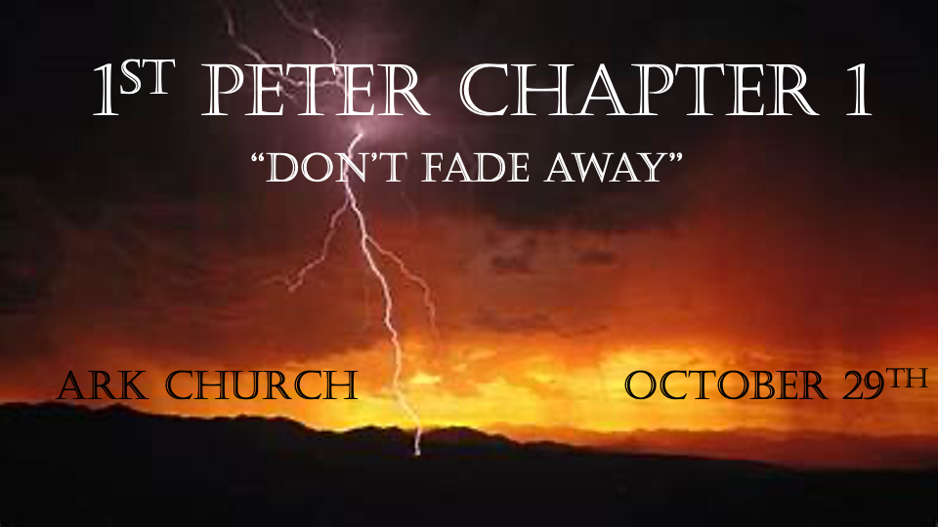

*A Eternal Mindset is a Vital Christian Perspective.

*I Peter 1:1 Peter, an apostle of Jesus Christ,
To the pilgrims of the Dispersion in Pontus, Galatia, Cappadocia, Asia, and Bithynia, 2 elect according to the foreknowledge of God the Father, in sanctification of the Spirit, for obedience and sprinkling of the blood of Jesus Christ:
Grace to you and peace be multiplied.
3 Blessed be the God and Father of our Lord Jesus Christ, who according to His abundant mercy has begotten us again to a living hope through the resurrection of Jesus Christ from the dead, 4 to an inheritance incorruptible and undefiled and that does not fade away, reserved in heaven for you, 5 who are kept by the power of God through faith for salvation ready to be revealed in the last time.

V:1-2 Pilgrims have a living hope in their constant awareness of their future home.
Believers who hold on too tight to this world are discouraged. Their hope is in the here and now.
The scriptures give us insights into an unknown world that is eternal.
An eternal perspective is a fundamental principle to have multiplied peace.

V:3-5 A living hope is God’s abundant mercy through the resurrection and the inheritance that does not fade away.
V:3-4 Do you have your reservation? Some Christians are holding on to this world too tight. You must place your reservation today and never cancel it.

V:5 Did you know there is a faith for salvation revealed in the last days?
Faith is more than a belief system.
*Hebrews 11:1 Now faith is the substance of things hoped for, the evidence of things not seen. 2 For by it the elders obtained a good testimony.
3 By faith we understand that the worlds were framed by the word of God, so that the things which are seen were not made of things which are visible.

*Genuine Faith will never fade, and those who seek it will find hidden mysteries.

*I Peter 1:6 In this you greatly rejoice, though now for a little while, if need be, you have been grieved by various trials, 7 that the genuineness of your faith, being much more precious than gold that perishes, though it is tested by fire, may be found to praise, honor, and glory at the revelation of Jesus Christ, 8 whom having not seen you love. Though now you do not see Him, yet believing, you rejoice with joy inexpressible and full of glory, 9 receiving the end of your faith—the salvation of your souls.
10 Of this salvation the prophets have inquired and searched carefully, who prophesied of the grace that would come to you, 11 searching what, or what manner of time, the Spirit of Christ who was in them was indicating when He testified beforehand the sufferings of Christ and the glories that would follow. 12 To them it was revealed that, not to themselves, but to us they were ministering the things which now have been reported to you through those who have preached the gospel to you by the Holy Spirit sent from heaven—things which angels desire to look into.

Insights for V:6-8 Grieving does not diminish our faith. Our emotions are not our faith.
Our faith is more precious than gold.
Grief is often a proper response to a world gone crazy, but we must allow grief to ignite a godly passion.

Insights for V:10-12 A supernatural angelic unknown world is watching.
Only the Bible teaches and instructs us the truth about the unseen world. Zechariah Chapters 1 through 6 will teach you about angels, their tasks, assignments, insights, and dialogue with God.

*This World is Withering Away, but the Word of God Endures!

*1 Peter 1:13 Therefore gird up the loins of your mind, be sober, and rest your hope fully upon the grace that is to be brought to you at the revelation of Jesus Christ; 14 as obedient children, not conforming yourselves to the former lusts, as in your ignorance; 15 but as He who called you is holy, you also be holy in all your conduct, 16 because it is written, “Be holy, for I am holy.”
17 And if you call on the Father, who without partiality judges according to each one’s work, conduct yourselves throughout the time of your stay here in fear; 18 knowing that you were not redeemed with corruptible things, like silver or gold, from your aimless conduct received by tradition from your fathers, 19 but with the precious blood of Christ, as of a lamb without blemish and without spot. 20 He indeed was foreordained before the foundation of the world, but was manifest in these last times for you 21 who through Him believe in God, who raised Him from the dead and gave Him glory, so that your faith and hope are in God.
22 Since you have purified your souls in obeying the truth through the Spirit in sincere love of the brethren, love one another fervently with a pure heart, 23 having been born again, not of corruptible seed but incorruptible, through the word of God which lives and abides forever, 24 because “All flesh is as grass,
And all the glory of man as the flower of the grass.
The grass withers,
And its flower falls away,
25 But the word of the LORD endures forever.” Now this is the word which by the gospel was preached to you.

Insights for V:13-16 Gird up the loins of your mind. How?
Holiness is more than what you are moving away from; it’s about what you are moving toward.

Does the call to be holy start with the understanding of being troubled by sinful conduct?

Don’t adapt to the deceptions of this world. Every Christian should be troubled in their soul by the outrageous lies, sins, and behavior of this world.

Lot was troubled in his soul.

*2 Peter 2:7-9 (NLT) Yes, Lot was a righteous man who was tormented in his soul by the wickedness he saw and heard day after day. So you see, the Lord knows how to rescue godly people from their trials, even while keeping the wicked under punishment until the day of final judgment.

How? Let your troubled spirit move you to God, His Word, and the power of prayer.

V:17-21 There’s one who set the stage before the foundations of the world. Plus, one unique insight.

V:17-18 The level of our righteous fear of God will judge us because it enables our obedience and work for the Kingdom of God.

V:19-20 God put into motion our redemption before the foundation of the world.
Special Note: The redemption knowledge is demonstrated/manifested in the last days.

V:22 The Truth is purifying your soul.
Should this purification play a part in our troubled souls? I believe so because those dead in their spirit are allowing the world to become rancid.

V:23-25 Don’t replace that which endures forever with something that fades.
The enemy questions God’s word, then he denies it, and finally, the devil substitutes a lie for it.

