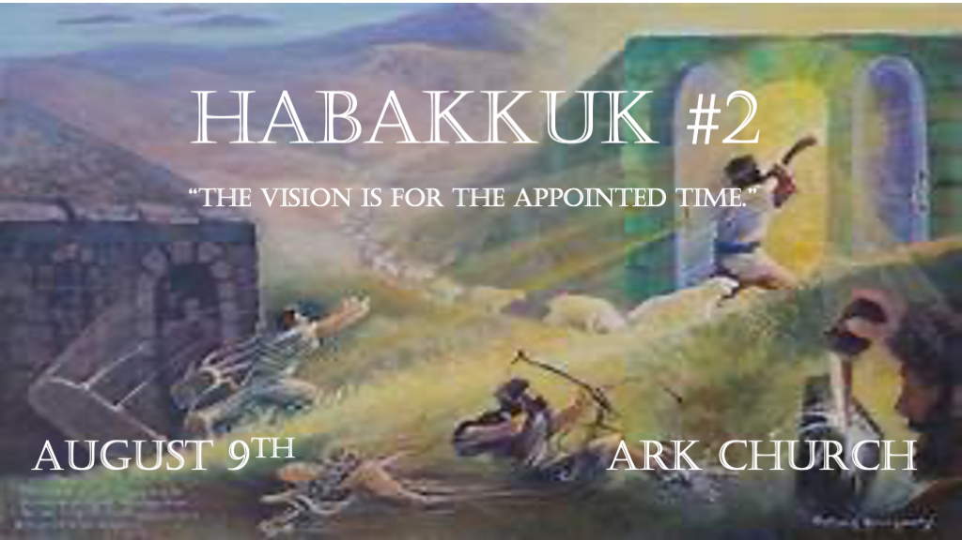
*Habakkuk means One Who Embraces or clings.
The Prophet clings firmly to God regardless of what is happening in his culture. 607 B.C.

*Corrections, vision, pride, and faith.
*Habakkuk 2:1 I will stand my watch and set myself on the rampart, and watch to see what He will say to me, and what I will answer when I am corrected.
2 Then the LORD answered me and said: “Write the vision and make it plain on tablets, that he may run who reads it.
3 For the vision is yet for an appointed time; But at the end it will speak, and it will not lie. Though it tarries, wait for it;
Because it will surely come, it will not tarry. 4 “Behold the proud, his soul is not upright in him; But the just shall live by his faith.

V:1 A person of faith who is willing to be corrected. They will understand appointed times.

A correctable person wants God to speak to them.

A correctable person accepts the truth even if it hurts.

V:2-3 When God speaks and directs, He makes it visible and permanent to others.

Until you know God’s direction, keep waiting on the Lord. (Understanding the way may come later, so don’t wait for total understanding.)

God never author’s confusion or a lie. If you believe anything that contradicts His Word (The Bible), It’s not from God.

V:4 Understanding the spirit of pride vs. Living by faith.

Christians who live by their devotion can be led astray by the power of commitment.
Christians who live by their works will become discouraged.
Christians who live by their feelings will become depressed.
Christians who live by their circumstances will look by-polar.

The spirit of pride comes in many forms. The rich, the poor, the talented, and the less talented have pride in their work ethic, the unbeliever in their unbelief, the simple person in their simplicity, the intellect in their learning, and the counter-cultural person in their revolutionary status. ~ David Guzik

*How God dealt with and will deal with “The Proud.”
*Habakkuk 2:5 “Indeed, because he transgresses by wine, he is a proud man, and he does not stay at home. Because he enlarges his desire as hell, and he is like death, and cannot be satisfied, he gathers to himself all nations and heaps up for himself all peoples. 6 “Will not all these take up a proverb against him, and a taunting riddle against him, and say, ‘Woe to him who increases what is not his—how long? And to him who loads himself with many pledges’? 7 Will not your creditors rise up suddenly? Will they not awaken who oppress you? And you will become their booty. 8 Because you have plundered many nations, all the remnant of the people shall plunder you, because of men’s blood and the violence of the land and the city, and of all who dwell in it. 9 “Woe to him who covets evil gain for his house, that he may set his nest on high, that he may be delivered from the power of disaster! 10 You give shameful counsel to your house, cutting off many peoples, and sin against your soul.
11 For the stone will cry out from the wall, and the beam from the timbers will answer it.

V:5-8 The spirit of Pride is original sin. Its ingredient is making less of God and more of self.
The spirit of Pride always ends up hating God and His creation.

The spirit of Pride will topple many nations.

V:9-11 Signs of demonic uprisings.

V:9 Craving evil gain within their household.

V:10 Giving shameful counsel to their household.

V:11 Your household walls and the beams feel the violation that your soul is numb to.

*Woe to the destroyer of cities and how it happens.
*Habakkuk 2:12 “Woe to him who builds a town with bloodshed, who establishes a city by iniquity! 13 Behold, is it not of the LORD of hosts that the peoples labor to feed the fire, and nations weary themselves in vain? 14 For the earth will be filled
with the knowledge of the glory of the LORD, as the waters cover the sea. 15 “Woe to him who gives drink to his neighbor,
pressing him to your bottle, even to make him drunk, that you may look on his nakedness! 16 You are filled with shame instead of glory. You also—drink! And be exposed as uncircumcised! The cup of the LORD’s right hand will be turned against you, and utter shame will be on your glory. 17 For the violence done to Lebanon will cover you, and the plunder of beasts which made them afraid, because of men’s blood and the violence of the land and the city, and of all who dwell in it. 18 “What profit is the image, that its maker should carve it, the molded image, a teacher of lies, that the maker of its mold should trust in it, to make mute idols? 19 Woe to him who says to wood, ‘Awake!’ to silent stone, ‘Arise! It shall teach!’ Behold, it is overlaid with gold and silver, yet in it there is no breath at all. 20 “But the LORD is in His holy temple. Let all the earth keep silence before Him.”

V:12 Building a city around bloodshed and sin.
It takes a city several generations of sin to be established in the way of iniquity.

V:13-14 In that day! The Lord of Host's power and glory is revealed.
A great promise amid outrageous sinning as God’s glory and knowledge are worldwide.

V:15-18 Warnings about false gods and spirits and unholy living.
Woe to those who are being overtly common in lewdness and drunkenness; wrath is coming.

V:19-20 There’s no contrast between the enemy and the breath of God.
Death results from idolatry and is marked by the lack of the Holy Spirit’s breath.

Jesus will soon reign from His holy temple, and there will be a holy hush.

