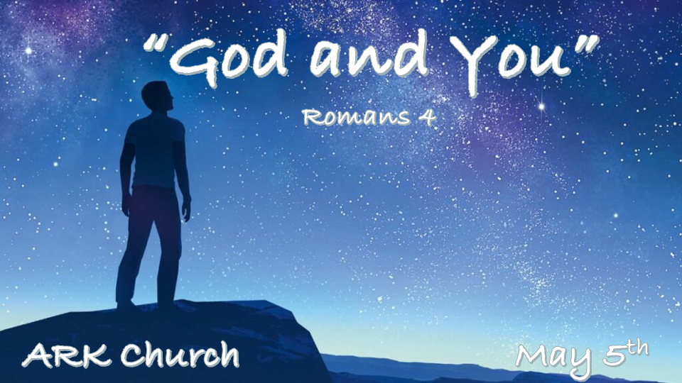

*Moving from the Physical to the Spiritual

- Chapters 1-3 were about the physical person, intellect, moral actions, and religious activities.
Chapter 4 Shows us the path to victory. It is by faith through grace.

- Jesus gives the gift of Salvation, and the spiritual transforms all that is physical.
By faith, you and I move to a spiritual answer and are saved through grace.
*Hebrews 11:1 Now faith is the substance of things hoped for, the evidence of things not seen.

*What Abraham & David Found in the Spirit, so Can We.

*Romans 4:1 What then shall we say that Abraham our father has found according to the flesh? 2 For if Abraham was justified by works, he has something to boast about, but not before God. 3 For what does the Scripture say? “Abraham believed God, and it was accounted to him for righteousness.” 4 Now to him who works, the wages are not counted as grace but as debt.
5 But to him who does not work but believes on Him who justifies the ungodly, his faith is accounted for righteousness, 6 just as David also describes the blessedness of the man to whom God imputes righteousness apart from works:
7 “Blessed are those whose lawless deeds are forgiven, and whose sins are covered;

- V:1-2 There is one that is coming who is the completeness of the flesh.
The complete fleshly person combines intellect, self-obtained morals, and religious values.

The man of lawlessness, his number is a trilogy of 666’s. The repetition of three of anything in Hebrew brings totality.
*Holy, Holy, Holy is the complete total essence of our Triune God in His Holiness.

- V:1-4 The distinction between works and grace is clear.
We work to gain physically or pay off the debt. A system of works tries to put God in debt to us.

Grace is the path to righteousness, and only is the way, the path, and the life of grace.

- V:3-7 Both Abraham and David became blessed by imputed (credited) righteousness.
The transformation comes when the ungodly, by faith, believe (trust God), and God places them in a right standing.

*Flawed humanity become spiritual beings as the gift of salvation came through God’s Grace.

*The Only Way to Build a Proper Account with God is with Faith.
*Romans 4:8 Blessed is the man to whom the LORD shall not impute sin.”
9 Does this blessedness then come upon the circumcised only, or upon the uncircumcised also? For we say that faith was accounted to Abraham for righteousness. 10 How then was it accounted? While he was circumcised, or uncircumcised? Not while circumcised, but while uncircumcised. 11 And he received the sign of circumcision, a seal of the righteousness of the faith which he had while still uncircumcised, that he might be the father of all those who believe, though they are uncircumcised, that righteousness might be imputed to them also, 12 and the father of circumcision to those who not only are of the circumcision, but who also walk in the steps of the faith which our father Abraham had while still uncircumcised.

- V:8-10 What an incredible day when sin is NOT credited to us.
The spiritual person will see things before there is evidence of them.

The spiritual person will trust in God when it seems ridiculous to do so.

- V:11-12 The Law of Faith is we walk in the steps Abraham did before there’s a physical change.
The changes come after we grab hold of God’s gift of grace through Jesus Christ!

*When the evidence says there’s no hope, we place our hope in Jesus.
*Romans 4:13 For the promise that he would be the heir of the world was not to Abraham or to his seed through the law, but through the righteousness of faith. 14 For if those who are of the law are heirs, faith is made void and the promise made of no effect, 15 because the law brings about wrath; for where there is no law there is no transgression.
16 Therefore it is of faith that it might be according to grace, so that the promise might be sure to all the seed, not only to those who are of the law, but also to those who are of the faith of Abraham, who is the father of us all 17 (as it is written, “I have made you a father of many nations”) in the presence of Him whom he believed—God, who gives life to the dead and calls those things which do not exist as though they did; 18 who, contrary to hope, in hope believed, so that he became the father of many nations, according to what was spoken, “So shall your descendants be.” 19 And not being weak in faith, he did not consider his own body, already dead (since he was about a hundred years old), and the deadness of Sarah’s womb. 20 He did not waver at the promise of God through unbelief, but was strengthened in faith, giving glory to God, 21 and being fully convinced that what He had promised He was also able to perform. 22 And therefore “it was accounted to him for righteousness.”

- Abraham wasn’t righteous because he was circumcised.
He became circumcised as a sign of his faith. (He changed physically because of the Spirit of Faith in God changed him.)

- David wasn’t innocent but became a man after God’s own heart by faith.
Neither lived a perfect life, but they did live a spiritually in tuned life by faith.

- All that we receive is done by faith.
The lack of physical or emotional strength is never a problem for those with faith.
That’s the story of Abraham and Sarah’s baby Isaac coming into the world by faith.

Are you ready to journey to the Spiritual side of life, or are you waiting to be convinced?

