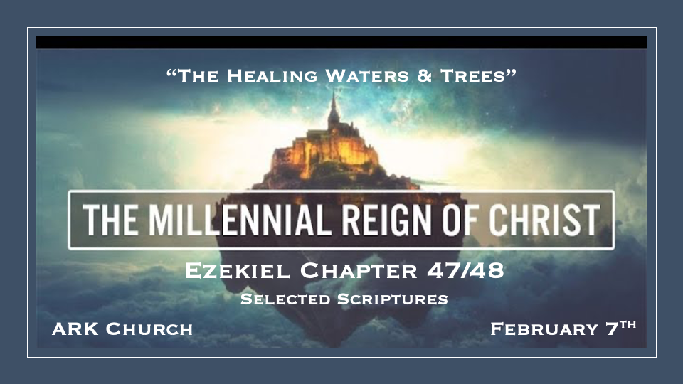

*The River of Life Plus Trees for Food and Medicine.

*Ezekiel 47:1 Then he brought me back to the door of the temple; and there was water, flowing from under the threshold of the temple toward the east, for the front of the temple faced east; the water was flowing from under the right side of the temple, south of the altar. 2 He brought me out by way of the north gate, and led me around on the outside to the outer gateway that faces east; and there was water, running out on the right side.
3 And when the man went out to the east with the line in his hand, he measured one thousand cubits, and he brought me through the waters; the water came up to my ankles. 4 Again he measured one thousand and brought me through the waters; the water came up to my knees. Again he measured one thousand and brought me through; the water came up to my waist. 5 Again he measured one thousand, and it was a river that I could not cross; for the water was too deep, water in which one must swim, a river that could not be crossed. 6 He said to me, “Son of man, have you seen this?” Then he brought me and returned me to the bank of the river.
7 When I returned, there, along the bank of the river, were very many trees on one side and the other. 8 Then he said to me: “This water flows toward the eastern region, goes down into the valley, and enters the sea. When it reaches the sea, its waters are healed. 9 And it shall be that every living thing that moves, wherever the rivers go, will live. There will be a very great multitude of fish, because these waters go there; for they will be healed, and everything will live wherever the river goes. 10 It shall be that fishermen will stand by it from En Gedi to En Eglaim; they will be places for spreading their nets. Their fish will be of the same kinds as the fish of the Great Sea, exceedingly many. 11 But its swamps and marshes will not be healed; they will be given over to salt. 12 Along the bank of the river, on this side and that, will grow all kinds of trees used for food; their leaves will not wither, and their fruit will not fail. They will bear fruit every month, because their water flows from the sanctuary. Their fruit will be for food, and their leaves for medicine.”

- *The River: Joel 3:18 & Zechariah 14:8 both confirm a life-giving river that will heal the world's waters after the Tribulation.

No river has flown directly from the door of the temple. It will flow in the millennium, suggesting that the source is God.
Jerusalem is the only ancient city not to have a major river flowing through it.

- A literal River: It increases in depth and becomes impossible to get across at its deepest point.

An allegory? Many see the walk of our faith that starts ankle-deep and progresses to a point where we are all in totally by faith. This is a great illustration, but don’t make the mistake of thinking this story is not literal.

The temple river in the Millennium Kingdom has healing power and increased volume supernaturally.

- The River will heal everything except the swamp land.
Some scholars believe the swamp land has spiritual and physical reasons for not healing.

- Revelation 22:1-2 Has similar river and trees, baring twelve fruits, one each month.

The difference between the river and trees in the New Jerusalem is that there is no temple.

Ezekiel tree leaves are medicine & Revelations leaves are for the healing of the nations. The fruit of the millennium trees are used for food.

*The Land Should Never be Dispute According to the Word of God.

*Ezekiel 47:13 Thus says the Lord GOD: “These are the borders by which you shall divide the land as an inheritance among the twelve tribes of Israel. Joseph shall have two portions. 14 You shall inherit it equally with one another; for I raised My hand in an oath to give it to your fathers, and this land shall fall to you as your inheritance.

The giving of land reinforces God's covenant to Abraham in Genesis.

The Northern border is 115 miles north of Damascus. Note: There are borders in the new millennium, with seven northern tribes above the temple and five below. (Perfection and Grace) Dan is the furthest from the temple.

The Eastern border did not include land east of the Jordan. The location and size differ from Joshua's chapters 13 through 19 descriptions of the boundaries.

*The Twelve Tribes receive their Land & The City of the Lord

*Ezekiel 48:1-29
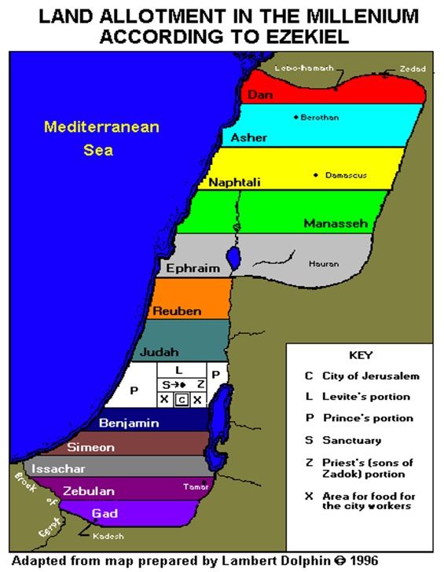

*Ezekiel 48:30 “These are the exits of the city. On the north side, measuring four thousand five hundred cubits 31 (the gates of the city shall be named after the tribes of Israel), the three gates northward: one gate for Reuben, one gate for Judah, and one gate for Levi; 32 on the east side, four thousand five hundred cubits, three gates: one gate for Joseph, one gate for Benjamin, and one gate for Dan; 33 on the south side, measuring four thousand five hundred cubits, three gates: one gate for Simeon, one gate for Issachar, and one gate for Zebulun; 34 on the west side, four thousand five hundred cubits with their three gates: one gate for Gad, one gate for Asher, and one gate for Naphtali. 35 All the way around shall be eighteen thousand cubits; and the name of the city from that day shall be: THE LORD IS THERE.”

- The gates again represent the 12 tribes of Israel. This time, Joseph and Levi receive a gate.
Similar to the twelve gates in the New Jerusalem in Revelation 21.

- *Chapters 40 through 48 never mention the name of Jerusalem. The land is called the city, the sanctuary, the holy city, and the temple.

- Yahweh Shammah is the name for Jerusalem in the millennium. God is there.

