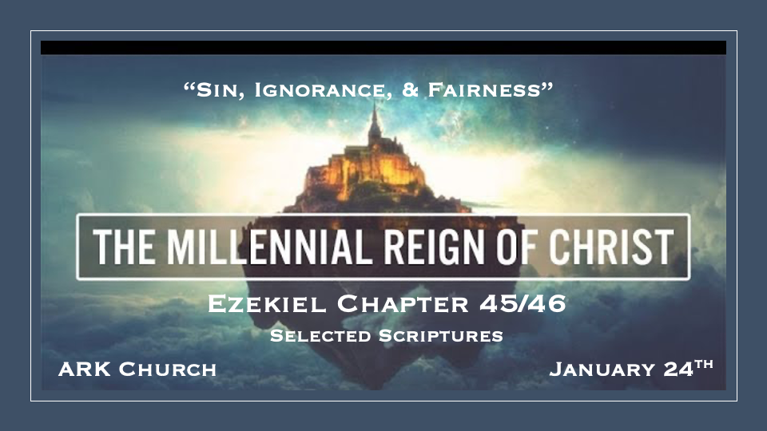

*Holy places for The Priests and the Prince.

*Ezekiel 45:1 “Moreover, when you divide the land by lot into inheritance, you shall set apart a district for the LORD, a holy section of the land; its length shall be twenty-five thousand cubits, and the width ten thousand. It shall be holy throughout its territory all around. 2 Of this there shall be a square plot for the sanctuary, five hundred by five hundred rods, with fifty cubits around it for an open space. 3 So this is the district you shall measure: twenty-five thousand cubits long and ten thousand wide; in it shall be the sanctuary, the Most Holy Place.
*Ezekiel 45:7 “The prince shall have a section on one side and the other of the holy district and the city’s property; and bordering on the holy district and the city’s property, extending westward on the west side and eastward on the east side, the length shall be side by side with one of the tribal portions, from the west border to the east border. 8 The land shall be his possession in Israel; and My princes shall no more oppress My people, but they shall give the rest of the land to the house of Israel, according to their tribes.”

- Is the “set apart places” a new plan for the millennial reign?
No, Hebrews 10:25-27 tells us God has holy places for His people to gather.
Deception during the pandemic was that the church is just a building and we shouldn’t look at it as sacred.

- The Prince is given his own land.

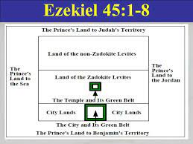

3. Each of the tribes of Israel will also have their own land.

*A Call to Justice and Fairness. Plus, a New Sacrificial process.

*Ezekiel 45:9 ‘Thus says the Lord GOD: “Enough, O princes of Israel! Remove violence and plundering, execute justice and righteousness, and stop dispossessing My people,” says the Lord GOD.
Ezekiel 45:18 ‘Thus says the Lord GOD: “In the first month, on the first day of the month, you shall take a young bull without blemish and cleanse the sanctuary. 19 The priest shall take some of the blood of the sin offering and put it on the doorposts of the temple, on the four corners of the ledge of the altar, and on the gateposts of the gate of the inner court. 20 And so you shall do on the seventh day of the month for everyone who has sinned unintentionally or in ignorance. Thus you shall make atonement for the temple.

V:9 Depriving and stealing from the people is a trait of evil leaders.

The Millennial has one word for addressing injustices and evil practices: Enough!

*V:18-20 The changes unique to the millennium. The cleansing of the sanctuary (Hanukkah?).
- The sacrifices are different than those under the Mosaic law.
- No lambs are sacrificed in The Passover feast. Instead, 7 bulls & 7 Rams are used for the offerings.
- The New Millennial Reign does not celebrate Pentecost, Trumpets, or The Day of Redemption.
- There is a year of Jubilee, but it is called “The Year of Liberty.” Ezekiel 46:16
- Unintentional sins and sins of ignorance are part of the reason for sacrificial ceremonies. 1st John 5:16 sins not leading unto death.
- The Prince partakes in the sin offering. Why?
- A consciousness about the consequences of sin is still needed for these 1,000 years.

*The Lamb and more about the prince. (Selected Verses)

*Ezekiel 46:3 Likewise the people of the land shall worship at the entrance to this gateway before the LORD on the Sabbaths and the New Moons. 4 The burnt offering that the prince offers to the LORD on the Sabbath day shall be six lambs without blemish, and a ram without blemish;
*Ezekiel 46:6 On the day of the New Moon it shall be a young bull without blemish, six lambs, and a ram; they shall be without blemish.
*Ezekiel 46:13 “You shall daily make a burnt offering to the LORD of a lamb of the first year without blemish; you shall prepare it every morning.

- V:3 & 6 The total number of lambs slain for Sabbath and New Moon is 384 yearly.
The Numerical value of the number 384 in Hebrew is “The anointed one or the Messiah of Yahweh.

- V:13 The morning sacrifice will have a one-year-old lamb sacrificed as a remembrance.
No evening sacrifice is mentioned. Many scholars think the evening sacrifice is implied, while others believe this is revealing that this is a statement that it’s not O.T. Law that is being observed.

*Ezekiel 46:16 ‘Thus says the Lord GOD: “If the prince gives a gift of some of his inheritance to any of his sons, it shall belong to his sons; it is their possession by inheritance. 17 But if he gives a gift of some of his inheritance to one of his servants, it shall be his until the year of liberty, after which it shall return to the prince. But his inheritance shall belong to his sons; it shall become theirs. 18 Moreover the prince shall not take any of the people’s inheritance by evicting them from their property; he shall provide an inheritance for his sons from his own property, so that none of My people may be scattered from his property.” ’ ”

- The Prince has sons. Is this a man who is married and has children in the millennium?

- If the Prince gives land to the servant, it returns to him after 50 years of the jubilee.
Humanity will learn what it is like to live under the Jubilee.

- Israel will not be scattered ever again in the 1,000-year reign.

Their time of being dispersed is over in the millennium.

