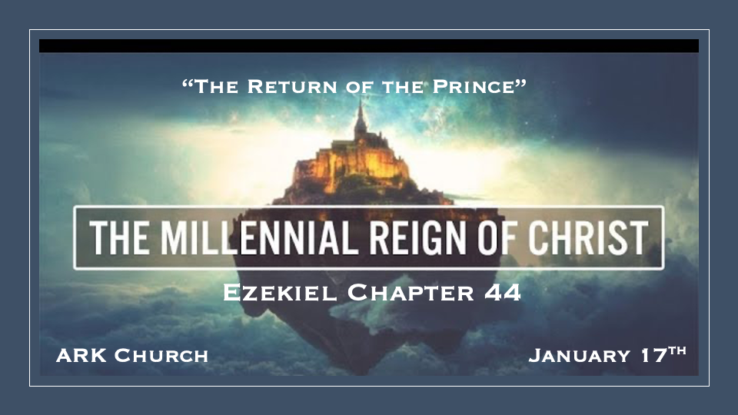

*King Jesus and the Eastern Gate, He reigns, and who is the Prince?

*Ezekiel 44:1 Then He brought me back to the outer gate of the sanctuary which faces toward the east, but it was shut. 2 And the LORD said to me, "This gate shall be shut; it shall not be opened, and no man shall enter by it, because the LORD God of Israel has entered by it; therefore it shall be shut. 3 As for the prince, because he is the prince, he may sit in it to eat bread before the LORD; he shall enter by way of the vestibule of the gateway, and go out the same way."

- Only the King enters through the Eastern Gate. Therefore, it is locked. The Spirit of God left through that gate in 586 B.C. on the 9th of AV, the day the temple was destroyed.
Ezekiel 10 is where we learned the Shekinah glory left through the eastern gate and returned in Ezekiel 43

- The prince is presumed to be King David or his lineage, who now has the title the Prince.
Is it David entering through the porch to the gateway? Ezekiel 34:23-24, Ezekiel 37:24

- The Prince is permitted to eat the sacrificial meal in the vestibule /porch.
Eating and privileges around life, like food, animals, and creation, are moved to a different level.

*Holiness will mark the Millennial Reign.

*Ezekiel 44:4 Also He brought me by way of the north gate to the front of the temple; so I looked, and behold, the glory of the LORD filled the house of the LORD; and I fell on my face. 5 And the LORD said to me, "Son of man, mark well, see with your eyes and hear with your ears, all that I say to you concerning all the ordinances of the house of the LORD and all its laws. Mark well who may enter the house and all who go out from the sanctuary.
6 "Now say to the rebellious, to the house of Israel, 'Thus says the Lord GOD: "O house of Israel, let Us have no more of all your abominations. 7 When you brought in foreigners, uncircumcised in heart and uncircumcised in flesh, to be in My sanctuary to defile it—My house—and when you offered My food, the fat and the blood, then they broke My covenant because of all your abominations. 8, And you have not kept charge of My holy things, but you have set others to keep charge of My sanctuary for you." 9 Thus says the Lord GOD: "No foreigner, uncircumcised in heart or uncircumcised in flesh, shall enter My sanctuary, including any foreigner who is among the children of Israel.

Mark well: If we are marked by God, our eyes and ears have insight into the Lord. V:5 The most essential mark and insight is listening to all God says or is written.

- V:6-7 Denouncing abominations and the complete rejection of a rebellious spirit will mark the millennial reign of Christ.

- V:8-9 A Charge and a rebuke for not keeping God’s Holiness supreme.

*The Burdens and Honors in the Millennial. (Selected Verses)

*Ezekiel 44:12 Because they ministered to them before their idols and caused the house of Israel to fall into iniquity, therefore I have raised My hand in an oath against them,” says the Lord GOD, “that they shall bear their iniquity.

*Ezekiel 44:15 “But the priests, the Levites, the sons of Zadok, who kept charge of My sanctuary when the children of Israel went astray from Me, they shall come near Me to minister to Me; and they shall stand before Me to offer to Me the fat and the blood,” says the Lord GOD. 16 “They shall enter My sanctuary, and they shall come near My table to minister to Me, and they shall keep My charge.

- Iniquity carries a stern burden.
The spreaders of iniquity rarely understand their destruction in the here and now. They will feel that burden in the millennial.

- The sons of Zadok. The honorable lineage is given extraordinary levels of Jesus' presence.
A special honor is given to those who were faithful during the times of unfaithfulness.

During the day of apostasy, those who stay faithful will receive special rewards.

*Teaching the differences between Holy and unholy things. (Selected Verses)

*Ezekiel 44:23 “And they shall teach My people the difference between the holy and the unholy, and cause them to discern between the unclean and the clean. 24 In controversy they shall stand as judges, and judge it according to My judgments. They shall keep My laws and My statutes in all My appointed meetings, and they shall hallow My Sabbaths.

*Ezekiel 44:28 “It shall be, in regard to their inheritance, that I am their inheritance. You shall give them no possession in Israel, for I am their possession. 29 They shall eat the grain offering, the sin offering, and the trespass offering; every dedicated thing in Israel shall be theirs. 30 The best of all firstfruits of any kind, and every sacrifice of any kind from all your sacrifices, shall be the priest’s; also you shall give to the priest the first of your ground meal, to cause a blessing to rest on your house. 31 The priests shall not eat anything, bird or beast, that died naturally or was torn by wild beasts.

- The world will be right side up. Those living in the millennial age will understand the value of the holy and the commonness of the ordinary.
We value so much today that it has no significance compared to what is holy.

- God’s judgments, not man, will rule society for a thousand years. No judge is allowed their own interpretation of the law. They must know God’s standards.
A world that continues to twist God’s law will see a time for proper judgment.

- *V:25-27 Death does happen in the millennial, and mourning is limited to immediate family.

A seven-day period of mourning is re-established.

- V:28-31 The priest has an inheritance, and it’s Jesus.
Jesus declares He is the priest's possession and inheritance.

