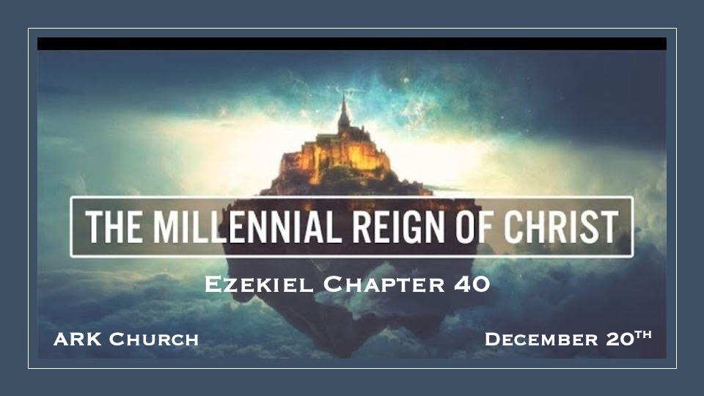
Chapter 39 Review.
Gog is the king of the demonic locust. He is the demonic evil spirit of war.
Gog will be defeated, with evil and its days of reign are coming to an end.

The Warfare is believed to be nuclear with seven years of consequences.

The Ultimate Outcome is the salvation of the Jew and the nation of Israel.

*The Vision of the Millennial Reign

*Insights for Ezekiel 40:1 In the twenty-fifth year of our captivity, at the beginning of the year, on the tenth day of the month, in the fourteenth year after the city was captured, on the very same day the hand of the LORD was upon me; and He took me there. 2 In the visions of God He took me into the land of Israel and set me on a very high mountain; on it toward the south was something like the structure of a city. 3 He took me there, and behold, there was a man whose appearance was like the appearance of bronze. He had a line of flax and a measuring rod in his hand, and he stood in the gateway.
4 And the man said to me, “Son of man, look with your eyes and hear with your ears, and fix your mind on everything I show you; for you were brought here so that I might show them to you. Declare to the house of Israel everything you see.” 5 Now there was a wall all around the outside of the temple. In the man’s hand was a measuring rod six cubits long, each being a cubit and a handbreadth; and he measured the width of the wall structure, one rod; and the height, one rod.

The beginning of Israel’s Year and the tenth day of the month is significant.

*V:1 Nisan Ten Is the day the lambs are selected for the Passover sacrifice.
Nisan 10 is also the day in the future that Jesus will ride into Jerusalem on Palm Sunday.
Ezekiel is taken by the hand of the Lord to Jerusalem.
The last time Ezekiel saw Jerusalem was in a vision in Chapters 8—11.

V:2-4 Yahweh leads Ezekiel to Jerusalem, where the 4th temple will be built.
In Jerusalem, Ezekiel meets a servant/angel of God who is measuring for the 4th temple in Jerusalem.
Ezekiel is instructed to be fully present, with eyes and ears, and to fix his mind on everything he must record for the house of Israel to see the future.
The second temple is yet to be built, and then the third will be the anti-Christ temple; neither fits this description.

V:5 When God gives measurements, it is to show the exactness of His Word.

*The New Temple’s Gateway
*Ezekiel 40:6 Then he went to the gateway which faced east; and he went up its stairs and measured the threshold of the gateway, which was one rod wide, and the other threshold was one rod wide. 7 Each gate chamber was one rod long and one rod wide; between the gate chambers was a space of five cubits; and the threshold of the gateway by the vestibule of the inside gate was one rod. 8 He also measured the vestibule of the inside gate, one rod. 9 Then he measured the vestibule of the gateway, eight cubits; and the gateposts, two cubits. The vestibule of the gate was on the inside. 10 In the eastern gateway were three gate chambers on one side and three on the other; the three were all the same size; also the gateposts were of the same size on this side and that side.
11 He measured the width of the entrance to the gateway, ten cubits; and the length of the gate, thirteen cubits. 12 There was a space in front of the gate chambers, one cubit on this side and one cubit on that side; the gate chambers were six cubits on this side and six cubits on that side. 13 Then he measured the gateway from the roof of one gate chamber to the roof of the other; the width was twenty-five cubits, as door faces door. 14 He measured the gateposts, sixty cubits high, and the court all around the gateway extended to the gatepost. 15 From the front of the entrance gate to the front of the vestibule of the inner gate was fifty cubits. 16 There were beveled window frames in the gate chambers and in their intervening archways on the inside of the gateway all around, and likewise in the vestibules. There were windows all around on the inside. And on each gatepost were palm trees.

Why does it matter to have all the details of gateways and buildings?

- *The Eastern Gate, according to Ezekiel 11:23, is where the Lord’s presence left the temple through this gate.

- Gate chambers are where the priest lived. In the tenth verse, the eastern gate is mentioned again because it is the Gate through which Jesus promises to return.

- All the details with height, ornaments, and even palm trees may not have any spiritual significant purpose for our generation. Still, they will be a faith booster for the millennial reign generation.

*The Outer Court, Lower Gate, and Northern Gate of the Temple
*Ezekiel 40:17 Then he brought me into the outer court; and there were chambers and a pavement made all around the court; thirty chambers faced the pavement. 18 The pavement was by the side of the gateways, corresponding to the length of the gateways; this was the lower pavement. 19 Then he measured the width from the front of the lower gateway to the front of the inner court exterior, one hundred cubits toward the east and the north.
The Northern Gateway
20 On the outer court was also a gateway facing north, and he measured its length and its width. 21 Its gate chambers, three on this side and three on that side, its gateposts and its archways, had the same measurements as the first gate; its length was fifty cubits and its width twenty-five cubits. 22 Its windows and those of its archways, and also its palm trees, had the same measurements as the gateway facing east; it was ascended by seven steps, and its archway was in front of it. 23 A gate of the inner court was opposite the northern gateway, just as the eastern gateway; and he measured from gateway to gateway, one hundred cubits.
The South Gate
24 And he led me toward the south, and behold, there was a gate on the south. And he measured its jambs and its vestibule; they had the same size as the others. 25 Both it and its vestibule had windows all around, like the windows of the others. Its length was fifty cubits, and its breadth twenty-five cubits. 26 And there were seven steps leading up to it, and its vestibule was before them, and it had palm trees on its jambs, one on either side. 27 And there was a gate on the south of the inner court. And he measured from gate to gate toward the south, a hundred cubits.

The Outer Court is a generous space for all.

There isn't a Western gate as in the Northern Gateway and Southern Gate for living quarters since the temple will be closer to the western wall. Special note: the southern gate is noted for its Palm Trees, and Jesus will, in the future, be traveling from Bethany Southeast of Jerusalem, where the Palm branches will spread out and be used by the crowd on Palm Sunday.

The Millennial Promise

*Psalm 89:34 I will not violate my covenant or alter the word that went forth from my lips.
35 Once for all I have sworn by my holiness; I will not lie to David.
36 His offspring shall endure forever, his throne as long as the sun before me.
37 Like the moon, it shall be established forever, a faithful witness in the skies.” Selah

*Daniel 2:44 And in the days of those kings the God of heaven will set up a kingdom that shall never be destroyed, nor shall the kingdom be left to another people. It shall break in pieces all these kingdoms and bring them to an end, and it shall stand forever.

