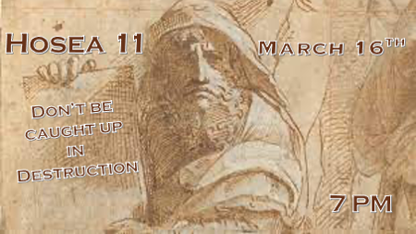

*Hosea 9:15 I will drive them out of my house.
*Hosea 10 Reveals there are three houses to choose from when they return to God’s House.

- The house of nothingness Beth Aven

- The house of ambush Beth Arbel

- The house of God Bethel

*Hosea 11:1 "When Israel was a child, I loved him, and out of Egypt I called my son.
2 But the more they were called, the more they went away from me. They sacrificed to the Baals and they burned incense to images.
3 It was I who taught Ephraim to walk, taking them by the arms; but they did not realize it was I who healed them.
4 I led them with cords of human kindness, with ties of love. To them I was like one who lifts a little child to the cheek, and I bent down to feed them.
5 "Will they not return to Egypt and will not Assyria rule over them because they refuse to repent?
6 A sword will flash in their cities; it will devour their false prophets and put an end to their plans.

*Insights to God’s love for the house of Israel and His people (The Church).

- V:1 Out of Egypt I called my son. Does this verse sound familiar? Matthew 2:13-15

- V:2-4 God the Father. A concept that is not in the O.T. for individuals, It’s alluded to 14x’s but as the father of the Nation of Israel. It is spelled out in Hosea 11.
- Jesus calls God, the father. There is only one time Jesus doesn’t call God father is when he is hanging on the cross.

- It becomes an N.T. Theme God the Father. The writers of the New Testament carry on the truth that God is our Heavenly Father.

- V:5-6 The house of Israel rejects God, his love, and turns to one more wicked than Egypt. This is one of the “Whys” the judgment of God falls on the house of Israel.

*Hosea 11:7 My people are determined to turn from me. Even though they call me God Most High, I will by no means exalt them.
8 "How can I give you up, Ephraim? How can I hand you over, Israel? How can I treat you like Admah? How can I make you like Zeboyim? My heart is changed within me; all my compassion is aroused.
9 I will not carry out my fierce anger, nor will I devastate Ephraim again. For I am God, and not a man—the Holy One among you. I will not come against their cities.

*The problem goes beyond our sin.

- V:7 The lack of repentance. Sin is a problem, the greater issue is a hard heart.

- V:8 God’s love how can I give you over to your wickedness. Admah and Zeboyim are two cities that were destroyed along with Sodom and Gomorrah a total of 5 cities were destroyed.

- V:9 It pains God to judge those he desires to save. Our choices cannot escape their consequences without God’s intervention.

*Hosea 11:10 They will follow the LORD; he will roar like a lion. When he roars, his children will come trembling from the west.
11 They will come from Egypt, trembling like sparrows, from Assyria, fluttering like doves. I will settle them in their homes," declares the LORD.
12 Ephraim has surrounded me with lies, Israel with deceit. And Judah is unruly against God, even against the faithful Holy One.

*Prophecy and Israel’s future.

- V:10 They will walk after the Lord. This will happen after the Anti-Christ sets up his image in the temple. They will individually and corporately follow Jesus
- The children will come trembling from the west. This speaks to 1948 (Ezekiel 37:1-4 & 22)
- The day of the Lord’s roaring is closer than most think!

- V:11 Back to Israel & the House of Israel. Prophetic scriptures are often dropped in-between the message of their contemporary reality. Assyria will destroy the house of Israel around 712 BC

- V:12 When God’s people depend on themselves. Does this not sound like our land today?

From last week’s teaching

*Hosea 10:14 The roar of battle will rise against your people, so that all your fortresses will be devastated—as Shalman devastated Beth Arbel on the day of battle, when mothers were dashed to the ground with their children.

15 So will it happen to you, Bethel, because your wickedness is great. When that day dawns, the king of Israel will be completely destroyed.

- Is there a roar of battle rising today? Bethel means the house of God. But they made it about a false god so the place of battle is at Beth Arbel the house of ambush.

- So what will happen to the House of God (The Church) because of its great wickedness?

