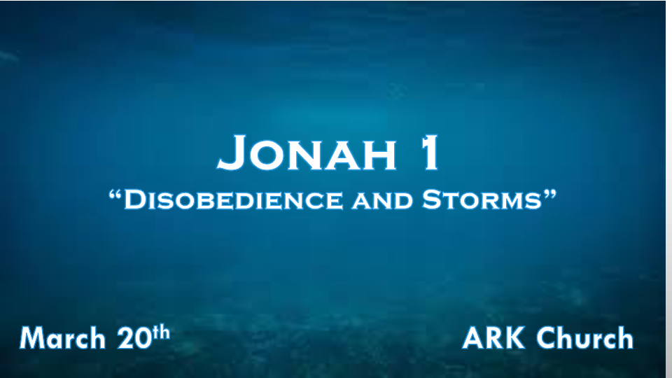

*What are you doing with God’s Word?

*Jonah 1:1 Now the word of the LORD came to Jonah the son of Amittai, saying, 2 “Arise, go to Nineveh, that great city, and cry out against it; for their wickedness has come up before Me.” 3 But Jonah arose to flee to Tarshish from the presence of the LORD. He went down to Joppa, and found a ship going to Tarshish; so he paid the fare, and went down into it, to go with them to Tarshish from the presence of the LORD.

- V:1-2 To many hear or read God’s Word and yet don’t obey.

- V:3 Are you going in the opposite direction of God’s will?

- What constituted an evil generation? Luke 11:24-26

Luke 11:28 But He said, “More than that, blessed are those who hear the word of God and keep it!”
29 And while the crowds were thickly gathered together, He began to say, “This is an evil generation. It seeks a sign, and no sign will be given to it except the sign of Jonah the prophet. 30 For as Jonah became a sign to the Ninevites, so also the Son of Man will be to this generation. 31 The queen of the South will rise up in the judgment with the men of this generation and condemn them, for she came from the ends of the earth to hear the wisdom of Solomon; and indeed a greater than Solomon is here. 32 The men of Nineveh will rise up in the judgment with this generation and condemn it, for they repented at the preaching of Jonah; and indeed a greater than Jonah is here.

Jesus gave this generation a Messiah and the Word of God.

- A generation

- Our generation

The queen of the South, a Gentile queen, sought Solomon's wisdom. She will judge the evil generation for one greater than Solomon is available to this generation.

*When the Creator uses the creation to get our attention.

*Jonah 1:4 But the LORD sent out a great wind on the sea, and there was a mighty tempest on the sea, so that the ship was about to be broken up.
5 Then the mariners were afraid; and every man cried out to his god, and threw the cargo that was in the ship into the sea, to lighten the load. But Jonah had gone down into the lowest parts of the ship, had lain down, and was fast asleep.
6 So the captain came to him, and said to him, “What do you mean, sleeper? Arise, call on your God; perhaps your God will consider us, so that we may not perish.”
7 And they said to one another, “Come, let us cast lots, that we may know for whose cause this trouble has come upon us.” So they cast lots, and the lot fell on Jonah. 8 Then they said to him, “Please tell us! For whose cause is this trouble upon us? What is your occupation? And where do you come from? What is your country? And of what people are you?”
9 So he said to them, “I am a Hebrew; and I fear the LORD, the God of heaven, who made the sea and the dry land.”

1.

2.

3.

4.

5.

The significant contrast between then and now.
*Jonah 1:10 Then the men were exceedingly afraid, and said to him, “Why have you done this?” For the men knew that he fled from the presence of the LORD, because he had told them. 11 Then they said to him, “What shall we do to you that the sea may be calm for us?”—for the sea was growing more tempestuous.
12 And he said to them, “Pick me up and throw me into the sea; then the sea will become calm for you. For I know that this great tempest is because of me.”
13 Nevertheless the men rowed hard to return to land, but they could not, for the sea continued to grow more tempestuous against them. 14 Therefore they cried out to the LORD and said, “We pray, O LORD, please do not let us perish for this man’s life, and do not charge us with innocent blood; for You, O LORD, have done as it pleased You.” 15 So they picked up Jonah and threw him into the sea, and the sea ceased from its raging. 16 Then the men feared the LORD exceedingly, and offered a sacrifice to the LORD and took vows.

The Evidence of a Wicked World

- *The men steering the ship ______________________________________________________.

- *There is no significant effort to correct ____________________________________________.

- *The world doesn’t know _________________________________________________________.

- *Our world doesn’t fear God, ______________________________________________________

________________________________.

