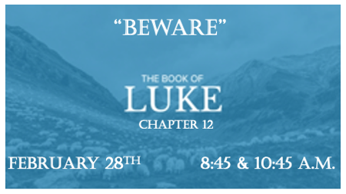

Be painstakingly aware of who or what is influencing you!

*Luke 12:1 Meanwhile, when a crowd of many thousands had gathered, so that they were trampling on one another, Jesus began to speak first to his disciples, saying: "Be on your guard against the yeast of the Pharisees, which is hypocrisy. 2 There is nothing concealed that will not be disclosed or hidden that will not be made known. 3 What you have said in the dark will be heard in the daylight, and what you have whispered in the ear in the inner rooms will be proclaimed from the roofs.
4 "I tell you, my friends, do not be afraid of those who kill the body and after that can do no more. 5 But I will show you whom you should fear: Fear him who, after your body has been killed, has authority to throw you into hell. Yes, I tell you, fear him.

Four Warnings for the Believer
Warning #1 (Hypocrisy)

- V:1 Yeast or Leaven is a common idiom for sin & pride. Leaven puffs up.

- V:1 Hypocrisy is from the word hypocrite to play a part as in an actor.

- V:2-3 Kingdom people must live with a high level of transparency. This will protect you from high levels of evil and darkness.

- V:4-5 Know who and what we should fear is a key ingredient to boldness in the Kingdom. Our political choices are killing the soul of a Biblical nation. Policies like the “Equality Act” show we are not getting our directions from God.

*Luke 12:15 Then he said to them, "Watch out! Be on your guard against all kinds of greed; life does not consist in an abundance of possessions."

*Luke 12:22 Then Jesus said to his disciples: "Therefore I tell you, do not worry about your life, what you will eat; or about your body, what you will wear. 23 For life is more than food, and the body more than clothes. 24 Consider the ravens: They do not sow or reap, they have no storeroom or barn, yet God feeds them. And how much more valuable you are than birds! 25 Who of you by worrying can add a single hour to your life ? 26 Since you cannot do this very little thing, why do you worry about the rest?
*Luke 12:30 For the pagan world runs after all such things, and your Father knows that you need them. 31 But seek his kingdom, and these things will be given to you as well.

Warnings #2 & 3 Coveting & Worry

- Is it possible what you covet, you may also end up worrying about it when you get it?

- Do you live like a lost person who doesn’t know God? Seek the kingdom of God and your earthly needs will be in His hands.

*Luke 12:35 "Be dressed ready for service and keep your lamps burning, 36 like servants waiting for their master to return from a wedding banquet, so that when he comes and knocks, they can immediately open the door for him.
*Luke 12:46 The master of that servant will come on a day when he does not expect him and at an hour, he is not aware of. He will cut him to pieces and assign him a place with the unbelievers.
*Luke 12:49 "I have come to bring fire on the earth, and how I wish it were already kindled! 50 But I have a baptism to undergo, and what constraint I am under until it is completed! 51 Do you think I came to bring peace on earth? No, I tell you, but division.
*Luke 12:56 Hypocrites! You know how to interpret the appearance of the earth and the sky. How is it that you don't know how to interpret this present time?

The 4th Warning for Believers

- V:46-51 The last warning for believers is the most important! An eternal outcome weighs in the balance if you are not ready. Jesus returning is the warning & if you don’t, acknowledge it you will be placed in the category of an unbeliever.

- The Jesus no one preaches! He promises in the context of the last day Jesus will bring the division to our homes and Churches but why?

- V:56 We have come full circle back to hypocrisy. It’s a warning to believers to discern the times before it’s too late.

