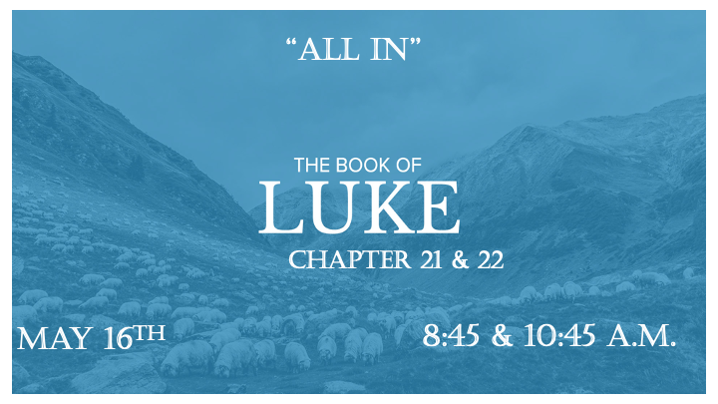

*What does “All In” mean to God?

*Luke 21:1 As Jesus looked up, he saw the rich putting their gifts into the temple treasury. 2 He also saw a poor widow put in two very small copper coins. 3 "Truly I tell you," he said, "this poor widow has put in more than all the others. 4 All these people gave their gifts out of their wealth; but she out of her poverty put in all she had to live on."

What do you have left?

- V:1 Some people give out of their abundance. Others give out of what they have leftover. How is the widow different from both?

- V:2-3 The widow was “all in” and it meant several things to her.
*Malachi 3: 16 Then those who feared the LORD talked with each other, and the LORD listened and heard. A scroll of remembrance was written in his presence concerning those who feared the LORD and honored his name.

*Luke 22:10 He replied, "As you enter the city, a man carrying a jar of water will meet you. Follow him to the house that he enters, 11 and say to the owner of the house, 'The Teacher asks: Where is the guest room, where I may eat the Passover with my disciples?'12 He will show you a large room upstairs, all furnished. Make preparations there."
13 They left and found things just as Jesus had told them. So, they prepared the Passover.

*Have you read the Bible and then ask yourself a question?

*Luke 22:14 When the hour came, Jesus and his apostles reclined at the table. 15 And he said to them, "I have eagerly desired to eat this Passover with you before I suffer. 16 For I tell you, I will not eat it again until it finds fulfillment in the kingdom of God."
17 After taking the cup, he gave thanks and said, "Take this and divide it among you. 18 For I tell you I will not drink again from the fruit of the vine until the kingdom of God comes."
19 And he took bread, gave thanks and broke it, and gave it to them, saying, "This is my body given for you; do this in remembrance of me."
20 In the same way, after the supper he took the cup, saying, "This cup is the new covenant in my blood, which is poured out for you.

*Was Jesus sharing more than a Passover ritual?

- The four cups of Passover are an integral part of the Passover celebration. They stand for each of the four promises the Lord makes to His people in Exodus 6:6-7.
- The Cup of Sanctification “I will bring you out from under the burdens of the Egyptians.” (Slaves)
- The Cup of Deliverance “I will rescue you from their bondage.” (The gift)
- The Cup of Redemption “I will redeem you with an outstretched arm.” (The price)
- The Cup of Praise “I will take you as My people.” (The Promise)
- The 5th cup is Elijah’s cup and remains untouched as a reminder to us of the sweet hope we have in the Messiah—that He has come and will come again to restore the Jewish people, regather us from the four corners of the earth.

- V:16 I will not eat again of it until it finds fulfillment in the Kingdom of God.

- V:18 I will not drink of the fruit of the vine until the Kingdom of God comes.

- V:19 Jesus was all in. His body would take on all the sins of humanity.

- V:20 Jesus cuts a betrothal covenant with us written in the eternal blood of Jesus.

