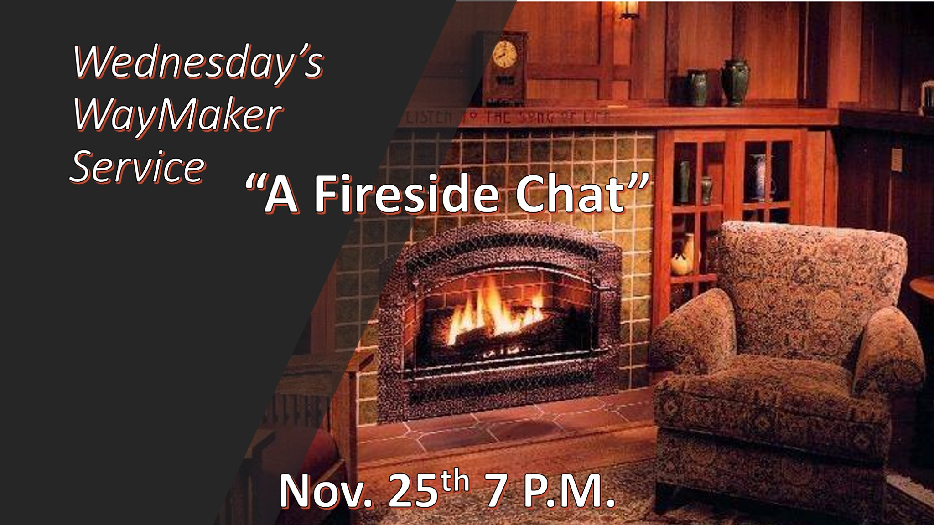

“Looking Back with Thanksgiving”
1. Lot’s wife: she looked back with longing for the life she was leaving behind. Tonight, we don’t look back like Lot’s wife. We look back with a grateful heart.

2. Gratitude: what do you have to share that has the mark of an appreciative attitude during this thanksgiving? (A special letter from within the Church)

3. Beholden: owing thanks to someone because of their service or help. Who comes to your mind? (Jack’s Dauer’s

“What we shouldn’t do about Tomorrow”

- Matthew 6:34 Don’t worry about tomorrow, for tomorrow will take care of itself
- Proverbs 27:1 Do not boast about tomorrow, for you do not know what a day may bring.

“What you can say about Tomorrow”

- Proverbs 19:20-21 But the Lord’s purpose will prevail. 20 Listen to advice and accept discipline, and at the end you will be counted among the wise.
21 Many are the plans in a person's heart, but it is the LORD's purpose that prevails.

- 1st Thessalonians 5:4-6 But you, brothers and sisters, are not in darkness so that this day should surprise you like a thief. 5 You are all children of the light and children of the day. We do not belong to the night or to the darkness. 6 So then, let us not be like others, who are asleep, but let us be awake and sober.

- Proverbs 16:3 Commit to the LORD whatever you do, and he will establish your plans.

- Proverbs 3:5-6 Trust (Delight) in the LORD with all your heart and lean not on your own understanding; 6 in all your ways submit to him, and he will make your paths straight.

- Philippians 1:6 being confident of this, that he who began a good work in you will carry it on to completion until the day of Christ Jesus.

